Hatch Valley Middle School
COVID RE-ENTRY PROTOCOL
For Parents
GUIDE FOR A SAFE RETURN

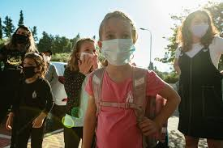

Hatch Valley Middle School
COVID Re-entry Protocol

In order to secure the safety and protection of our Hatch Valley Middle School Students and their families across the state, Governor Michelle Lujan-Grisham, in collaboration with the NMPED and the NMDOH, closed public school buildings for in-person instruction through an executive order on March 16th and was extended through the remainder of the 19-20 school year.
As the new school year approaches, it has been recommended by individual districts around the state to begin planning out safety measures that will allow students, teachers, and staff to return to a healthy and sanitary environment.

This protocol should be a guide for families and students to understand what health practices will be in place when students return to school. All public schools will be required to follow certain health practices in this guide noted as “required.”

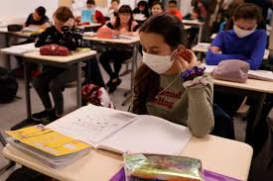
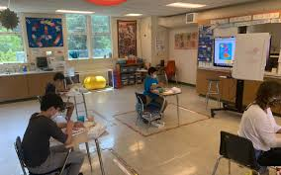

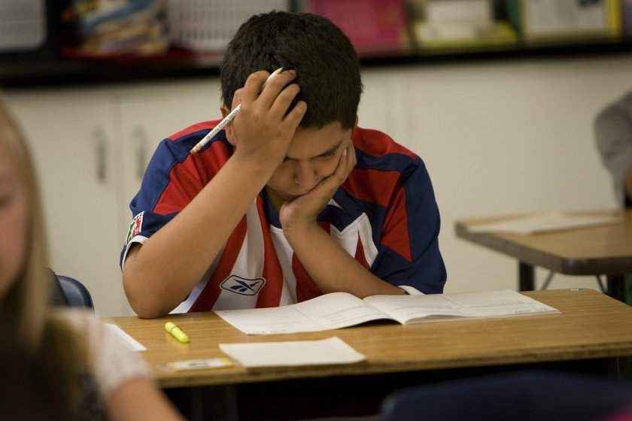

Why are there Health Requirements Needed Now?

COVID-19 is a contagious respiratory illness. The virus may spread to hands from contaminated surface and then to the nose or mouth, causing infection. Personal prevention practices such as washing your hands and staying home when you are ill are recommended. Frequent cleaning and disinfection are important practices included in maintaining a healthy and safe environment.
Any scenario in which many people gather together poses a risk for COVID-19 transmission. While children generally experience mild symptoms with COVID-19, and have not been found to contribute substantially to the spread of the virus, transmission from even those with mild or no apparent symptoms remain at risk.

Symptoms appear 2-14 days after exposure to the virus and may include but is not limited to the following:

- Fever or Chills
- Cough
- Shortness of Breath
- Fatigue
- Difficulty Breathing
- Muscle or Body Aches
- Loss of Taste/Smell
- Sore Throat
- Congestion or Runny Nose
- Headache

There have also been reports of vomiting, or diarrhea. External temperature of 100.4º or higher may indicate possible illness and may require further testing. While symptoms in children are similar to adults, children may have milder symptoms. Children have been reported to experience cold-like symptoms such as fever, runny nose, and cough. Children with COVID-19 may not initially present with fever and cough as often as adult patients.

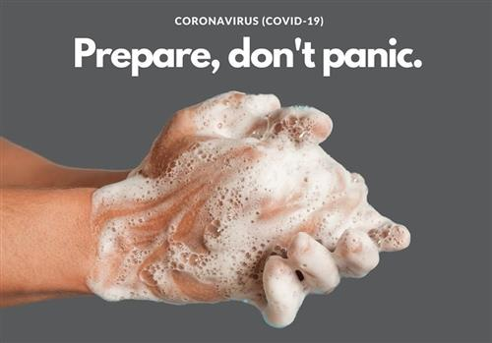

Fortunately, there are many actions that a district and school administrators can take to
help lower the risk of COVID-19 exposure and spread during school sessions and activities

Checklist for Parents

PLAN AND PREPARE
- Practice and reinforce good prevention habits with your family
- Avoid close contact with people who are sick.
- Cover your cough or sneeze with a tissue, then throw the tissue in the trash.
- Wash hands often with soap and water for at least 20 seconds, especially after going to the bathroom; before eating; and after blowing your nose, coughing, or sneezing. If soap and water are not readily available, use a hand sanitizer that contains at least 60% alcohol.
- Keep your child at home if sick with any illness
- If your child is sick, keep them at home and contact your healthcare provider. Talk with teachers about classroom assignments and activities they can do from home to keep up with their schoolwork.
- Be prepared if your child’s school or child care facility is temporarily dismissed
- Talk with your employer about sick leave and work from home options in case you need to stay home with your child. Consider planning for alternate child care arrangements.

IF YOUR SCHOOL/CHILD CARE PROGRAM IS CLOSED

- Keep track of school dismissal/closure updates
- Read or watch local media sources that report school dismissals or stay in touch with your school.
- Options for digital and distance learning will be provided
- Discourage children and teens from gathering in other public places while school is dismissed to help slow the spread of COVID-19 in the community
- Seek guidance from your school administrator to determine when students and staff should return to schools
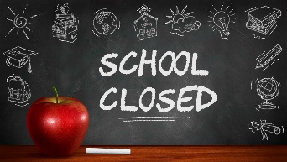
Duration of school dismissals will be made on a case-by-case basis based on the most up-to-date information about COVID-19 and the specific situation in your community. Students and staff should be prepared for durations that could last several days. Administrators should work with their local health authorities to determine duration of dismissals.

HVMS Plan for Re-entry

HVMS Leadership Team met continuously for weeks to plan for the reopening of schools around the district under three different scenarios, depending on what restrictions are necessary when the NMPED allows for a reopening date.

- Remote: Most students will engage in online instruction. Limited small groups (students with specialized education plans) are eligible for in-person instruction, if feasible.

- Hybrid: Under the hybrid model, schools are required to adhere to all requirements put forth and:

- Ensure sufficient social distancing with at least 6 feet between people at all times in school facilities and on school transportation vehicles
- Limit density of people in school facilities and transportation vehicles to no greater than 50% maximum occupancy to ensure safe social distancing.
- Students not in the building will engage in remote learning.

- Full Re-Entry: All students are eligible to return to the building with social distancing practiced to the greatest extent possible.

The following pages will reflect the HVMS protocol for the above-mentioned models. Please be ready at a moment’s notice to switch between any two models at any time.

Hatch Valley Middle School
COVID-19 Re-entry Protocol

The following will describe HVMS’s re-entry protocols specific to the three instructional models:
Learning Models

TRADITIONAL LEARNING WITH ENHANCED PREVENTATIVE MEASURES
All students are eligible to return to the building. Social distancing is practiced to the greatest extent possible. Preventative measures, including masks and temperature screenings, are recommended.
Group activities are minimized.
- All students eligible to return five days per week.
FULL REENTRY

REMOTE LEARNING
HVMS will use CARES Act money or other funds to ensure that each student has access to a digital device and options for connectivity in order to provide a robust online learning program in the event of a closure.
- Students engage in remote learning.
- Limited small groups (special education, etc.) eligible for in-person instruction, if feasible.
REMOTE
HYBRID LEARNING
Combination of some in-person days and some online days.
HVMS will be split into two learning cohorts:
Cohort 1:
Mon/Tues - in person
Wed – Fri - Online
Cohort 2:
Mon - Wed - Online
Thur/Fri – in person

- The number of students in the building at any time is capped by the number that can be accommodated while adhering to at least six feet of social distancing or 50% classroom capacity level.
- Students not in the building will engage in remote learning.
HYBRID
REENTRY GUIDELINES
INSTRUCTIONAL MODEL
BEGINNING OF THE DAY

REMOTE

- Attendance will be taken through student log-ins.
- Students must log-in to be accounted for.
- Students who don’t have internet access will call Attendance Liaison by 8:30 am to report attendance.
HYBRID

- Students will adhere to social distancing and follow flow paths to enter the building.
- Prior to entrance into the building, students will have external temperature checked at screening station.
- Masks/Face shields will be required to enter the building.
- Students will report to 1st period for breakfast.
- Students will listen to all daily announcements.

FULL ENTRY

- Students will adhere to social distancing and follow flow paths to enter the building.
- Prior to entrance into the building, students will have external temperature checked at screening station.
- Masks/Face shields will be required to enter the building.
- Students will report to 1st period for breakfast.
- Students will listen to all daily announcements.

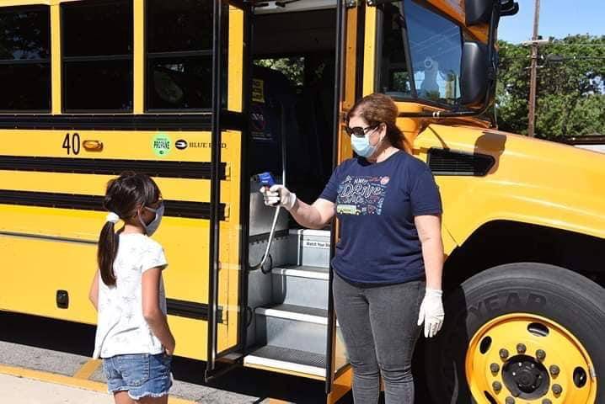

CLASSROOM ENVIRONMENT

REMOTE

- Students will be expected to fully participate in online instruction.
- Those students who do not have internet access, paper packets will be provided and the process for turn-in will be followed.
- Regular communication with teacher will be required.
HYBRID

- Students will adhere to social distancing and follow flow paths within the classroom.
- Masks/Face shields are required within the classroom.
- Hand sanitizer will be available.
- Student seating will be 6 ft. apart.
- Routines for disinfecting classrooms/materials will be put in place.
- Students will not share any materials.
- Students will be allowed restroom/water breaks and must follow the flow paths.
- Students who are not scheduled for in-person instruction will be expected to fully participate online.

FULL ENTRY

- Students will adhere to social distancing and follow flow paths within the classroom.
- Masks/Face shields are required within the classroom.
- Hand sanitizer will be available.
- Student seating will be as socially distant as possible.
- Routines for disinfecting classrooms/materials will be put in place.
- Students will not share any materials.
- Students will be allowed restroom/water breaks and must follow the flow paths.
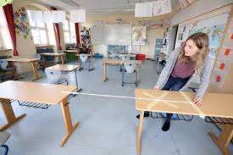
MEAL SERVICE

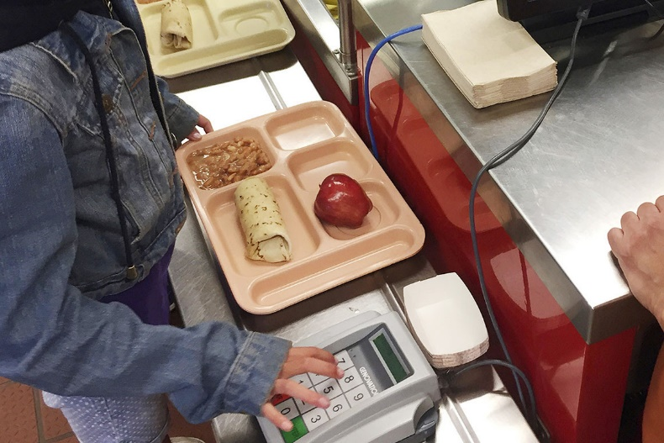
REMOTE

- Food distribution sites at both the middle school and at particular bus stops/routes, to the greatest extent practicable.
- Social distancing protocols will be adhered to during pickup.
- Multiday meals may be provided.
HYBRID

Distance Learners:
- Meals to distance learning students will be provided.
- Meals will be individually packed for distance learners.
On-Campus Learners:
- Students will be dismissed by intercom announcement.
- Students will follow flow paths to outside area for recess first.
- All students will be temperature screened upon exit outside.
- Lunch times per grade level.
- Social distancing will be enforced.
- Students will wear masks/face shields at all times when not eating/drinking.
- Absolutely NO sharing of foods and utensils.
- ABSOLUTELY NO OUTSIDE FOOD/SNACKS ALLOWED (unless approved by administration for medical reasons)!

FULL ENTRY

- Follow flow paths.
- Lunch times per grade level.
- Social distancing will be enforced.
- Students will wear masks/face shields at all times when not eating/drinking.
- Absolutely NO sharing of foods and utensils.
- ABSOLUTELY NO OUTSIDE FOOD/SNACKS ALLOWED (unless approved by administration for medical reasons)!

TRANSITIONS
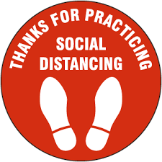
REMOTE

School buildings are closed.
- If small groups are meeting, cohorts will be kept together to minimize transitions.
HYBRID

- Limit mixing between groups.
- For class changes,
  - Additional transition time may be allowed.
  - Flow paths will be followed.
  - Only 2 students allowed in the restrooms at any given time.
- Students will wear masks/face shields at all times during transition.
- Students will ONLY be allowed locker access at the beginning of the day, at lunch, and at the end of the day.

FULL ENTRY

- Limit mixing between groups.
- For class changes,
  - Additional transition time may be allowed.
  - Flow paths will be followed.
  - Only 2 students allowed in the restrooms at any given time.
- Students will wear masks/face shields at all times during transition.
- Students will ONLY be allowed locker access at the beginning of the day, at lunch, and at the end of the day.

CLASSROOM INSTRUCTION
REMOTE

- Students will be expected to fully participate in online instruction.
- Those students who do not have internet access, paper packets will be provided and the process for turn-in will be followed.
- Regular communication with teacher will be required.
- Online instruction will be on the Canvas LMS platform.

HYBRID

- Chromebooks will be issued for home use only. DO NOT bring back and forth from home.
- Online instruction will be on the Canvas LMS platform.
- Cohort 1 will meet as follows:
  - M/Tu on campus
  - W-F remote
- Cohort 2 will meet as follows:
  - M-W remote
  - Th-F on campus
- Holiday schedules will be provided.
- Grades will be entered into PowerSchool.
FULL ENTRY

- All Cohorts will attend full day schedule while adhering to social distancing.
- PPE and sanitation requirements will be enforced.
END OF THE DAY

REMOTE

- Make sure all assignments are submitted on time per class schedule.
HYBRID

- Students will be dismissed from classroom by bus number.
- Students will adhere to social distancing and follow flow paths to exit the building.
- Masks/Face shields will be required to exit the building.
- Bus procedures will follow Transportation Dept. guidelines.

FULL ENTRY

- Students will be dismissed from classroom by bus number.
- Students will adhere to social distancing and follow flow paths to exit the building.
- Masks/Face shields will be required to exit the building.
- Bus procedures will follow Transportation Dept. guidelines.

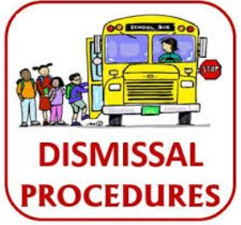
IF STUDENTS/STAFF BECOME SICK AT SCHOOL
- HVMS will utilize a designated isolation room to separate anyone who exhibits COVID-like symptoms.
- School nurses will use Standard and Transmission-Based Precautions when caring for sick people.
- HVMS will establish procedures for safely transporting anyone who is sick home or to a healthcare facility.
- HVMS will notify local health officials, staff, and families immediately of a possible case while maintaining confidentiality consistent with the Americans with Disabilities Act (ADA) and other applicable federal and state privacy laws.
- The school building will be closed if used by a COVID-19 positive sick person and will not be used before cleaning and disinfection.
- HVMS will ensure safe and correct application of disinfectants and keep disinfectant products away from children, and have waited 24 hours before cleaning and disinfecting. If it is not possible to wait 24 hours, wait as long as possible.
- HVMS will advise sick staff members and children not to return until they have met NMDOH criteria to discontinue home isolation.
- HVMS will follow NMDOH restrictions and guidelines.

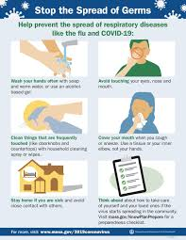

Hatch Valley Middle School Schedules

Remote:
 | Monday | Tuesday | Wednesday | Thursday | Friday
ALL STUDENTS: | REMOTE LEARNING

Hybrid:
 | Monday | Tuesday | Wednesday | Thursday | Friday
Cohort 1: Last Name A-L | On Campus | On Campus | Remote learning for all students. Planning/office hours/PD for teachers Deep cleaning buildings and busses | Remote | Remote
Cohort 2: Last Name M-Z | Remote | Remote |  | On Campus | On Campus

Full Entry:
 | Monday | Tuesday | Wednesday | Thursday | Friday
ALL STUDENTS: | On Campus 1st - 4th | On Campus 5th - 8th | On Campus Skinny Wednesday 1st - 8th | On Campus 1st - 4th | On Campus 5th - 8th
Assumption of the Risk and Waiver of Liability Relating to COVID-19

COVID-19 is extremely contagious virus and is believed to be spread mainly from person-to-person contact. Hatch Valley Public Schools cannot guarantee that your child will not become infected with COVID-19. Attendance in school could increase the risk of contracting COVID-19.

Student First and Last Name ________________________________________________

Parent First and Last Name _________________________________________________

READ CAREFULLY BEFORE SIGNING – PLEASE INITIAL EACH PARAGRAPH

_____ By signing the above agreement, I acknowledge receipt of the HVMS COVID Re-entry Protocol.

_____ By signing the above agreement, I acknowledge the contagious nature of COVID-19 and voluntarily assume the risk that my child may be exposed to or infected by COVID-19 through school attendance, and that such exposure or infection may result in personal injury, illness, permanent disability, and/or death.

_____ By signing the above agreement, I understand that the risk of becoming exposed to or infected by COVID-19 at HVMS may result from the actions, omissions, or negligence of the myself and others, including but not limited to HVMS staff, students, and families.

_____ By signing the above agreement, I voluntarily agree to assume all of the foregoing risks and accept sole responsibility for any injury to my child, including but not limited to, illness, permanent disability, and/or death, damage, loss, claim liability, or expense, of any kind, that I may experience or incur in connection with participation with HVPS.

_____ By signing the above agreement, on my behalf, I hereby release, covenant not to sue or hold liable Hatch Valley Public Schools, it’s staff, other students, and families of and from the claims, including all liabilities, claims, actions, damages, costs, or expenses of any kind arising out of or relating thereto.

__________________________________ ______________________
Parent Signature Date

