SPAGHETTI DINNERS!!!
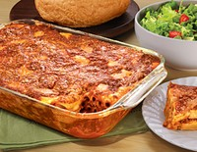

What is a SPAGHETTI DINNER?
Typically, on a Thursday or Friday night before a meet, the team gathers together to load up on carbohydrates and have some fun. These are great bonding experiences for the athletes. The dinner is hosted by one or more team member’s families. The host is responsible to provide their home, plates, cups, napkins, silverware, caffeine free drinks and of course some form pasta with sauce. Salad, bread, meatballs, desserts, etc. are welcome but are not a necessity.
Families that have hosted in the past could be very helpful in advising how much pasta should be prepared for the team.
The dinners are usually well attended. You can expect 10-20 athletes at your home (or site of your choosing) for the spaghetti dinner. The dinners usually start at 6:00 PM and end around 8:00PM. One or more coaches will usually attend the dinner to help supervise the team, give instructions, etc... It is very helpful to have a couple of parents share the hosting responsibilities.
If your child has a special dietary concern or restriction, please feel free to send something that is suitable for them to eat and have them join the dinner for the team bonding experience.
If you are interested in hosting a team spaghetti dinner, please see one of the coaches.

