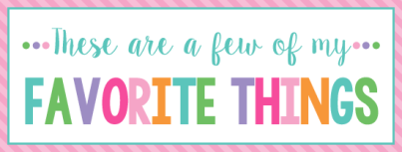

Name:__Amy Elaine Tice_______ T Shirt Size:____AL______________
Birthday:___Julu 25th_________ Monogram:_____just “A” please___
Favorite Color:Turquoise_______ Favorite Flower:_Rose/ Sunflower
Favorite Scent:_Clean Cotton Favorite Candy:_Snicker, Twix, Jolly Ranchers, Sugar free gum
Favorite Drink:_Dr. Pepper, Coke Zero, or Diet Snapple Tea_
Favorite Food:_Grilled chicken, pasta_________________
Favorite Snack:_Salty______ Favorite Fruit:_Apples, Strawberries__
Favorite Restaurant: Olive Garden, La Siesta__________________
Favorite Fast Food:_Wendy’s, Sonic, Chick fil a, subway_____
Favorite Places to Shop:__TJ Max, Hobby lobby, Commerce St. Market_____
Favorite Bath & Body Works Scent: Magic in the air_________
Things I collect:_Willow tree angels, Etta B pottery, crosses, bottles of sand from all over different beaches_____________
Favorite Author /Book Series for my own personal reading:__Fun fact books, daily devotional books, seek a word_________________
Wish List for Classroom:_colored pens, sharpies, small award prizes, stickers, wrapped candy________________________________________
_________________________________________________________________
** Please turn in to Mrs. Still by Friday.***

