Parent(s), graded papers go home tomorrow. Please be sure you are checking your child’s backpack and folder daily. Continue to encourage reading and homework completion. Write any comments or suggestions below, send additional note, or email me if needed (karla.thompson@dcsms.org). Thank you for your support!

You can also Stay Connected with Remind. Text @g7fc3f to 81010 Standard text message rates apply.
Visit remind.com to learn more. Thanks to those parents already registered! ☺

Classroom Newsletter January 21, 2020
Mrs. Thompson – 3rd Grade
Boosterthon FunRun:
Thursday, January 23, 2020
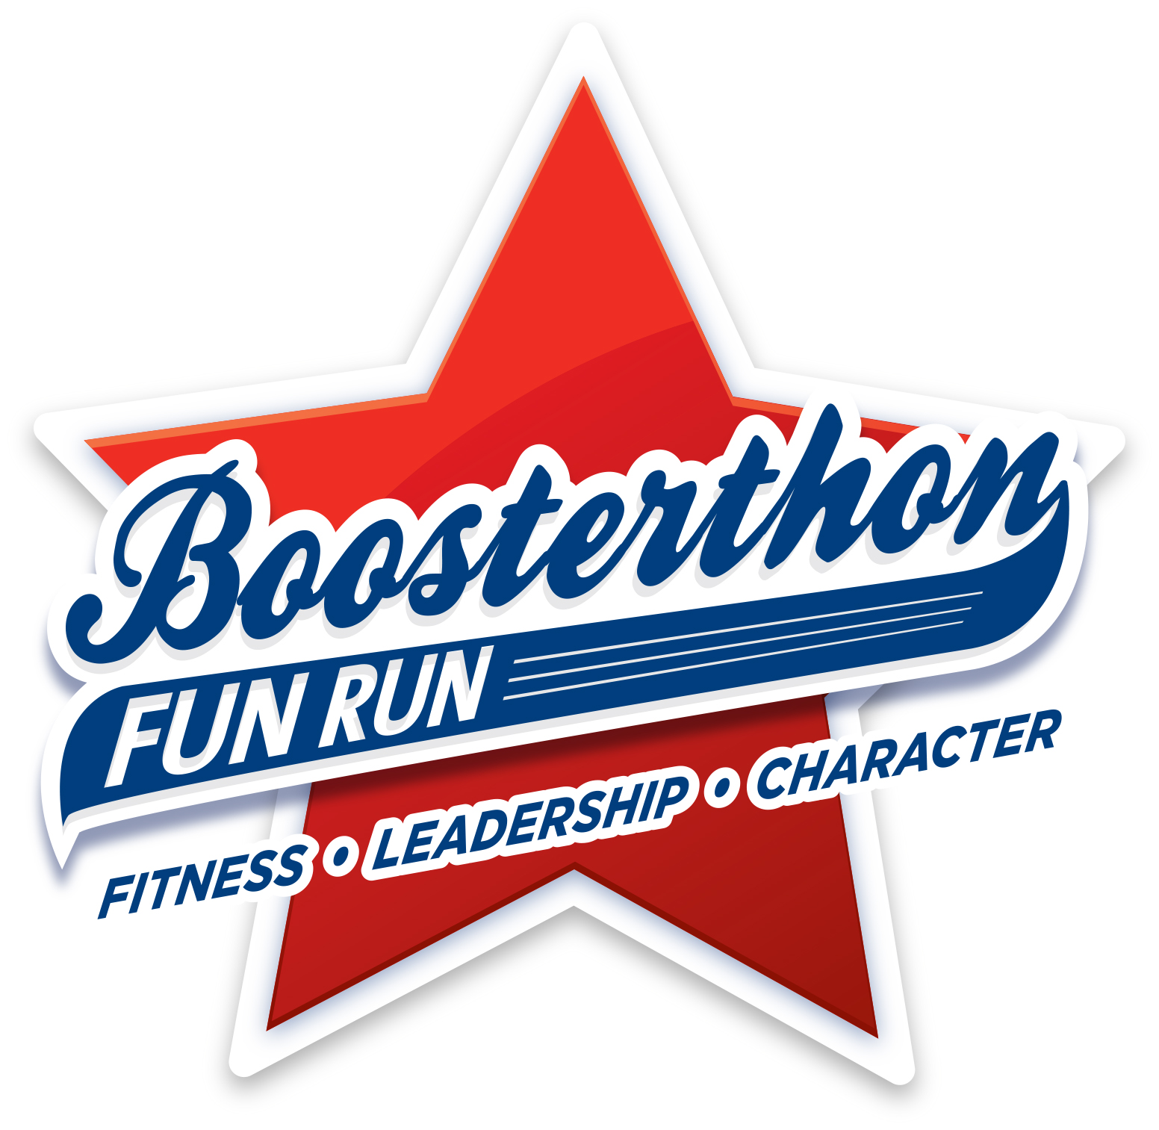
Thank you so much for all of your support!.
Teacher Notes: Midterms the week of January 27th. We will take our reading midterm next week and then our math midterm the first week in February. These tests are scheduled to be administered on the computer to prepare our students for the state test, which is also on the computer. Thank you so much for your support of your child’s education. It really does show when you are an active part of helping them learn. * Next GATOR CLUBS – TODAY, January 21, 2020 Reading: central message, main idea & details, context clues
Writing: text evidence
Math: fractions
Social Studies: historical figures

Classroom
Topics

We may encounter many defeats, but we must not be defeated. – Maya Angelou
Reading Strategy Focus - Inference
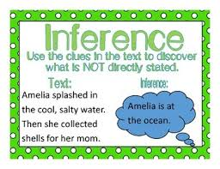
Daily Homework:
- Read, read, read – at least 20 minutes every day; Single page Tuesday: Meriwether Lewis… and Single page Thursday: Nellie Bly
- Practice multiplication facts; complete single daily problem: Daily Problem Solving

Upcoming Tests:
Reading
- Reading Quiz: 01/21
- Reading Midterm: next week
Math
- Kicking It Quiz (multiplication facts): 01/21
- Math Test (fractions): 01/24

