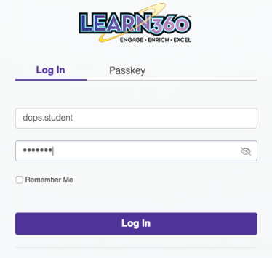

DESOTO CENTRAL PRIMARY SCHOOL
LEARN360 VIDEO STREAMING
UNIVERSAL STUDENT LOGIN INSTRUCTIONS: With option 1 (basic student login), students and parents cannot save searches or their favorite videos. With option 2
(unique user login) students and parents can create their own unique login and save favorite videos, save searches and edit shareable videos for student presentations and research projects.

OPTION 1: BASIC STUDENT/PARENT LOGIN

1. From the “Parents & Students” menu on the DCPS school website
(http://dcps.desotocountyschools.org/) select the “Online Textbooks & Programs” option 2. Click the button entitled “Learn360 Video Portal”

3. In the “Username” box, type dcps.student 4. In the “Password” box, type jaguars Example:

5. Click the “Login” button.

DeSoto County School District
Learn360 Student/Parent Instructions
1
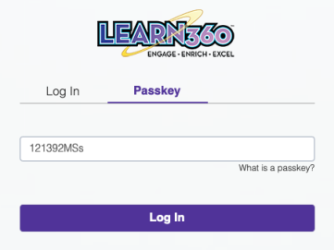
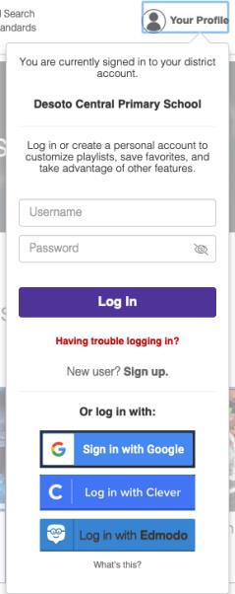
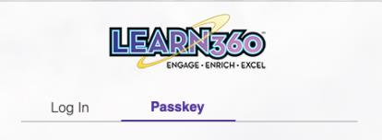

OPTION 2: UNIQUE STUDENT LOGIN: CREATE YOUR OWN ACCOUNT

1. From the “Parents & Students” menu on the DCPS school website
(http://dcp.desotocountyschools.org/) select the “Online Textbooks & Programs” option.

2. Click the button entitled “Learn360 Video Portal” .

3. Click the “Passkey” option.

4. In the “Passkey” box, type 121392MSs and click the “Login” button.

5. Create your account by clicking on the profile image in the top right-hand corner and clicking “New User? Sign Up”

DeSoto County School District
Learn360 Student/Parent Instructions
2
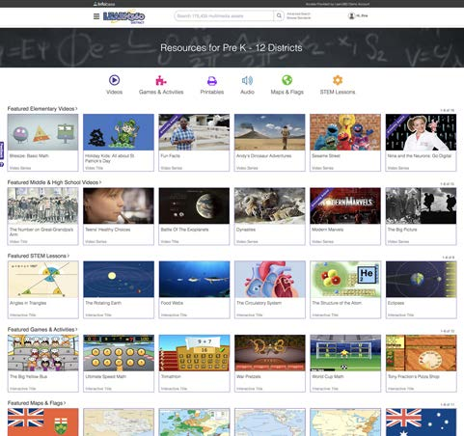
Streaming Media, Use On-Site or Off Welcome to Learn360 Streaming Media!
Learn360 is a multisubject, easy-to-use K–12 media library (videos, interactives, articles, songs, games, images, and more) that can be used on-site or off.
TEACHERS can use this versatile resource to fnd content for lesson plans, to introduce topics, as assignments, and much more.
STUDENTS can use Learn360 independently for research, homework help, or self-directed learning; to enhance projects and assignments; or even just for fun.
Highlights include:
• Vetted, safe, ad-free content—
• Add a personalized video intro-
better alternative than scouring the
duction to your playlists to give an free web or YouTube
overview or context
• Available on-site or remotely, 24/7
• Dynamic citations, multiple formats
—ideal for distance learning and
• Easily add content to lesson plans virtual instruction
and LMSs
• Easy to use, easy to navigate—no
• Add your own Custom Content
Tech & Learning
The ComputED
special software or hardware needed
from educational Web Channels or
Award of Excellence
Gazette
• Correlated to educational standards YouTube
Two-time winner!
Best Educational Soft-
as well as 21st Century Skil s
ware Award (BESSIES)
• Monthly calendar for research
Tech & Learning
• Captions and searchable, interac-suggestions and ideas

ISTE Best of Show
The ComputED
tive transcripts
• Share to Google Classroom and Award
Gazette
Education Software
• Create and share playlists—use Save to Google Drive
eSchool News
Review Award
premade clips, full videos, or custom
• Searchable Support Center
Readers’ Choice
(EDDIES)
segments to engage students
Award
1
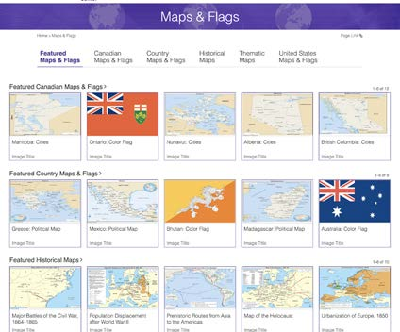
Streaming Media, Use On-Site or Off A Variety of Content for All Classes & Departments We handpick titles from more than 550 top educational content providers to offer a wide variety of the most relevant videos and multimedia suiting the unique instructional needs of every subject.
And new, diverse content is added regularly.
Essential teacher & classroom resources: Signifcant resources across ALL subjects:
• Full-Length Videos
• Interactive Games
• Science and
• Mathematics
• Video Clips
and Lessons
Technology
• Arts
• Teacher Guides
• Images
• Health and Guidance
• World Languages
• Student Activities and • Articles
• Social Studies
• Vocational Guidance
Worksheets
• Fact Sheets
• Language Arts
• Music Tracks
• Maps and Flags
• Sound Effects
• Timelines
Plus, a wealth of
• Audiobooks
• Science Diagrams
new maps and fags
recently added!
• Audio and Video
and Experiments
Speeches
• Plus, Spanish-
• Newsreels
language content!
Learn360 content is vetted, safe, and curated for students and
educators—a source you can trust!
2
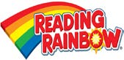
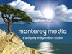
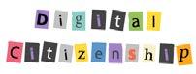
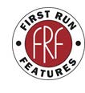
Streaming Media, Use On-Site or Off The Best Content from the Best Producers & Providers 3
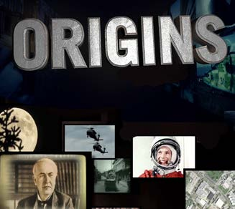
Streaming Media, Use On-Site or Off A Wealth of New and Classic Videos & Series With New, Diverse Content Added Regularly New & notable
landmark titles that
both educators and
students will love,
including:
• Blue Planet
• Life
Virtual
• Life Story
Fieldtrips
• Africa
• Spy in the Wild
• Horrible Histories
• TEACH
• Bitesize
• Treasures of Ancient
Greece
• This Day in History
• Show Me Science
• Discover the World
• Dynasties
• The Big Picture
4
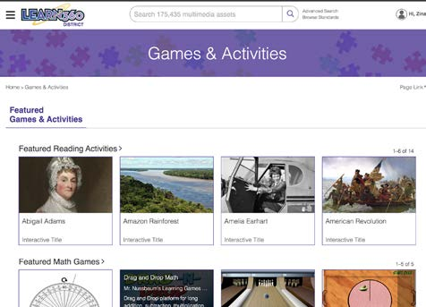
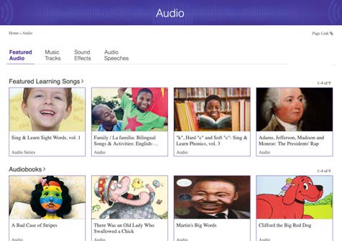
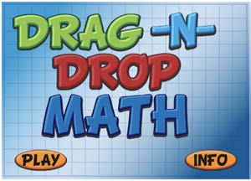
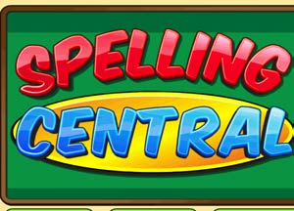
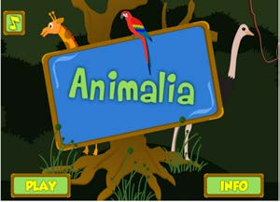
Streaming Media, Use On-Site or Off Games, Activities, and More for Elementary Level Engaging and fun… and perfect for distance learning!
Find these resources in
“Games & Activities”
and “Audio“ from the
drop-down menu if you
are browsing by
“District” or “Elementary”
Keep younger students
motivated and engaged
while learning from home
SELECT & SHARE
games, activities, stories,
learning songs, audio-
books, and more
Mix up core topics and
And check out our storybook videos for elementary!
fun titles for variety
Bilingual songs for
Search for
ELL students
“Children’s
Picture Books”
by Weston Woods
5
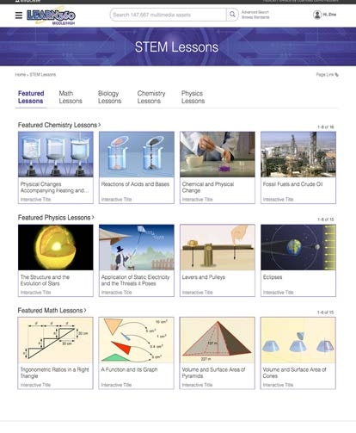
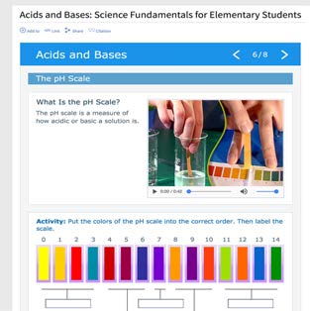
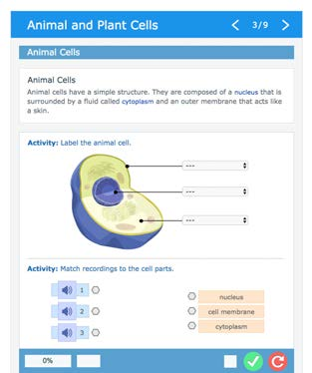
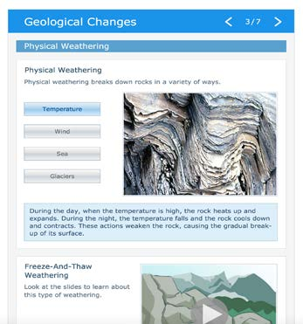
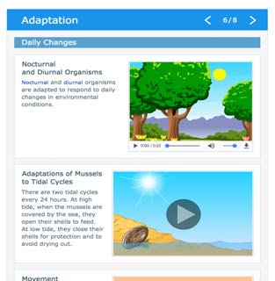
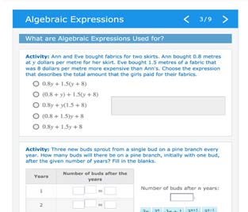
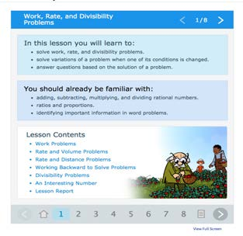
Streaming Media, Use On-Site or Off Engaging, Interactive STEM Lessons
Find them via the
Use for distance learning—assign as drop-down menu
homework or for self-assessment
on every page if
• Activities and quizzes support applied learning, allowing students to you are browsing by
test themselves by completing equations, labeling images, setting
“District” or
events in order, flling in tables and sentences using the drop-down menu, and more
“Middle/High”
• Lesson Reports at the end of each interactive assess students’ work
• Increase students’ understanding of key concepts in general science, biology, physics, mathematics, chemistry, and more at upper elementary, middle, and high school levels
6
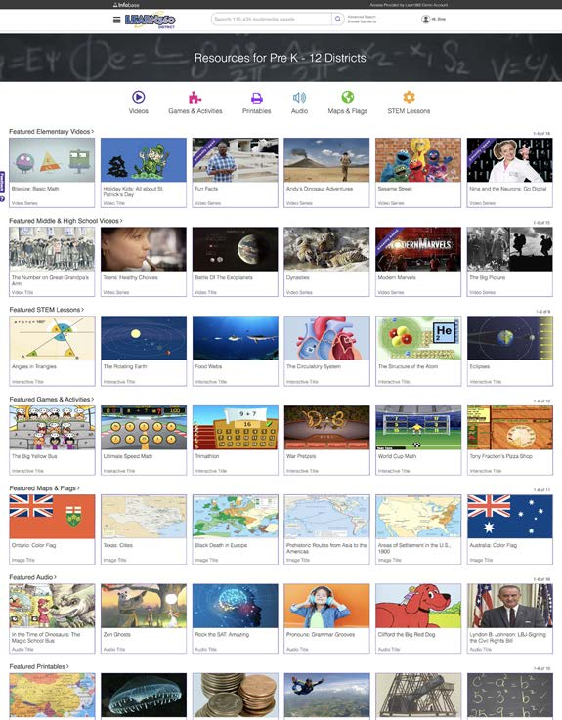
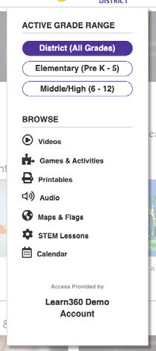
Streaming Media, Use On-Site or Off Learn360 Home Page and Navigation Filter the
Customize It!
entire site
Admins and users can
and all landing
set preferences for
pages by
GRADE RANGE so that
grade level!
only the content you
need will display,
making it easy to fnd
appropriate material
Easy
Featured
Access
Content
The top navigation provides
Featured content has
quick access to all media assets
been handpicked by
and grade ranges. You can easily
our editors to guide
flter content by grade range via the
and inform research,
drop-down menu at the top of
lesson planning, and
each page
programming
7
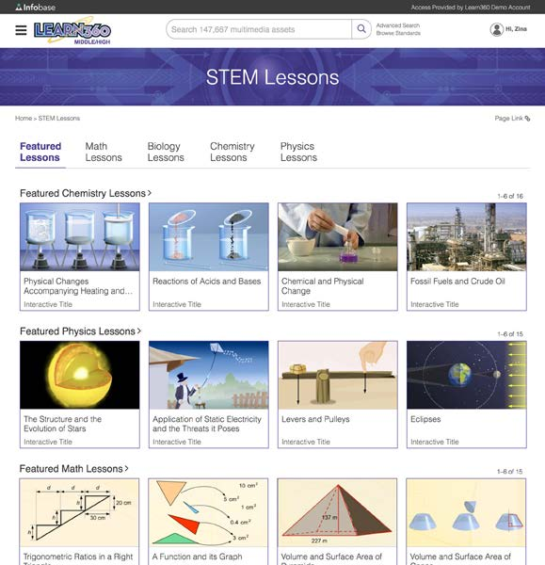
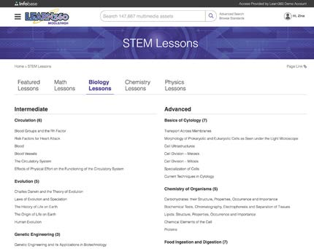
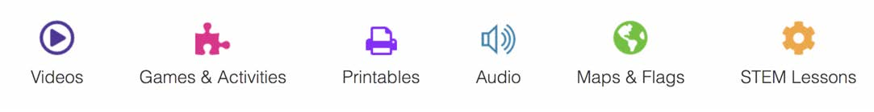
Streaming Media, Use On-Site or Off Content Landing Pages for Targeted Browsing Each media type has its own
landing page—accessible via
the drop-down menu in the
header of every page or at
the top of the home page—
for better access to the
diverse content
Featured Content
Featured content for each
media type has been hand-
picked by our editors to
guide and inform research,
Complete Indexes
lesson planning, and
Each media type subgroup features
programming
a neatly organized, comprehensive,
fully browsable index, so you
can see the complete selection
of content
8
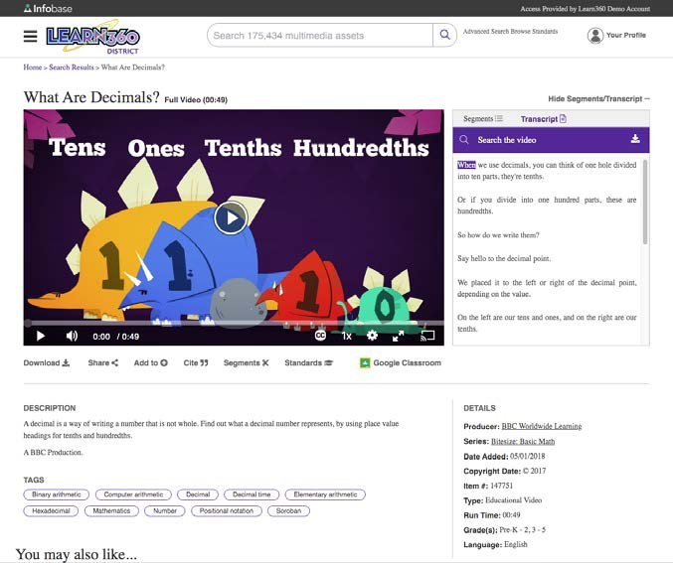
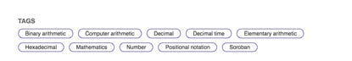
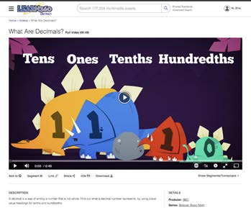
Streaming Media, Use On-Site or Off Clean and Intuitive Video Player Page Correlations
Helpful Segments
All video content is corre-
All full-length videos are organized
lated to Common Core,
into convenient segments, but
national, state, provincial, IB,
you can also create your own.
C3 Framework for Social
Use segments to teach what’s
Studies, Col ege Board AP,
relevant—short and sweet!
AASL, national STEM, and
Next Generation Science
Transcripts
Standards, as well as 21st
Searchable, interactive, download-
Century Skil s
able transcripts appear right next
to the video so users can follow
Keyword Tags
along. Bonus: Transcripts can be
for all content provide links
translated.
to related material
Google Translate
Customize It!
You can translate all descriptions,
Users can set preferences for video display, type of citation, transcripts, and navigation into
closed captioning settings, and Google Translate language one of more than 100 languages.
This is the size of the player if you hide Find Google Translate in the footer
segments & transcripts
of every page.
9
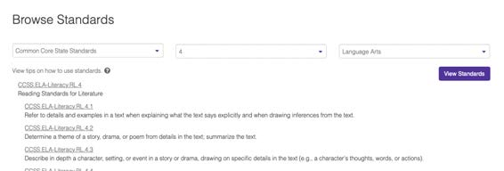
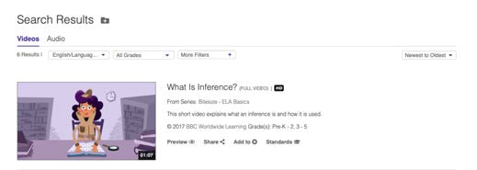
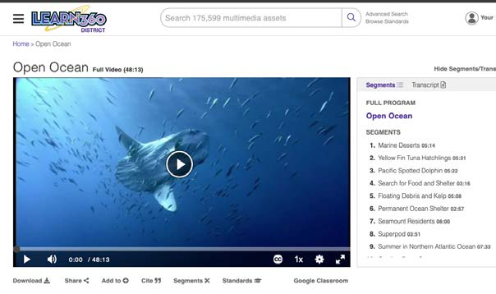
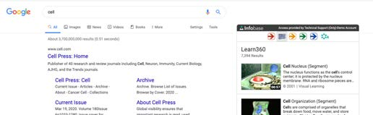
Streaming Media, Use On-Site or Off Searching and Standards in Learn360
Browse by Standards
Advanced
You can browse for standards and find Search
correlated content from the Browse lets you narrow your
Standards link next to the Search Bar search using AND
/ OR / NOT bool-
Select the Standard, Grade, and Subject you need from ean operators, plus
the three drop-downs and then click “View Standards”
flter by asset type,
producer, language,
copyright, subject,
and other criteria
View Standards
Search from Google Chrome
You can see any video’s
Get the Chrome extension—as you perform Click on a standard and get a list of standards from the player
searches in Google, relevant results from videos correlated to that standard
page or from the browse or
Learn360 will automatically populate a search results listing
widget to the right of your results
10
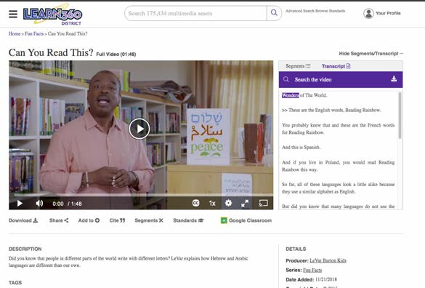
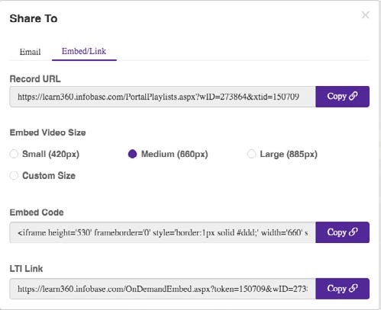
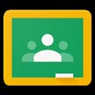
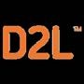
Streaming Media, Use On-Site or Of Str
f
eaming Media, Use On-Site or Of
Sharing Learn360 Content via Your LMS
Learn360 Content Is Easy to Share with students from a learning management system (LMS) your school may be using Record URLs/Permalinks
Record URLs, also known as permalinks, allow you to share links to specifc pages or content. Just cut and paste the record URL
into your LMS (if you use one) or into an email and send.
Embed Codes
Embed codes allow you to add content into any HTML page or LMS such as Schoology, Brightspace/D2L, Canvas, Moodle, Itslearning, Edmodo, and others. This makes it easy to share content with students via systems you may already have in place.
When you use the embed code, the video will stream within your LMS, web page, online classroom, or Google Doc, keeping the students focused on your full lesson.
LTI Link
Share to
Like embed codes, the LTI link creates a playable video player directly in your LMS, web page, online course, or Google Doc.
Google Classroom
Skip the “Share” Tool!
Use this link when the destination cannot accept HTML coding and therefore the embed code won’t work, such as many Couldn’t be easier—just
A NOTE for schools that use Schoology, Canvas, LibGuides or lesser-used LMSs.
click on the link!
Itslearning, Moodle, or Brightspace/D2L
For schools that use one of these fve LMSs and have our apps installed, you can directly embed Learn360 content into your courses without leaving that LMS (meaning you don’t have to use the embed codes in the “Share” tool or go into Learn360
to get content).
11
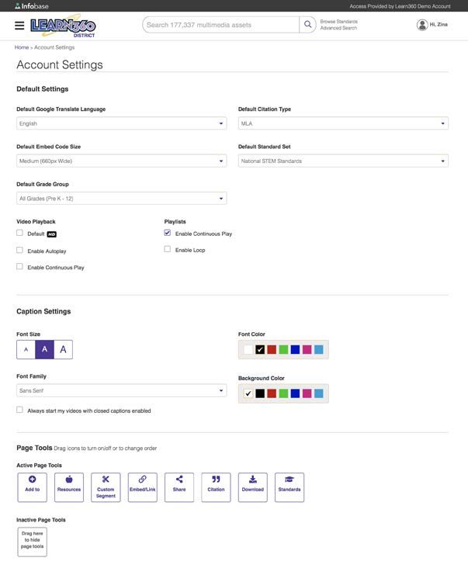
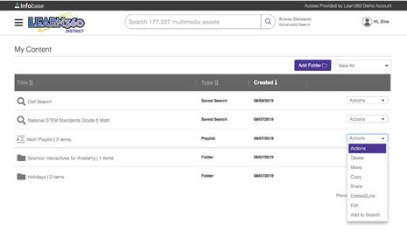
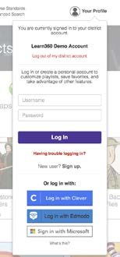
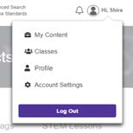
Streaming Media, Use On-Site or Off Create a Learn360 User Account Customize Your
Own Preferences!
Create a user account to
customize a variety of helpful
It’s quick and
settings:
easy to set up a
user account!
• Default Grade Group
• Default Citation Type
• Default Educational
My Content
Standards Set
(formerly “My Learn360”)
• Default Google Translate
Language
Get easy access to all of your
• Default Embed Code Size
saved titles, searches, and
• Video Playback Settings
playlists. Create folders for bet-
• Playlist Settings
ter organization. Create classes
• Caption Settings
so you can share content to
all of your students at once.
• Page Tool Settings
Move, copy, share, embed/link,
delete, or edit your content
right from this page.
12
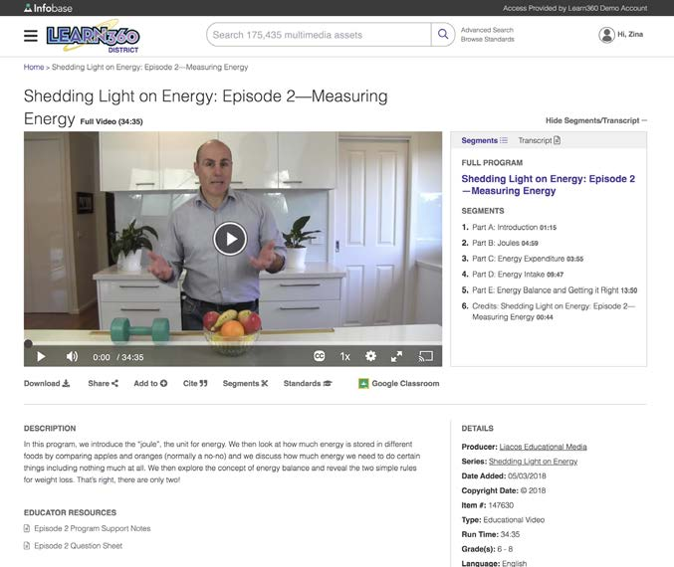
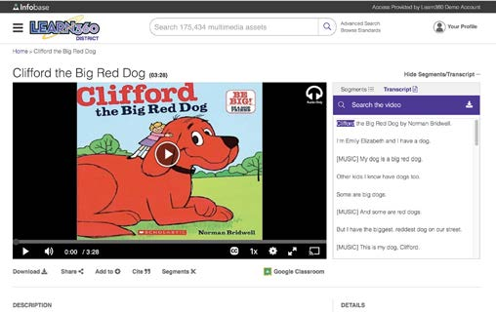
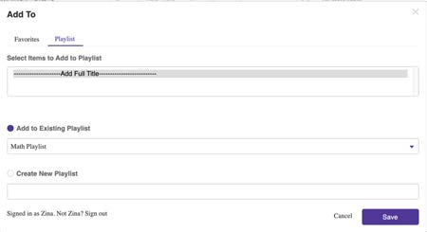
Streaming Media, Use On-Site or Off Creating a Playlist in Learn360
Use Playlists to Customize Video and Audio Sequence for Your Lessons
Playlists are easy to create, manage, and share, and are a great way to give students access to exactly what you want them to view in the preferred order. Full videos, video seg-VIDEO
ments, and audio fles can be added to playlists. PLUS, you can add a personalized video intro to any playlist you create to add context and connect with your students—see next page for more information.
Using the
“Add To” Tool
Add complete videos, seg-
ments, or other content to
your Favorites folder or to
AUDIO
a Playlist (or Classes if you use them). You can add to an
existing playlist, or you can
create a new playlist.
13
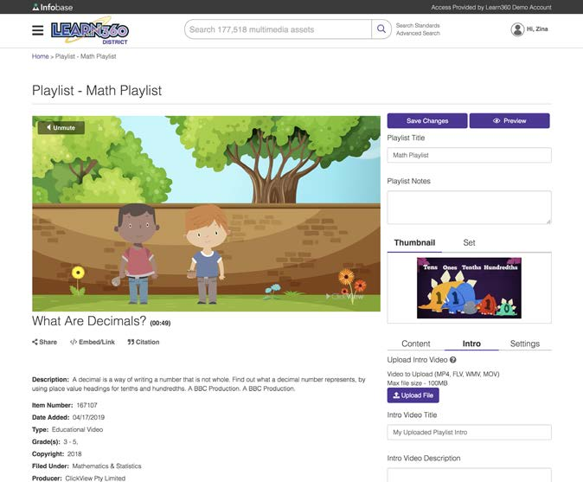
Streaming Media, Use On-Site or Off Add a Personalized Video Introduction to a Playlist Add Context for
Create a User
Students
Account or Login
You can add a video introduc-
Create a user account to save
tion under three minutes long
and access favorites, including
to any playlist you create in
playlists—which you can
Learn360. This video intro
personalize with your own
will then be viewable by your
introduction and easily share
students as part of the playlist.
with students
Uses and benefits include:
• Provide an overview of the topic
for your students
Add Your Intro
• Offer context to the videos in the It’s easy to add your personal-playlist
ized intro directly into the Edit
• Suggest specifc points in videos
for students to pay attention to
Playlist page—simply upload
the video fle, give it a title and
• Give homework instruction to
your students
Let students know what’s
description, and save changes
• Perfect for distance learning,
important in the playlist
virtual instruction, and fipped
right at the beginning!
classrooms!
14

