Students Instructions to Access Schoology

To access Schoology
- Login to computer
- Go to dcsdms.org
- Click Schoology link
- Login using email and password
  - Username: First initial last initial last 6 of MSIS (no spaces)
  - Password: Quistors birthdate (no spaces)
- Courses will automatically show up based on schedule

Students Instructions to Access Materials for class

To access Course Materials
- Click on course on Course Dashboard
- Teacher will have course setup and give instructions for completing lessons and assignments

Student Instructions to Submitting Assignments

An assignment created in Schoology
- Click on Assignment to open
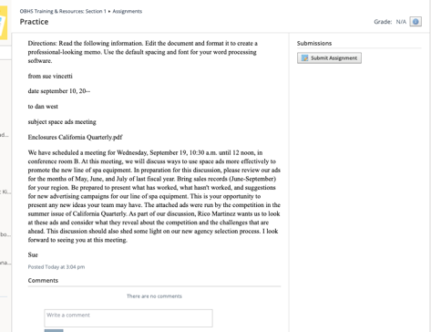
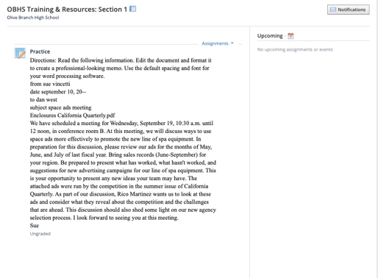

- Click Submit Assignments

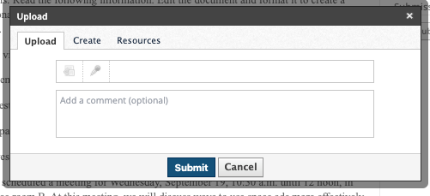
- To Upload a file from any location, click on the Upload tab, click File

- Choose your file location
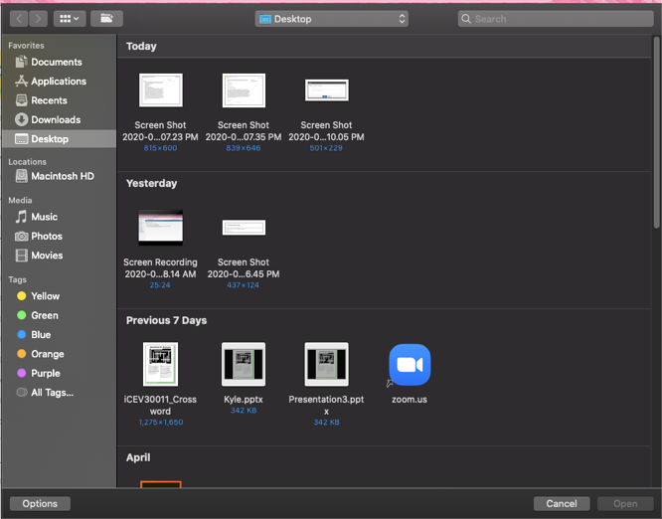

- Click on your file, then open
- Click Submit
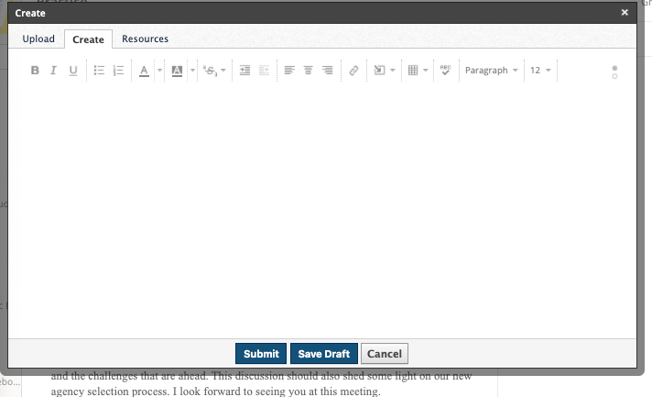
To answer in Schoology,, Click create

- Type answer in box
  - You can insert files, images, etc. also by clicking on Insert Content
  - Then Click submit

To upload from OneDrive or Google Drive
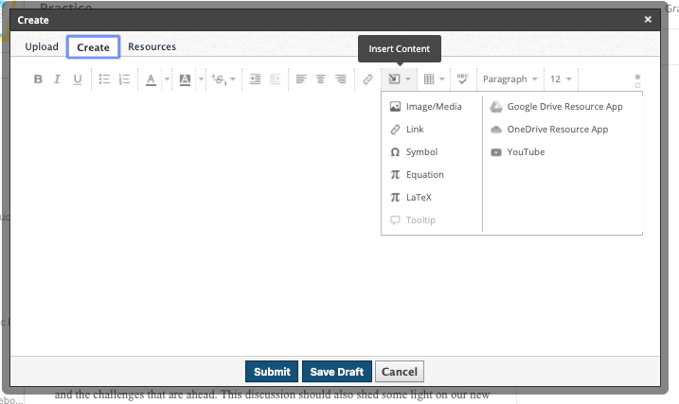
- Click on Resources Tab
- Click Apps
- Choose/login to OneDrive
- Locate file
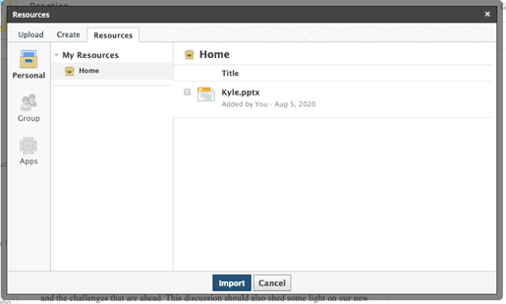
- Click Import

Saving documents
- If you create a document in Word from Office365, save it to your OneDrive.
  - Click File, SaveAs
  - Navigate to One Drive Folder
  - Click Save
- Then use the upload file steps to submit.

