**How to Access your Student Email Account**

1. Go to www.desotocountyschools.org.

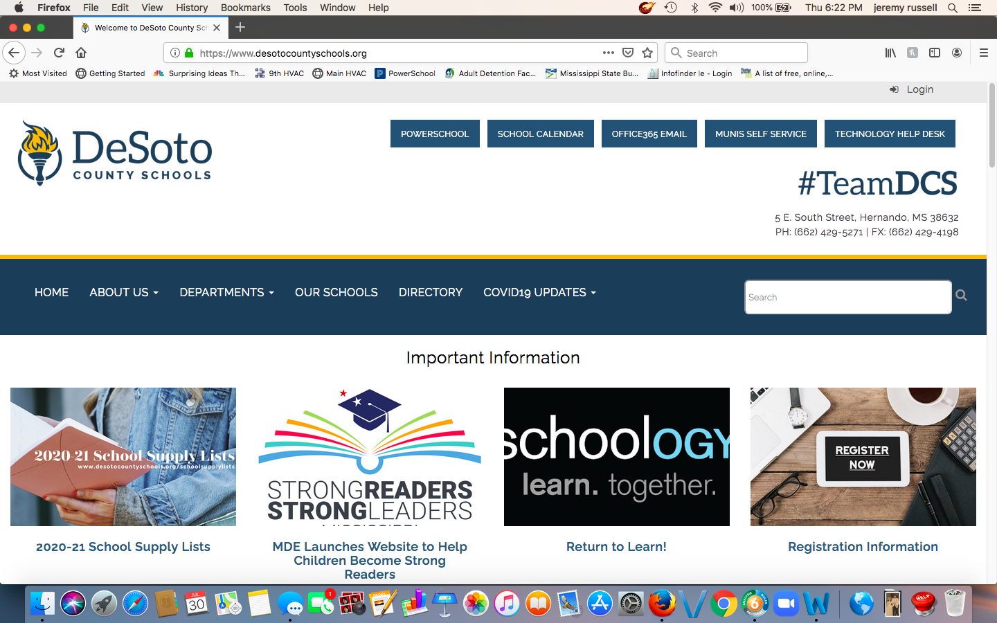

2. Choose Office 365 Email.



3. Enter your DCS Student email address. Students’ email addresses are constructed using the following formula:

* First initial of first name + first initial of last name + last 6 digits of their lunch number followed by @dcsms.org.
* Example: If Amy King’s lunch number is 1234567, her DCS student email address would be ak234567@dcsms.org.
* Password is setup as your school mascot + your date of birth (mmddyy).
* Example: Your school is Southaven High School and your birthday is July 8, 2004, your password is Chargers070804. (Capitalize only the first letter!)
* Note: you will enter email address and password on separate screens.

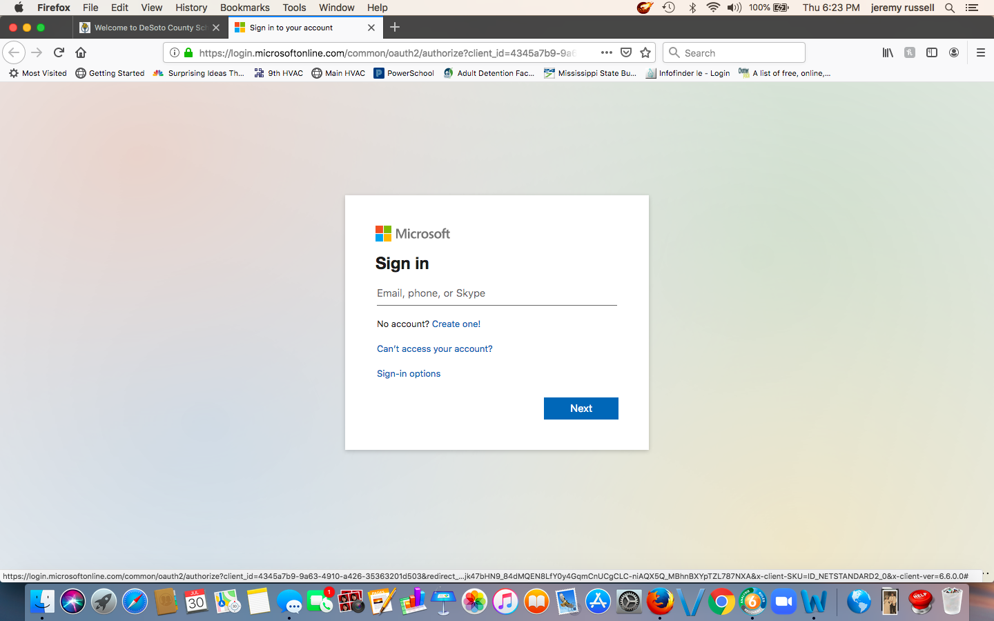

4. The next screen will list all of the applications within Microsoft Office 365. Choose Outlook.

