CASTLEN ELEMENTARY SCHOOL
PreK Wish List
2020-2021
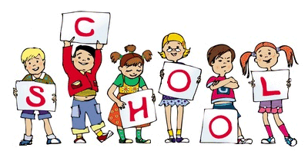
Central Office is requesting that parents provide a face mask for their child to have with them at school each day. Cloth is preferred due to durability.
General school supplies have already been purchased by the state department.
Listed below are items that are needed and the teacher, Mrs. Stewart, is requesting. You are not required to purchase them.

WISH LIST
4 rolls of paper towels (preferably small size-select a sheet)
3 boxes of Kleenex
1 large container of wet wipes (Wet Ones Brand or Baby Wipes)
1 Large container of Clorox/Lysol Wipes
1 large bottle of hand sanitizer
1 box of sandwich sized Ziploc bags

