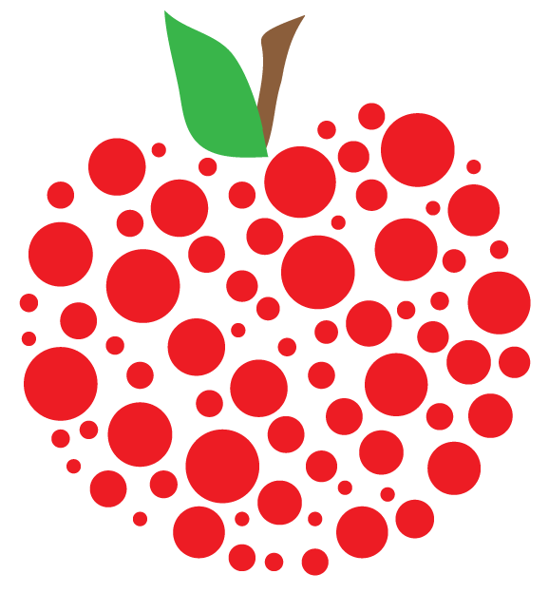

Weekly news from Mrs. Newburn’s Class

* This week we will still be focusing on the letter A and APPLES!!! We have a lot more fun activities planned involving apples.
* Each night when you check your child’s folder, please remind them of how important it is to follow the rules at school! There are 18 kids in our class (14 of them are boys), so it’s important that they all follow the rules to keep our day moving along smoothly!
* Cookie Dough sales have to be turned in by **WEDNESDAY, SEPTEMBER 18th.**
* My website has the newsletters and calendar. I will be updating it often!
* We will have college students in our classroom observing every Thursday until Thanksgiving break. We will also have another college student that just has to do a couple observations – right now she’s scheduled to be in here on Wednesday, September 18th. All the students have passed their background checks and have been approved by our school. At no time, whatsoever, will they be left alone with your child or in charge of your child; they are only here to “observe”.

**Upcoming Events / Reminders…**

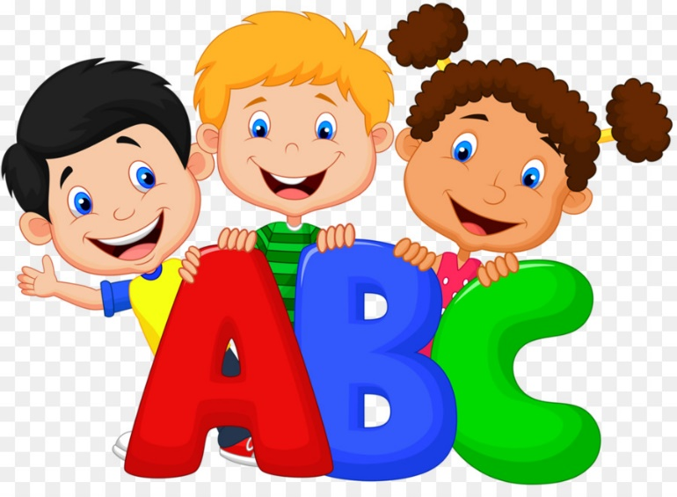

**Skills we are working on…**

* The letter “Aa”
* Identifying first name
* Following the school rules

**Things to work on at home…**

* Rules….classroom and hallway
* Writing their name
* Holding their pencil correctly

As always, if you have any questions or concerns, don’t hesitate to contact me. [erin.newburn@southern.k12.oh.us](mailto:erin.newburn@southern.k12.oh.us)

*Website: sles.southern.k12.oh.us/newburn*