Envelope Fundraiser
$5.00 for a Bundle of 50
The school envelope is for
ALL students to help
indicate the reason money is sent to school.
*The snack money envelope is for
1st and 2nd graders
who buy snack from the school snack room.

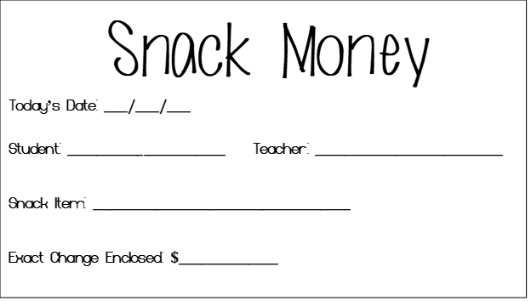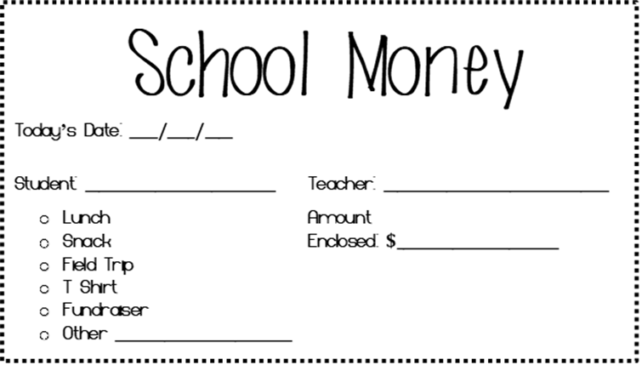
*These are preprinted envelopes to write on, and make life a little easier for the family on the go.

Student’s Name: _____________________________________
Homeroom Teacher: ______________

____ I would like _____ bundle(s) of the SNACK MONEY envelope (1 bundle is 50 for $5.00)
____ I would like _____ bundle(s) of the SCHOOL MONEY envelope (1 bundle is 50 for $5.00)

I have included $__________ for a total of _______ Bundle(s)
***Please make all checks payable to DPES

Office Use Only:
Date Received: _____________ Amount Received: _________ __Cash __ _________Check Number
Date Placed in Teacher Box: _________________

