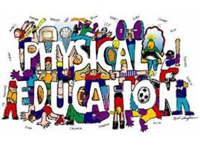
Dear Parent/Guardian,
Welcome to a new school year! I am excited to be back with the City Day family and look forward to an awesome year in Physical Education. As an experienced educator, I want to help the students at City Day develop the physical components and confidence that helps them maintain a physical lifestyle. Physical education not only teaches the psycho-motor domain, but the cognitive and affective domains as well. My goal is to have every student experience success. Good sportsmanship and teamwork are very important not only in the gym, but in real life situations too. Good sportsmanship is always required in class! I look forward to having your child in physical education class this year. In order to have a safe and productive learning environment the school-wide discipline plan will be enforced. Simple rules/expectations will be enforced within the gym.

Physical Education Expectations
*Be Prepared to Learn *Help Others and Cooperate
*HAVE FUN *STOP, LOOK and LISTEN on the whistle
*Try Your Best *MOVE safely and in control
*Be Respectful *Leave with a SMILE

*PLEASE NOTE--ALL STUDENTS IN GRADES 5-8 WILL BE REQUIRED TO DRESS OUT FOR PE CLASS. (GYM SHORTS/SWEATPANTS, T-SHIRT AND TENNIS SHOES)
The GRADING POLICY in physical education is based primarily on these areas:
* Dress out (grades 5-8 ONLY) *Attitude
* Participation * Effort
*Standard Based Assessments
If there is a time when your child can not participate due to injury or illness, then please send a note to the school. If there is a medical issue such as asthma, allergies, heart problems, etc., then please let me know. Prior knowledge will help me closely monitor your child, as the safety of all students is of my upmost importance at City Day as they go through their daily PE routine.

Thank you for your cooperation, and let’s make this a great year!
Helping Kids Stay Fit,
Ms. Rye, PE Instructor

