



**Why aren’t scuba divers crushed by the ocean?** Humans are over 3/4 water. Like solids, liquids can't be easily compressed like gasses can. This is why a container of gas is quickly crushed at great depths and why **hydraulic jacks** can be as powerful as they are. The problem divers face is the fact nitrogen becomes very water soluble at high pressure. It saturates the bloodstream and then causes bubbles to form if the diver decompresses too quickly. This is what the **"bends"** are, and deep sea divers have to breath a mixture of Oxygen and Helium to minimize the possibility of trapped gas in their arteries and veins.

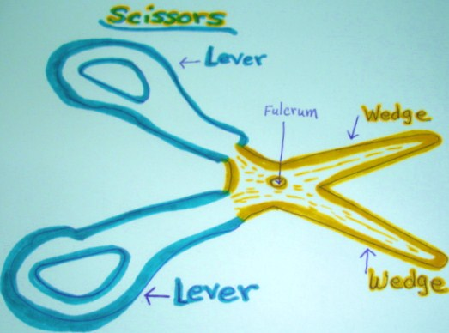

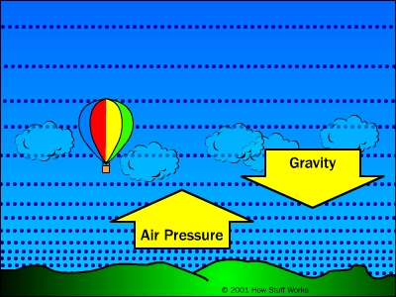

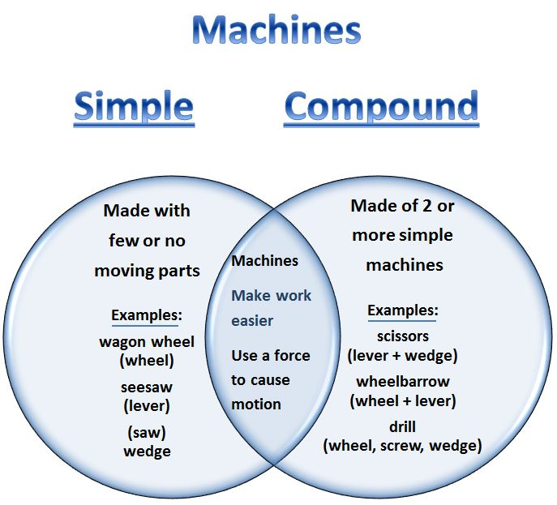

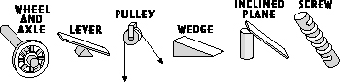

**1 2 3 4 5 6**

**Simple machines**

