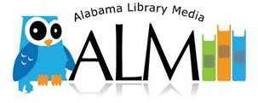
Collaborative Planning Organizer

Planning Team:
Today’s Date: | Lesson Date(s):
Number of Students: | Grade:
Unit: | Core Subject(s)
Total days of Instruction: | Due date for project:

Assignment Overview/Objective(s):
Content Standard(s):
Literacy Standard(s): (Grades 6-12) | AASL Standard(s) –(21st Century Learner):

Assessment of Student Learning (Backwards Design- Begin with the end in mind)
What do we want students to know and be able to do? ( Insight tool – Evidence & Knowledge)
How will we know? ( Insight Tool - Skills)
What form of assessment will we use?

Created 07/03/2013

LMS Level of Involvement
Plan Gather Resources Prepare Materials Teach Lesson Assist Students Assess
Assignment Level (Blooms Taxonomy)
Remembering Understanding Applying Analyzing Evaluating Creating
Assignment Level (Depth of Knowledge)
Recall Skill/Concept Strategic Thinking Extended Thinking

Activities
What will the student do?
Rationale for the activity:

Resources for Instructional Plan
Resource: | Location: | Responsibility  (LMS, Teacher, Student)
1.
2.
3.
4.
5.

Evaluation/Differentiation Notes:

