Western Line School District

PROFESSIONAL DEVELOPMENT HANDBOOK



2019 – 2020

PROFESSIONAL DEVELOPMENT HANDBOOK

CONTENTS

Mission Statement ……………………………………………………… 3

Introduction ……….……….……………………………….……. .3

Professional Development ……………………………………..…….... 4

Principals of Excellence in Professional Development ……….……...…. 4

District/School Component ………………………..………….…….……...5

Program Goals and Objectives …….………………………………..……….6

Program Evaluation ………………….…………….…………..…………….6

Assessment of Needs …………………………….……………..…………....7

Management System ………………………………..…….…..…………….7

Individual Component …………………………..…………………….. .7

License Renewal Requirements …………………………………………...7

Continued Educational Units (CEU’s) …………………………………………8

CEU Required Request forms ………………………………………………….9

Schedule of Activities ………………………………………………...……..13

PROFESSIONAL DEVELOPMENT HANDBOOK

MISSION STATEMENT

The Goal of the Western Line School District is to educate ALL students to become productive citizens by providing a world-class educational system that prepares students for the 21st Century. It is our mission to graduate ALL students on an individualized career plan that will ensure that they are college and career ready.

INTRODUCTION

In 1982, Mississippi passed a landmark piece of legislation which began a grassroots wave of education reform that swept the nation. Included in that legislation were mandates for the establishment of a statewide system of professional development which affected every educator in the state. In 1996 the State Board of Education approved a new professional development model which supports educators in meeting ever changing needs of students as they prepare for the new challenges of a technologically advanced society.

New curriculum frameworks, performance assessments, increased student performance expectations, and changes in school organization call for new forms of professional development which assist educators in developing new skills and strategies to effect change in practice. Professional development must shift from a fragmented system based upon one-shot activities to one which is embedded in every day life of the school. It must be planned and implemented by the educators it is designed to serve.

Educators must have time, resources, and opportunities to assess their own teaching methods, to develop and learn new subject matter, to work together as professionals, to develop and implement school improvement plans, and to stay abreast of current research in their fields of study. Professional development is essential to school improvement and must be seen as an investment in life-long learning for all educators.

The new model for professional development includes multiple forms of learning intended to be relevant to teachers in the classroom, as well as, supportive of school plans for organizational improvement. It is based upon a shared vision and goals for improving student performance including high achievement, behavior, and attitude. It supports professional development that is intensive, high-quality and of a sufficient duration to have a positive impact on teaching and learning and ultimately on student success in the classroom.

The Mississippi professional development model was developed by a professional development work group appointed by the former State Superintendent of Education Tom Burnham. The work group was comprised of administrators, teachers and pupil services personnel from public school districts and representatives from business, community colleges, and institutions of higher learning, the Mississippi Department of Education, and the state legislature.
PROFESSIONAL DEVELOPMENT
DEFINITION

Professional Development is a growth-promoting learning process that empowers stakeholders* to improve the educational organization.

PURPOSE

To improve student learning by creating an environment that will enable stakeholders* to:
- Invest in quality job opportunities to grow individually and collaboratively,

- Enhance job-related skills,

- Acquire new knowledge, and

- Share expertise and insights.

* Stakeholders- teachers, administrators, staff, and other school personnel

PRINCIPLES OF EXCELLENCE IN PROFESSIONAL DEVELOPMENT

Professional development programs must be based on the following principles:

- Professional development is based on a shared vision and goals for improving student performance derived through a strategic planning process.

- Professional development advances individual growth and organizational improvement.

- Professional development involves institutional collaboration.

- Professional development provides for networking and collegiality.

- Professional development models constructivist teaching that builds knowledge through exploring, debating, questioning, and reflecting.

- Professional development provides time and follow-up necessary for change in practice.

- Professional Development is site-based and school-initiated.

- Professional development has an evaluation component that focuses on improvement in teaching practice and in student results.

- Professional development is ongoing and job-embedded.
- Professional development enhances knowledge of subject matter, teaching and learning, and child development.

- Professional development is supported by resources of time, money, and personnel.

- Professional development addresses the diversity of all learners.

- Professional development acknowledges the Standards for Staff Development published by the National Staff Development Council.

- Professional development encourages individuals to generate, articulate, and disseminate knowledge based on their classroom experiences and action research.

- Professional development allows stakeholders to develop and strengthen leadership skills.

DISTRICT/ SCHOOL COMPONENT

Each district must design and implement a professional development program for the purpose of continuous improvement of student learning and performance.

REQUIREMENTS

- The district professional development program is required by law, State Board of Education Policy and for district accreditation.

- District staff development activities may be used for license renewal assuming all follow-up activities are met.

- All district personnel have a contractual obligation to participate in the district professional development program. License renewal options are separate from the required district professional development program.

RATIONALE

Successful district and school professional development programs strengthen the effectiveness of the educational organization, improve student learning and performance, and promote professional growth for all employees.
PROGRAM GOALS AND OBJECTIVES

Goal: To improve student achievement and staff performance and knowledge as a vehicle for school improvement.

Objectives:
- Based on the results from the MAAP assessments, the District mean in all areas assessed will meet or exceed the annual minimums set by the Mississippi State Department of Education

2. Based on the results from the MAAP EOC assessments in Algebra I, English II, Biology I, and U.S. History, the District mean in all areas assessed will meet or exceed the annual minimums set by the Mississippi State Department of Education

3. As listed on the most recent Western Line Report Card, the attendance as a percentage of enrollments shall improve to 96%.

4. As listed on the most recent Western Line Report Card, the graduation rate shall be a minimum of 80%.

5. As of 2010-2011 and beyond all educators will be considered highly qualified.

6. The District Instructional Management Plan shall be developed for new curriculums and revised for all other curriculums used by teachers and administrators.

PROGRAM EVALUATION

Data from the following sources will be complied and analyzed for comparison purposes in the evaluation of the staff development program:

1. Performance appraisal/evaluation instrument results

2. Administrative and peer observations

3. MKAS and MAAP scores

4. Western Line Report Card Statistics

5. Strategic Plan for Improvement

ASSESSMENT OF NEEDS

In order to accomplish planned district goals and meet the goals and objectives of the Strategic Plan for Improvement, the staff development program is to address those areas where the district has identified a need for improvement of performance. The following will be used to develop the Professional Development Program:

1. Curriculum needs based on state assessments results (MKAS, MAAP, ACT).

2. Needs assessments from staff as determined by staff meetings and survey.

3. Mandates by State Department of Education and Every Student Succeeds Act.

MANAGEMENT SYSTEM

Each employee is required to attend all sessions designed for his/her position as designated on the Schedule of Activities listed in this Handbook. A Group Participation Form will be used to verify attendance. The principal shall send the original Group Participation Form and agenda for all scheduled sessions and approved make-up sessions to the professional development coordinator immediately following each session.

Each employee shall be responsible for the implementation for all professional development activities. Follow-Through forms shall not be required; however, the presenter(s) of the session or his/her designee shall assign an implementation activity to be completed by each participant.

INDIVIDUAL COMPONENT

Educators have the professional and contractual responsibility to participate in the school district’s professional development program and in professional development options for license renewal. The selection of professional development options is to be focused on improving student learning.

LICENSE RENEWAL REQUIREMENTS

Within each five-year cycle, an individual must complete the following for license renewal:

Bachelor’s degree or equivalent
- Ten (10) continuing education units(CEUs) in content area or job/skill* related area
Or
- Three (3) semester hours in content area or job/skill* related area
And
- Five (5) continuing education (CEUs) in content area or job/skill* related area
Or
- Three (3) semester hours in content area or job/skill* related area.

Masters Degree or above
- Three (3) semester hours in content area or job/skill* related area
Or
- Five (5) continuing education units (CEUs) in content area or job/skill* related area.

*Content area refers to the area of certification (e.g.., mathematics, science, special education, etc.) Job/skill related areas include pedagogy and skills essential for effective teaching and leadership (e.g., computer technology, cooperative learning, learning styles, methodology, etc.)

RATIONALE

Through varied opportunities for Professional Development, educators can continue to learn both within and outside of local schools and districts. This allows them to stay abreast of current knowledge in fields of teaching and learning and improve educational practices that lead to enhanced student learning. It also encourages networking with colleagues and other professionals, and pursuit of advanced degrees.

CONTINUED EDUCATION UNITS (CEU’S)

The Board of Trustees understands how important professional development is to the school system. It also understands the teachers need to gain CEU’s for license renewal. In an effort to give teachers the continued education units necessary to gain license renewal and in an effort to keep teachers in the classroom educating students during as many school days as possible, the Western Line School District has partnered with Delta State University to allow teachers to earn CEU’s through the ongoing professional development offered within the school.

Staff members need to complete all forms required by Delta State University. Staff members must note that attendance to all professional developments sessions is required for CEU credit.

The following forms are required to be complete in full by the participant requesting CEU’s.
- Participant Application for CEU credit
- Professional Development Evaluation
- WLSD Professional Development Application
- Payment

Checks or money order should be made payable to Delta State University for the first semester. All Required paperwork must be filled out and turned in to your building principal by December 18, 2017. Second semester CEU applications and fees are due by May 24, 2018.

Please note: Delta state prefers money order. Check payments must clear the bank before transcripts are mailed. (Minimum wait is 3 weeks from the date check payments are deposited in Student Business Services)

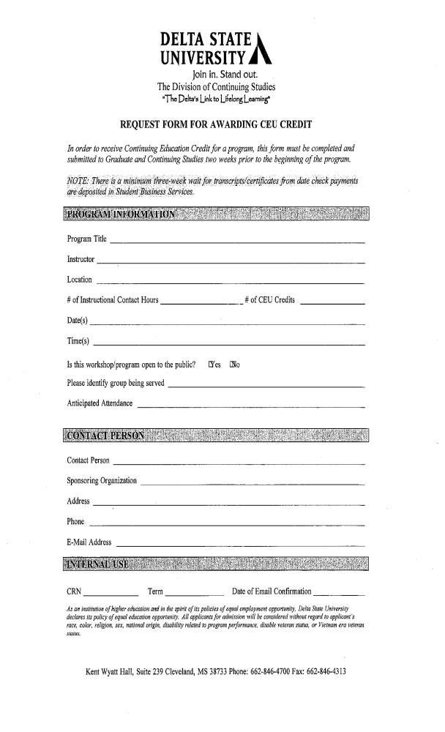
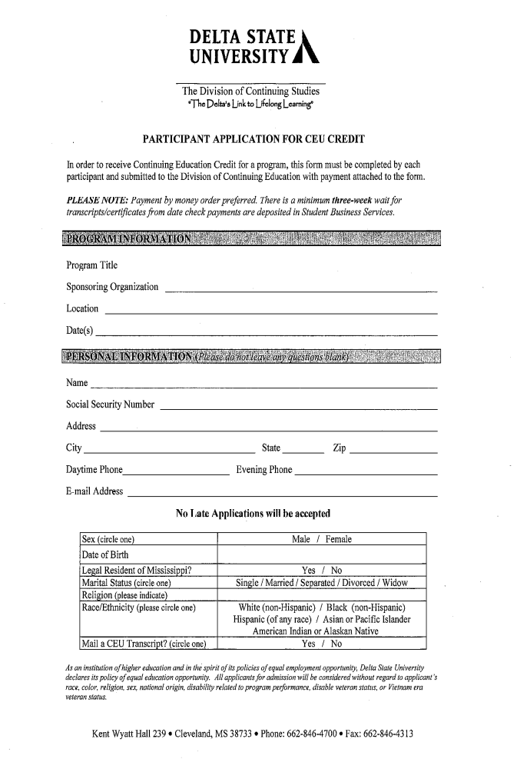
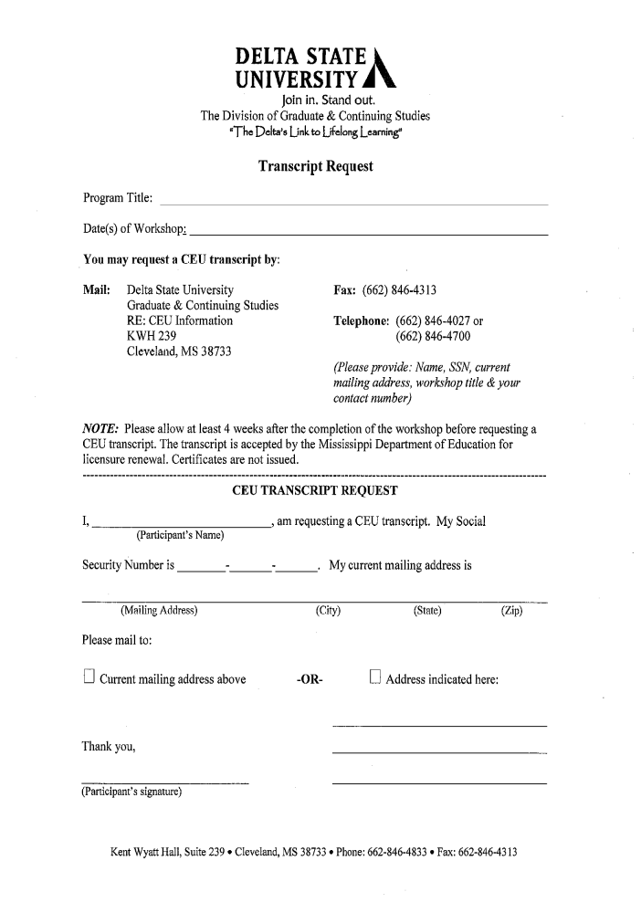

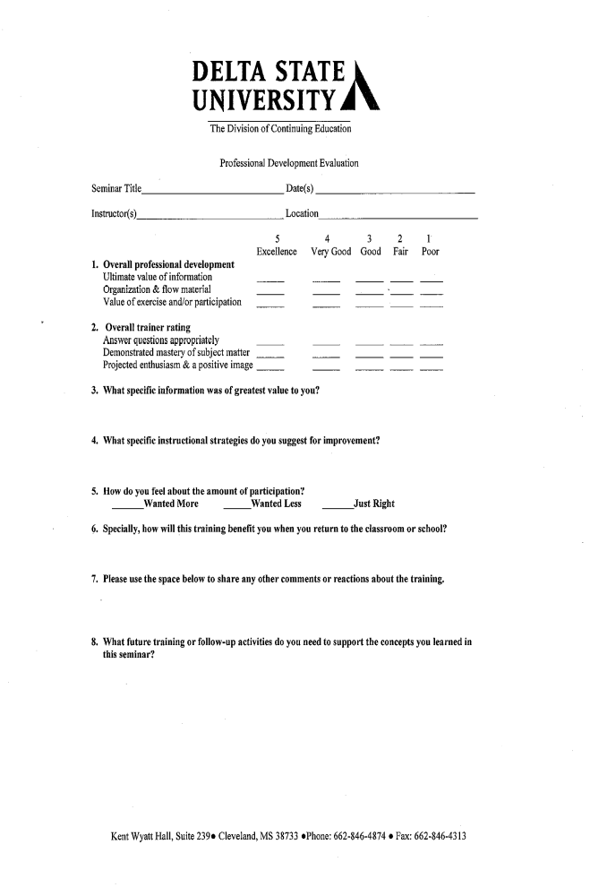

Western Line School District
Professional Development 2019 – 2020
# | Date | Time | Title / Description of Activity | Person  Responsible | Location | Audience | Outcomes

1 | 7/30/2019 | TBD | Food Service Training | B Jones | TBD | Food Service Staff | Food Services will meet all state & federal regulations regarding food service processes & standards
2 a |  | 8:30 – 2:00 | New Teacher Orientation:  District Policies & Procedures | L Tatum | RHS 119 | New Hires to the District | Newly hired staff will be equipped for a successful school year
 | 7/31/2019
2 b | 7/31/2019 | 8:00-4:00 | New Teacher Orientation –  Research-Based Strategies That Work | T Winters | GHEC  Room 215  Base Schools | New Hires | 8:00-11:30 T Winters on Strategies That Work  1:00-4:00 New Teachers to base schools for school orientation
3 |  | 12:00-4:00 | Research-Based Strategies That Work  – Experienced Teachers (by invitation only) | T Winters | GHEC  Room 215 | Teachers invited by principals | Strengthened instructional skills to facilitate maximum student performance
 | 8/1/2019
4 | 8/1/2019 | 8:00-12:00 | Back-to-School Welcome | Hudson | RHS Gym | All Staff | Hudson: Welcome to 2019-20, State of the District, Code of Ethics, Data Review  Dixon: CRASE training
 | 8/1/2019 | 12:00–12:45 | Lunch at Riverside Cafe | B Jones | Riverside Cafe | All Staff | Ensure attendance & attention of all staff for upcoming training
5 |  | 1:00-4:00 | Game of Inches | Benigno | RHS Gym | Instructional Staff | Teachers will establish high expectations for all students
6 |  | 1:00 – 4:00 | School Safety | Branning / Dixon | GHEC  Room 153 | Safety Officers:  SROs, SSOs | Review of rules, requirements & responsibilities for safety officers in the school setting
7 | 8/2/2019 | 8:00 – 11:10 | PD Rotations  See below | Tatum | O'Bannon campuses | Instructional Staff | Teachers will participate in various sessions geared toward maximized teaching & learning
 | 8/2/2019 | 11:20 – 12:50 | Lunch at O'Bannon Cafe
 | 8/2/2019 | 1:00-4:00 | PD Rotations  See below | Tatum | O'Bannon campuses | Instructional Staff | Teachers will participate in various sessions geared toward maximized teaching & learning
8 | 8/5/2019 | 8:00-11:00 | School Specific topics | Principals | Base Schools | Instructional Staff | Principals will review student data from 2018-19 to design instructional plans for 2019-20
 | 8/5/2019 | 11:00-12:00 | Lunch on your own
9 | 8/5/2019 | 12:30–4:00 | School Specific topics | Tatum | Base Schools | Instructional Staff | Principals will review student data from 2018-19 to design instructional plans for 2019-20
 |  |  | PD Rotations for August 2
 |  | 8:00 – 9:30
 |  | 9:40 – 11:10
 |  | 11:20 – 12:50 | Lunch served in the O'Bannon Cafe
 |  | 1:00 – 2:30
 |  | 2:40 – 4:00
 |  | Sessions: | ELA Pacing, Instruction, Assessment & Monitoring
 |  |  | Math Pacing, Instruction, Assessment & Monitoring
 |  |  | Science Pacing, Instruction, Assessment & Monitoring
 |  |  | Code.org – Implementing STEM in Elementary School
 |  |  | Life Help – Community Resources for At-Risk Students
 |  |  | Millcreek – Suicide Prevention
 |  |  | ACT – Maximizing Student Potential
 |  |  | Financial Literacy
 |  |  | Success for All – Strategies for Every Classroom
 |  |  | Business Office Procedures – Tending to the Business of Education
 |  |  | Paraprofessionals – Redefining Expectations
Western Line School District
Professional Development 2019 – 2020

10 | 8/7/2019 | 3:15-4:15 | Classroom Management – School opening | Principals | Base Schools | School Staff | Principals will work with staff to ensure effective & efficient school operations
11 | 8/14/2019 | 3:15 – 4:15 | PGS Standards for Instruction  + BOY self-assessment regarding Planning, Instruction & Professional Responsibilities | Principals | Base Schools | Instructional Staff | Teachers will have a clear understanding of administrator expectations during walk-through observations
12 | 8/21/2019 | 3:15 – 4:15 | School Safety Meeting | Principals | Base Schools | Instructional & Support Staff | Staff will review the safety plan & revise as needed
13 | 8/21/2019 | 3:15 – 4:15 | Dyslexia Screener (1st grade) | Spencer  Ables | Elementary Schools | 1st grade teachers | Teachers will effectively administer Dyslexia Screener
14 | 8/21/2019 | 3:15 – 4:15 | Homeless & ELL Student Policies Review | Principals | Base Schools | Instructional Staff | Principals will review the school plan for implementation of state and federal mandates regarding students who are homeless & ELL
15 | 8/28/2019 | 3:15 – 4:15 | Tiered Interventions  &  TST Work Groups | Principals / TST | Base Schools | Instructional Staff | Review students listed for TST & determine intervention needs
16 | 8/28/2019 | 3:15 – 4:15 | IDEA Regulations & Requirements;  Re-evaluations & new students | Spencer  Ables | Base Schools | SpEd Staff | Teachers will meet timelines for re-evaluations

Western Line School District
Professional Development 2019 – 2020

# | Date | Time | Title / Description of Activity | Person  Responsible | Location | Audience | Outcomes

17 | 9/4/2019 | 3:15 – 4:15 | Instructional Management | Principals | Base Schools | Instructional Staff | Teachers will remain abreast of current issues
18 | 9/4/2019 | 3:15 – 4:15 | Effective Implementation of MS Testing Program – GIFTED | Spencer  Ables | Elementary Schools | Instructional Staff | Teachers will successfully implement Gifted program
19 | 9/11/2019 | 3:15 – 4:15 | Effective Partnerships w/SpEd Teachers | Base School SpEd teachers | Base Schools | Instructional Staff | SpEd teachers will provide protocol & strategies for maximum instructional effectiveness
20 | 9/11/2019 | 3:15 – 4:15 | TST meetings – Review of Interventions | Principals / TST Committee | Base Schools | Instructional Staff | Committee members will review interventions & document progress of students
21 | 9/11/2019 | 3:15 – 4:15 | School Health Council Meeting (1 of 3) | Principals & Wellness Committee | Base Schools | Instructional & Support Staff | Committee members will review & revise the School Wellness Plan to ensure effective implementation of procedures
22 | 9/18/2019 | 3:15 – 4:15 | PGS – PLANNING  (Review of PGS standards for lesson plans, protocol for submission & review) | Principals | Base Schools | Instructional Staff | Teachers will have a clear understanding of administrators when evaluating teacher lesson plans and classroom assessments
23 | 9/25/2019 | 3:15 – 4:15 | PGS – PROFESSIONAL RESPONSIBILITIES  (Process for teacher-led professional development) | Principals | Base Schools | Instructional Staff | Teachers will have a clear understanding of administrator expectations when evaluating how teachers are meeting professional responsibilities
Western Line School District
Professional Development 2019 – 2020

# | Date | Time | Title / Description of Activity | Person  Responsible | Location | Audience | Outcomes

24 | 10/2/2019 | 3:15 – 4:15 | Instructional Management  Teachers submit documentation of meeting PGS standards for Planning, Instruction & Professional Resp during 1st quarter | Principals | Base Schools | Instructional Staff | Teachers will remain abreast of current issues
25 | 10/9/19 | 3:15 – 4:15 | BMA 1 data analysis & intervention design | Principals | Base Schools | Instructional Staff | Teachers will analyze assessment data to determine areas of student success / need
26 | 10/15/19 | 8:00 – 12:00 | Districtwide departmental meetings  Include – ASCD Activate #1 (Intro)  Assign ASCD Activate Topic #2 | Lead Teachers | OBHS | Instructional Staff | By department, teachers will collaborate to refine district pacing guides for maximum efficiency and effectiveness
27 | 10/15/19 | 8:00 – 12:00 | MAAP Accommodations, MAAP-A, making determinations for assessments | Spencer  Ables | OBHS | SpEd Instructional Staff | Teachers will make appropriate testing determinations & follow through on state tests
28 | 10/16/19 | 3:15 – 4:15 | ASCD Activate Topic #2  Assign ASCD Activate Topic #3 | Principals | Base Schools | Instructional Staff | Designated teachers will lead a review of video training, supplement with research-based strategies, and facilitate plans for implementation of new strategies
29 | 10/23/19 | 3:15 – 4:15 | ASCD Activate Topic #3  Assign ASCD Activate Topic #4 | Principals | Base Schools | Instructional Staff | Designated teachers will lead a review of video training, supplement with research-based strategies, and facilitate plans for implementation of new strategies
30 | 10/30/19 | 3:15 – 4:15 | ASCD Activate Topic #4 | Principals | Base Schools | Instructional Staff | Designated teachers will lead a review of video training, supplement with research-based strategies, and facilitate plans for implementation of new strategies
Western Line School District
Professional Development 2019 – 2020

# | Date | Time | Title / Description of Activity | Person  Responsible | Location | Audience | Outcomes

31 | 11/6/19 | 3:15 – 4:15 | Instructional Management | Principals | Base Schools | Instructional staff | Teachers will remain abreast of current issues.
32 | 11/6/19 | 3:15 – 4:15 | Test Administrator Training (HS only) for Re-Testers | STCs | Base Schools | Select Staff | Effective implementation of MS Assessment Program
33 | 11/13/19 | 3:15 – 4:15 | School Health Council Meeting (2 of 3)  Assign ASCD Activate Topic #5 | Principals & Wellness Committee | Base Schools | Instructional & Support Staff | Teachers will review the School Wellness Plan to ensure effective implementation of procedures.
34 | 11/13/19 | 3:15 – 4:15 | Cumulative Record Review | Elementary Principals | Elementary Base Schools | Instructional Staff | Teachers will effectively use student information for identification of student needs
35 | 11/13/19 | 3:15 – 4:15 | Review Progress of Federal Programs:  Nurses, Social Workers, Consultants, Technology,  Safe & Drug-Free Schools, Rural & Low-Income  Students, Pre-K | Principals | Base Schools | Instructional Staff | Teachers will review the progress of federally funded programs to ensure efficiency & effectiveness
36 | 11/20/19 | 3:15 – 4:15 | ASCD Activate Topic #5 | Principals | Base Schools | Instructional Staff | Designated teachers will lead a review of video training, supplement with research-based strategies, and facilitate plans for implementation of new strategies

Western Line School District
Professional Development 2019 – 2020

# | Date | Time | Title / Description of Activity | Person  Responsible | Location | Audience | Outcomes

37 | 12/4/19 | 3:15 – 4:15 | Instructional Management | Principals | Base Schools | Instructional staff | Teachers will remain abreast of current issues.
38 | 12/11/19 | 3:15 – 4:15 | PGS – Review of Standards for Planning, Instruction & Professional Responsibilities | Principals | Base Schools | Instructional Staff | Teachers will have a clear understanding of expectations of administrators when principals review teacher documentation of meeting MSTAR standards
39 | 12/11/19 | 3:15 – 4:15 | ESY & Transition Requirements | A Spencer  M Ables | Base Schools | SpEd Instructional Staff | Teachers will document ESY and transition portfolios
40 | 12/18/19 | 3:15 – 4:15 | Peer Review of PGS documentation  Teachers submit documentation of meeting PGS standards in Planning, Instruction & Professional Responsibilities during 2nd quarter | Principals | Base Schools | Instructional Staff | Teachers will peer review documentation of success in meeting MSTAR standards and will assist in revising analysis of documents as needed

Western Line School District
Professional Development 2019 – 2020

# | Date | Time | Title / Description of Activity | Person  Responsible | Location | Audience | Outcomes

41 | 1/8/2020 | 3:15 – 4:15 | Instructional Management | Principals | Base Schools | Instructional staff | Teachers will remain abreast of current issues.
42 | 1/11/2020 | 9:00 – 11:00 | Bus Driver Safety Training | TBD | RHS Media Center | All bus drivers | Safe & effective transportation program for the spring semester
43 | 1/15/2020 | 9:00 – 11:00 | BMA 2 data analysis & intervention design | Principals | Base Schools | Instructional Staff | Teachers will analyze assessment data to determine areas of student success and need
44 | 1/22/2020 | 3:15 – 4:15 | School Health Council Meeting (2 of 3)  Assign ASCD Activate Topic #6 | Principals & Wellness Committee | Base Schools | Instructional & Support Staff | Teachers will review the School Wellness Plan to ensure effective implementation of procedures.
45 | 1/22/2020 | 3:15 – 4:15 | Cumulative Record Review | Elementary Principals | Elementary Base Schools | Instructional Staff | Teachers will effectively use student information for identification of student needs
46 | 1/29/2020 | 3:15 – 4:15 | ASCD Activate Topic #6 | Principals | Base Schools | Instructional Staff | Designated teachers will lead a review of video training, supplement with research-based strategies, and facilitate plans for implementation of new strategies

Western Line School District
Professional Development 2019 – 2020

# | Date | Time | Title / Description of Activity | Person  Responsible | Location | Audience | Outcomes

47 | 2/5/2020 | 3:15 – 4:15 | Instructional Management  Assign ASCD Activate Topic #7 | Principals | Base Schools | Instructional staff | Teachers will remain abreast of current issues.
48 | 2/12/2020 | 3:15 – 4:15 | ASCD Activate Topic #7  Assign ASCD Activate Topic #8 | Principals | Base Schools | Instructional Staff | Designated teachers will lead a review of video training, supplement with research-based strategies, and facilitate plans for implementation of new strategies
49 | 2/19/2020 | 9:00 – 11:00 | School Cleaning & Maintenance | TBD | RHS media center | Custodial & Maintenance Staff | Buildings & grounds will continue to improve & remain clean & safe
50 | 2/26/2020 | 3:15 – 4:15 | ASCD Activate Topic #8 | Principals | Base Schools | Instructional Staff | Designated teachers will lead a review of video training, supplement with research-based strategies, and facilitate plans for implementation of new strategies

Western Line School District
Professional Development 2019 – 2020

# | Date | Time | Title / Description of Activity | Person  Responsible | Location | Audience | Outcomes

51 | 3/4/2020 | 3:15 – 4:15 | Instructional Management  & | Principals | Base Schools | Instructional staff | Teachers will remain abreast of current issues.
51 | 3/4/2020 | 3:15 – 4:15 | Test Security Training | STCs | Base Schools | Select Staff | Effective implementation of MS Assessment Program
52 | 3/18/2020 | 3:15 – 4:15 | BMA 3 data analysis & intervention design  Assign ASCD Activate Topic #9 | Principals | Riverside campuses | Instructional Staff | Teachers will analyze assessment data to determine areas of student success and need
53 | 3/20/2020 | 8:00 – 12:00 | Districtwide departmental meetings | Lead Teachers | OBHS | Instructional Staff | By department, teachers will collaborate to refine district pacing guides for maximum efficiency and effectiveness
54 | 3/25/2020 | 10:00–12:00 | Districtwide Federal Programs Meeting | M Ray | Central Office | Select staff, parents & community members | Participants will discuss ideas from school-based meetings & how they are incorporated into various program planning & budgets
 |  |  | ASCD Activate Topic #9 | Principals | Base Schools | Instructional Staff | Designated teachers will lead a review of video training, supplement with research-based strategies, and facilitate plans for implementation of new strategies

Western Line School District
Professional Development 2019 – 2020

# | Date | Time | Title / Description of Activity | Person  Responsible | Location | Audience | Outcomes

55 | 4/1/2020 | 3:15 – 4:15 | Instructional Management | Principals | Base Schools | Instructional staff | Teachers will remain abreast of current issues.
56 | 4/8/2020 | 3:15 – 4:15 | PGS End-of-Year Self Assessment  Assign ASCD Activate Topic #10 | Principals | Base Schools | Instructional Staff | Teachers will reflect on their growth throughout the year in order to set professional growth goals
57 | 4/15/2020 | 3:15 – 4:15 | ASCD Activate Topic #10 | Principals | Base Schools | Instructional Staff | Designated teachers will lead a review of video training, supplement with research-based strategies, and facilitate plans for implementation of new strategies
58 | 4/15/2020 | 3:15 – 4:15 | IEP Meeting Procedures | A Spencer  M Ables | Base Schools | SpEd Instructional Staff | Teachers will hold compliant & effective IEP meetings
59 | 4/22/2020 | 3:15 – 4:15 | Handbook Revisions:  Discuss & Submit suggestions for changes to Student Handbook and Employee Handbook  Assign ASCD Activate Topic #11 | Principals | Base Schools | All Staff | Staff members will review current policies & procedures in district handbooks. Concerns and suggestions for changes will be submitted by the principal at the April Administrative Meeting.
60 | 4/29/2020 | 3:15 – 4:15 | ASCD Activate Topic #11 | Principals | Base Schools | Instructional Staff | Designated teachers will lead a review of video training, supplement with research-based strategies, and facilitate plans for implementation of new strategies
Western Line School District
Professional Development 2019 – 2020

# | Date | Time | Title / Description of Activity | Person  Responsible | Location | Audience | Outcomes

61 | 5/6/2020 | 3:15 – 4:15 | Instructional Management  Assign ASCD Activate Topic #12 | Principals | Base Schools | Instructional staff | Teachers will remain abreast of current issues.
62 | 5/13/2020 | 3:15 – 4:15 | ASCD Activate Topic #12 | Principals | Base Schools | Instructional Staff | Designated teachers will lead a review of video training, supplement with research-based strategies, and facilitate plans for implementation of new strategies
63 | 5/13/2020 | 3:15 – 4:15 | Safety Committee Meeting to review & revise School Safety Plan | Principals | Base Schools | Committee Members | Review the current safety plan, make corrections & prepare for Board Approval
64 | 5/20/2020 | 3:15 – 4:15 | Cumulative Record Review | Elementary Principals | Elementary Base Schools | Instructional Staff | Teachers will effectively use student information of identification of student needs
65 | 5/26/2020 | 8:00 – 3:00 | School Year Close-Out | Principals | Base Schools | Instructional Staff | Teachers will successfully collect student data & annotate student records
66 | 5/27/2020 | 8:00 – 3:00 | School Year Close-Out | Principals | Base Schools | Instructional Staff | Teachers will successfully collect student data & annotate student records

