8th grade Math & 8th grade Adv. Math

School Supply List

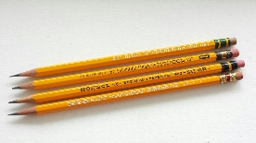
Needed Supplies:
☐ 3-Ring Binder – 1 ½ in. or 2 in.
☐Tab Dividers for Binder
☐ Loose-Leaf Paper
☐ Pencils & Pencil-top Erasers
☐ 1 Folder with fasteners & pockets – any color – for IXL
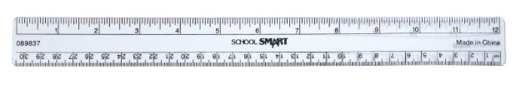
☐ Crayons/Colored Pencils/Markers
☐ Ruler & Scissors
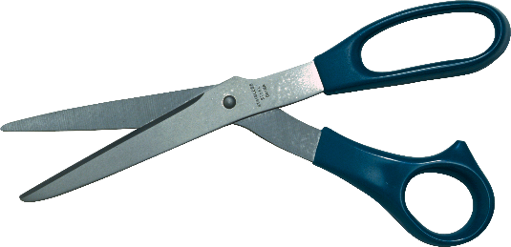
☐ Glue Stick
☐ Graph Paper
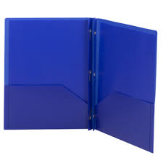
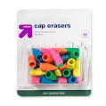

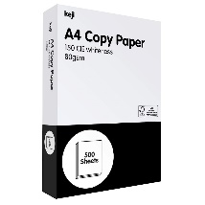
HoMEROOM APPRECIATED Supplies:
☐ White Copy paper
☐ Kleenex boxes…lots and lots!
☐ Hand sanitizer (Lots!!)
☐ Paper Towels
☐ Lysol Air Fresheners
☐ Clorox Wipes (Lots!)
