Instructions for Setting Up Gradebook in iNOW for Quarter 2

- Go to the “Gradebook” tab from the drop down menu under “Classroom”. Since we are in the second quarter, it should automatically default to “Q2” under Grading Period.
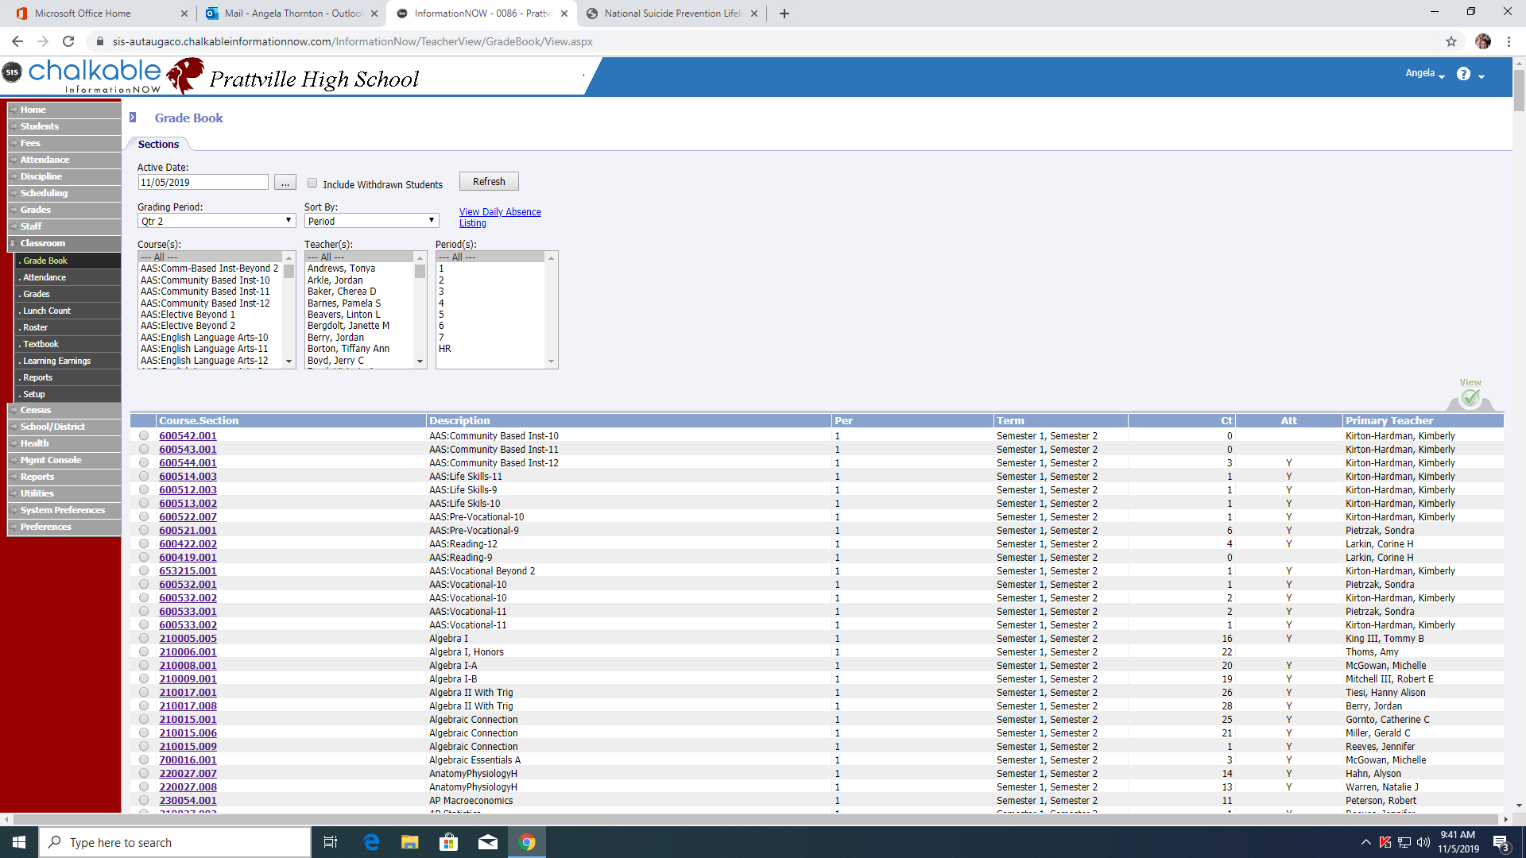

- Select Your First class to bring up the Gradebook for that class. You will always work under the “Manage” tab when configuring your grades. It is ALWAYS a good idea to check your categories to make sure they are correct. iNOW automatically carries them over from Quarter 1, but it is always good to double check to make sure they are set up with the correct percentages
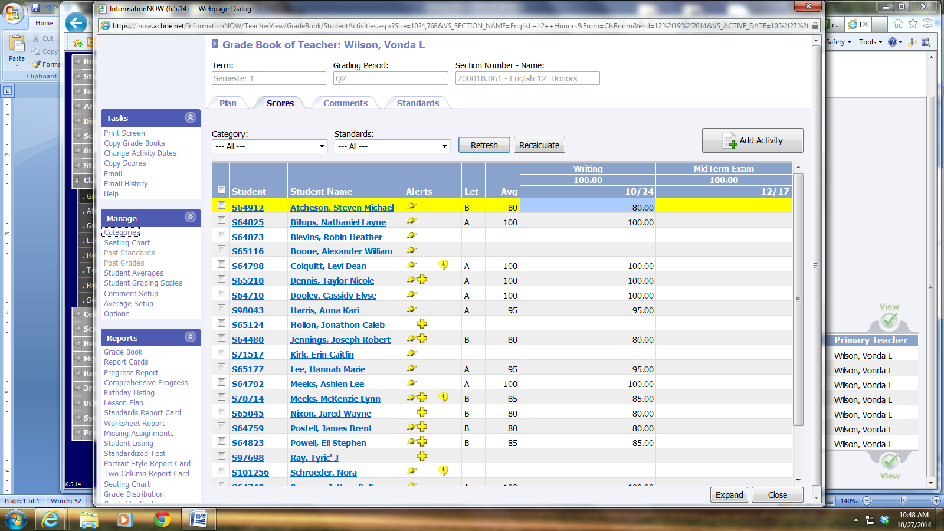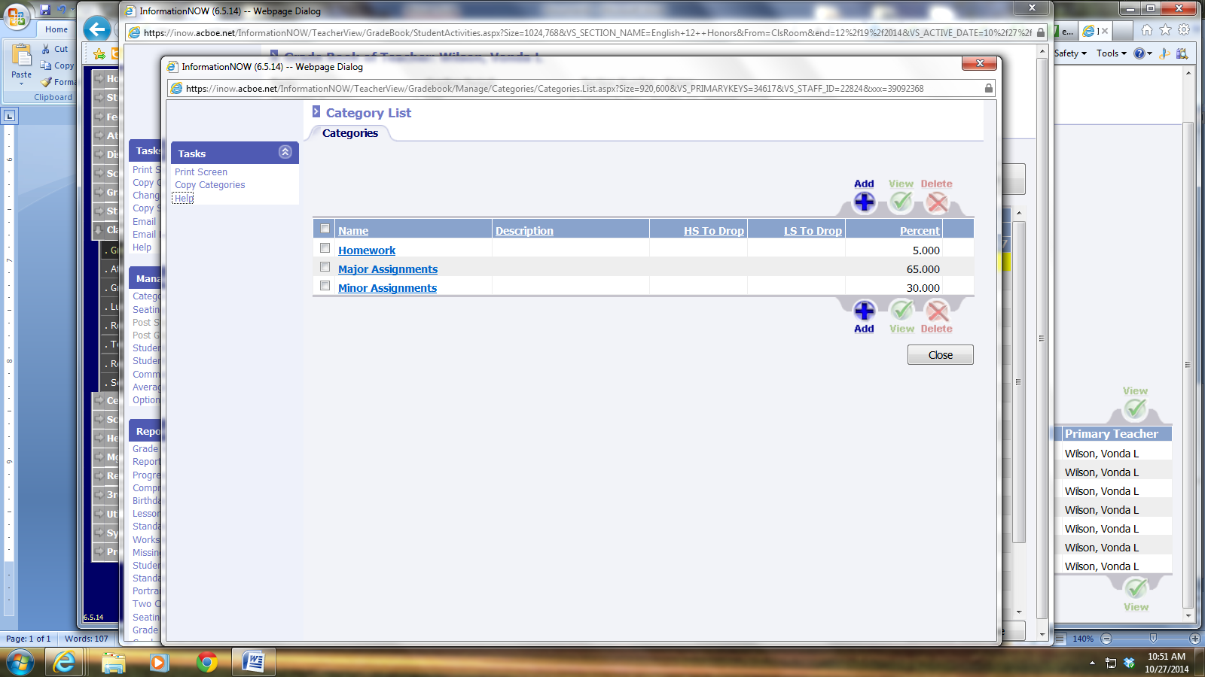

- Next, under “Manage” go to “Options” and make sure all that is checked is correct.
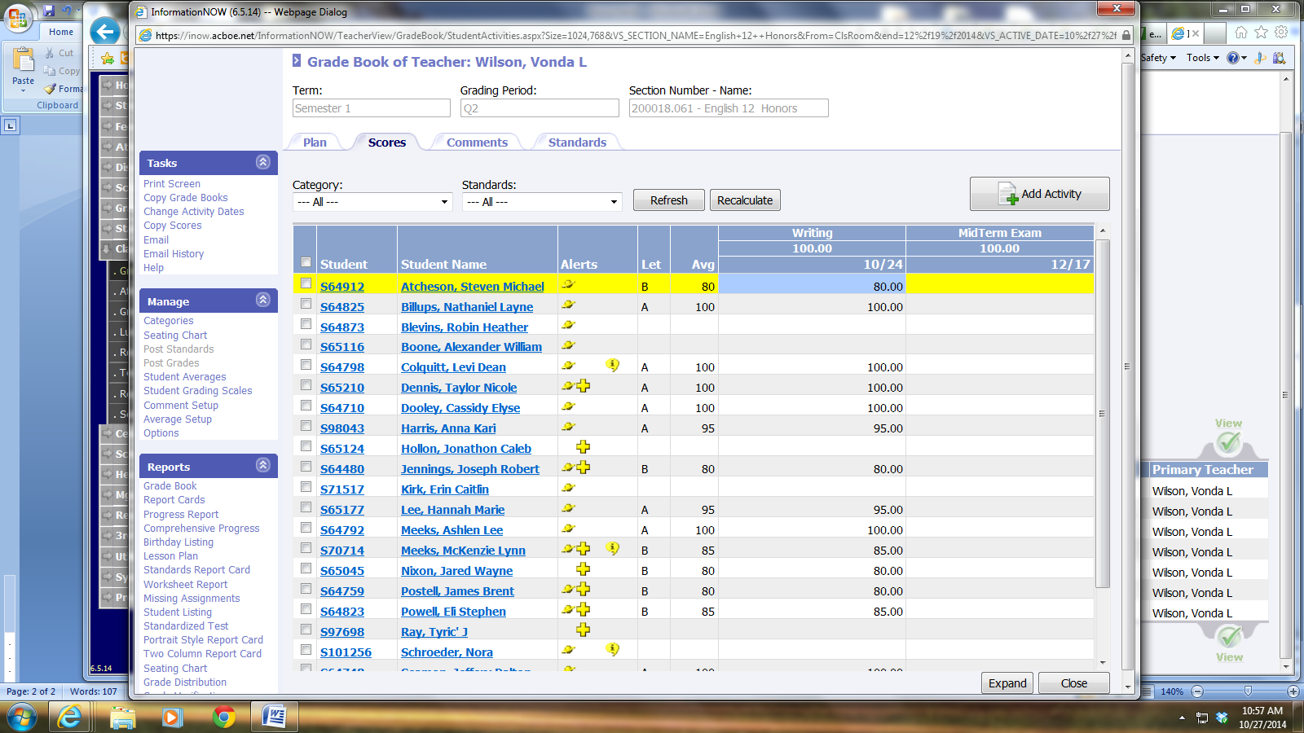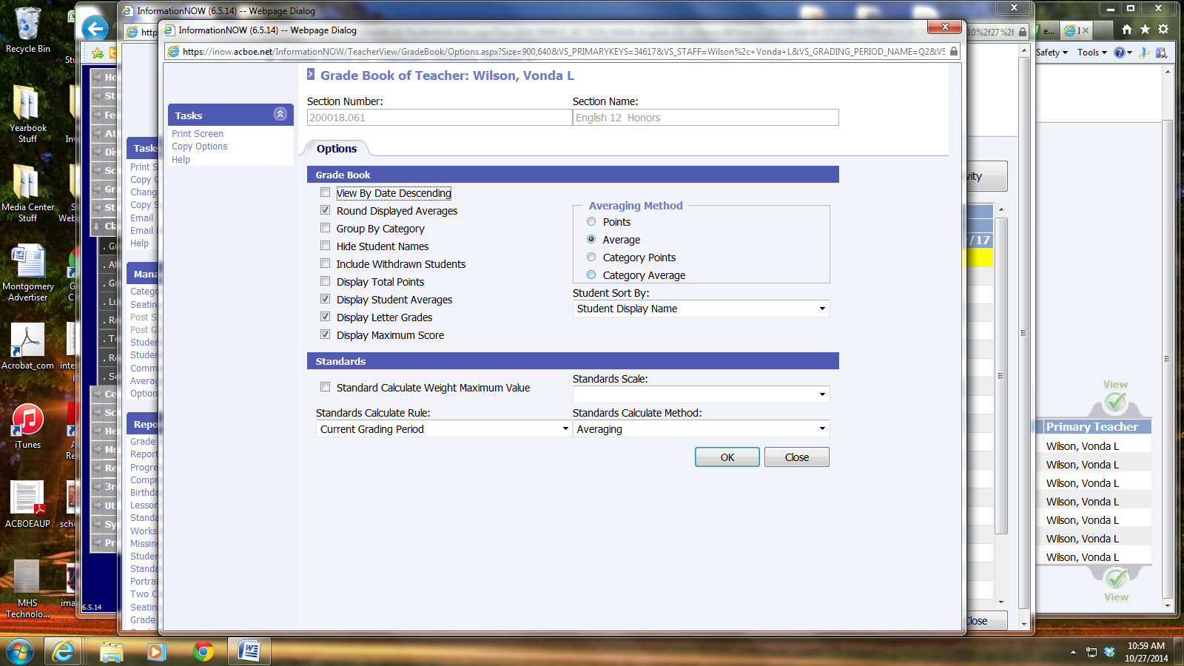

If you do a weighted average (Homework is 5%, Tests are 65%, etc.) then you need to select “Category Average” If you select “Average” then it only averages all the grades without regard to the percentages for each category. Click “Okay” and Close.

- Next, you need to make sure to click on “Average Setup” under the Manage tab and select “Q1”
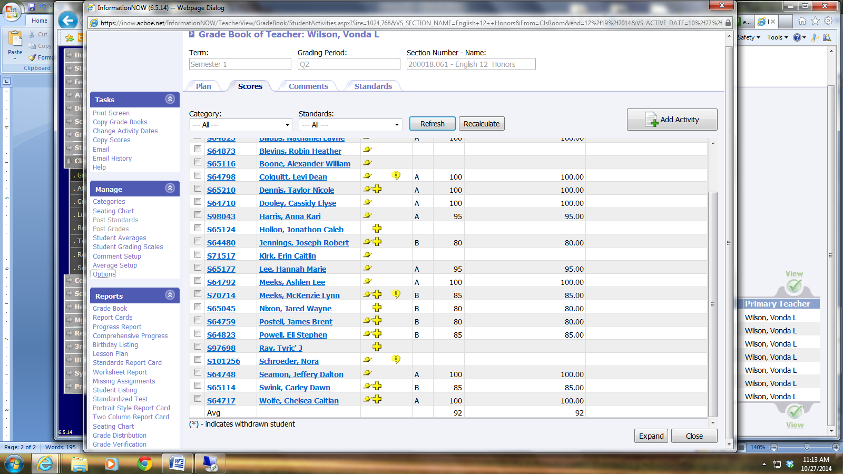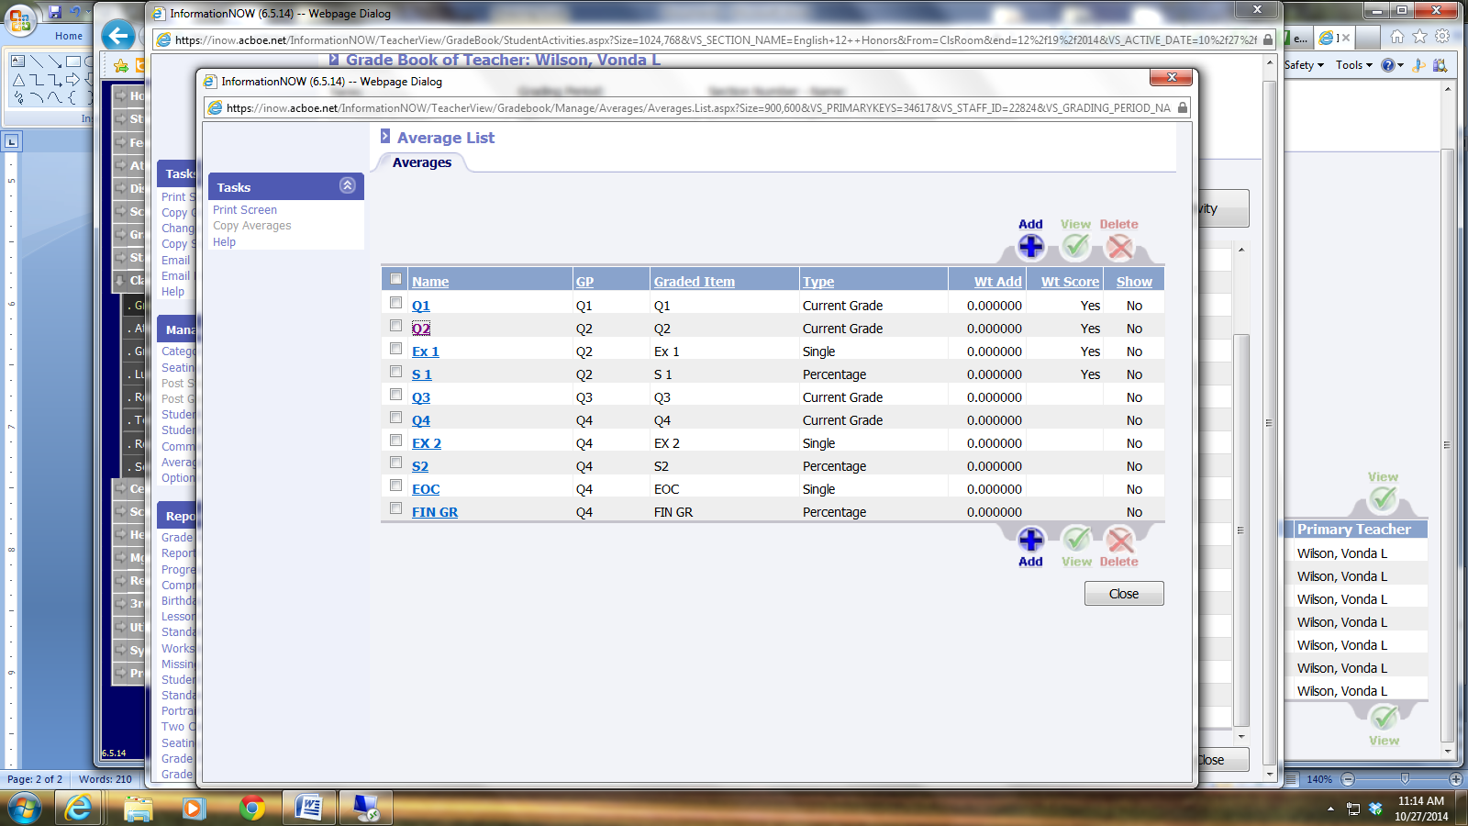

- When this screen is brought up, you need to check and un-check a few things. This is VERY important.
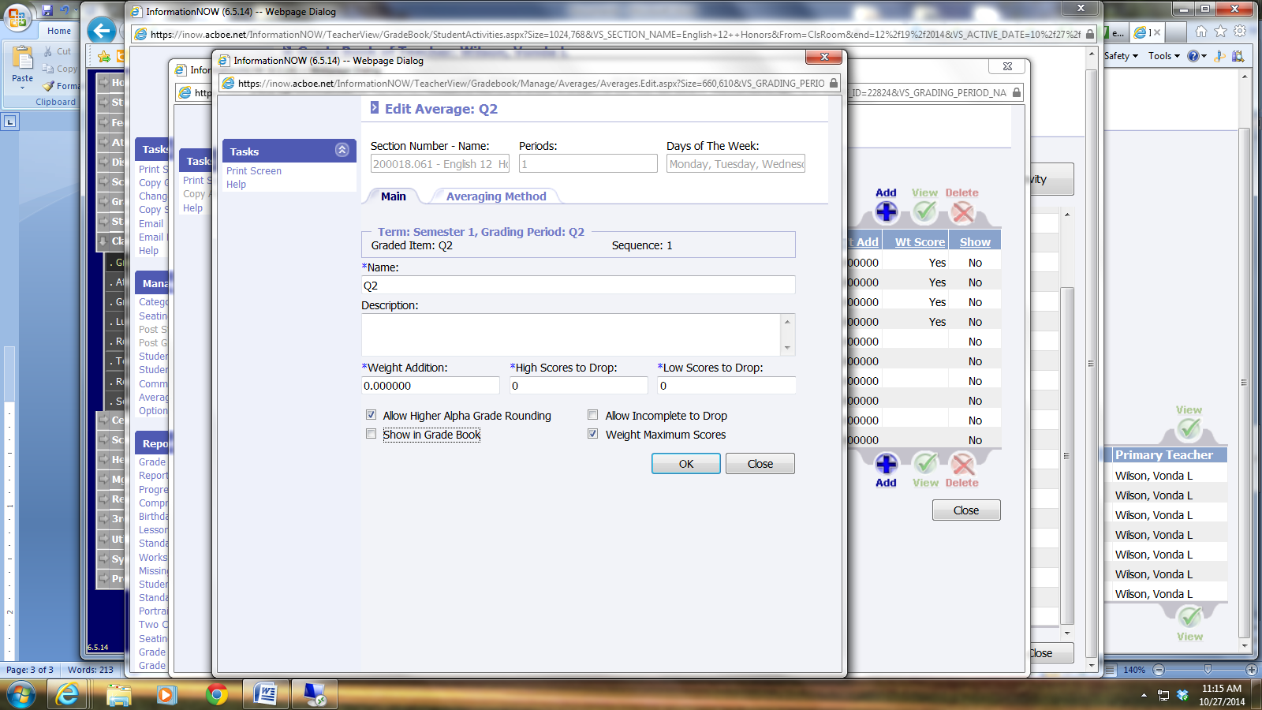

You need to make sure to CHECK “Allow Higher Alpha Grade Rounding” and “Weight Maximum Scores”. You need to UNCHECK “Allow Incomplete to Drop”. You can click “Show in Gradebook” only if you want it to show in your grade book, but it is not required. Click “Okay” “Recalculate” “Refresh”

**You need to do the exact same thing for Q2 for Quarter 2 and for S1 for the Semester Average to come out correctly!!**
If you want to go ahead and set up Q 3 and Q4, you can do so.

- *** This is VERY IMPORTANT FOR SEMESTER AVERAGES AND MIDTERMS****

Your grade book for Quarter 2 will bring up an Error in Blue at the top regarding “Ex 1”

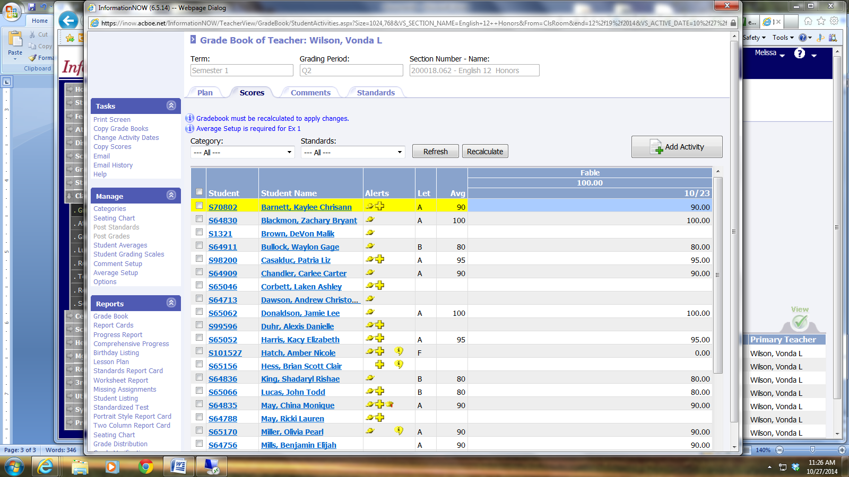

Before you go to Average SetUp, you need to plan your Midterm in your Gradebook.

Usually exams are the week we get out for Christmas break. It will make you select a category for it.

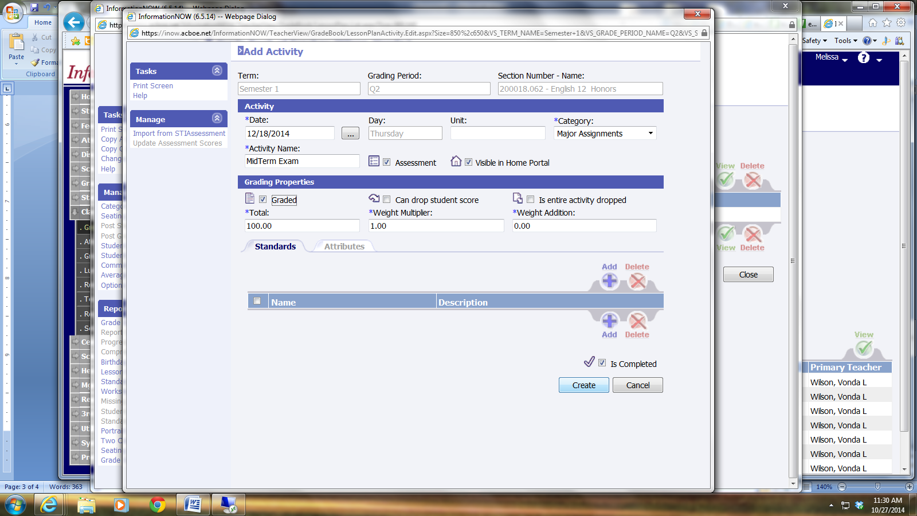

Next, go back to “Average Setup” and Click on “Ex 1” check and uncheck the items like I did for Q 1, Q 2, and S 1. However, for the EX 1, click on the “Averaging Method” Tab. The choice “Single Activity” should be already selected for you. This means that the Ex 1 will be a stand-alone grade to average into the semester average. Click on the Blue Link “Single Activity”
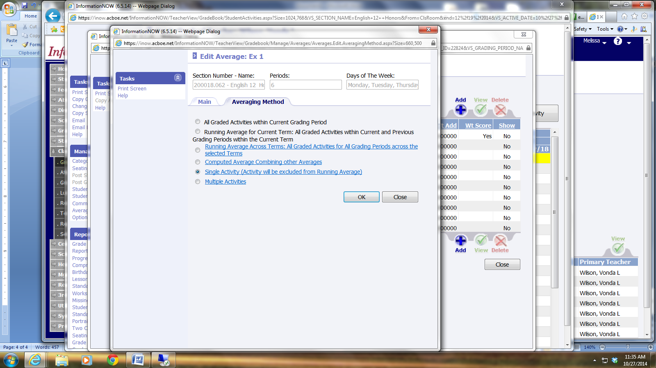
In the new Screen select the Midterm Exam you created in your grade book and Click “Okay” Click “Okay” Click “Okay” then Recalculate and Refresh.
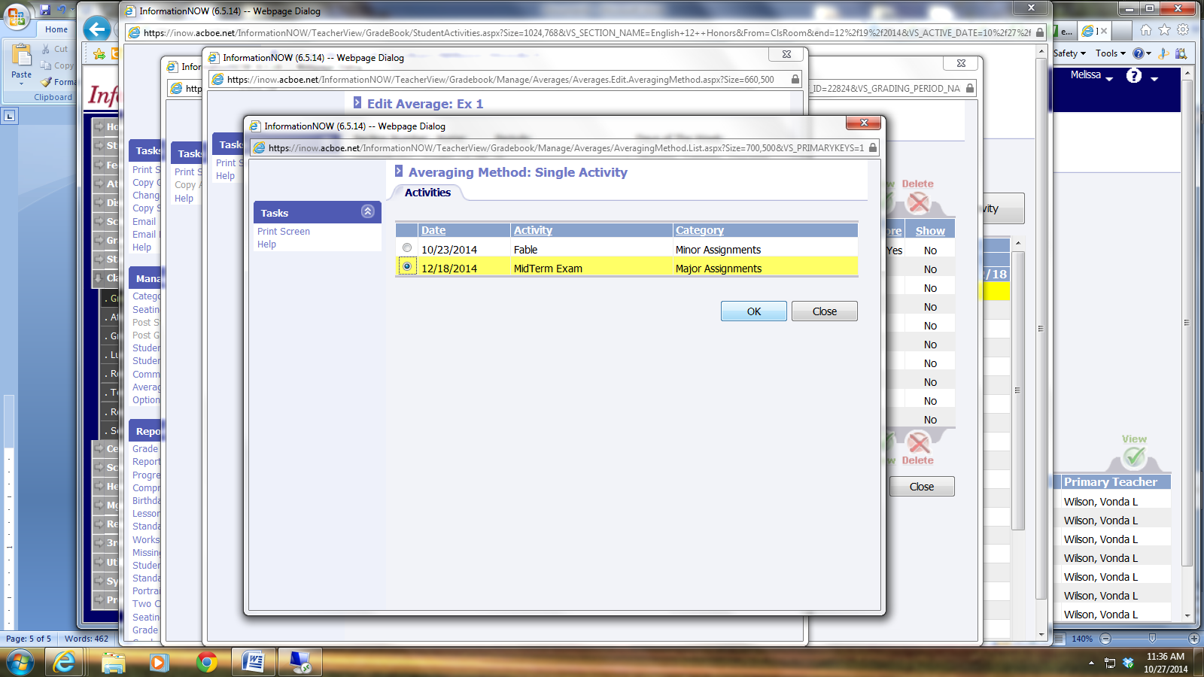
YOU MUST REPEAT THIS PROCESS FOR EACH CLASS.

This should be all you have to do in order for everything to calculate correctly. However, for everyone else, this is how it should be completed. If you have any questions, please email me or come to me, and I’ll be happy to sit down and help you with this. It is vitally important that you do not wait to complete this process.
I cannot emphasize enough how important it is that you have your grade book set up correctly and that you regularly check it to make sure it is calculating correctly. If something looks off, then check it by hand, then check the above to make sure all the correct things are checked. If there is still a problem, then please come to me immediately and we will find the solution to the problem together.
One last thing, please make sure when you are setting up your assignments that you click the “Visible in Home Portal” check box. This means that it will show up in Home Portal so parents can see the grades for those individual assignments. 

