Step One:
Go to the county’s website and click on SSO Portal.
Or, click on the link below:
https://portal.hcbe.net/_auth/Login.aspx?ru=L3Nzby9wb3J0YWw=
Step Two:
Students should sign in using their school/county username and password. If you have questions on your username and password, please ask your teacher.

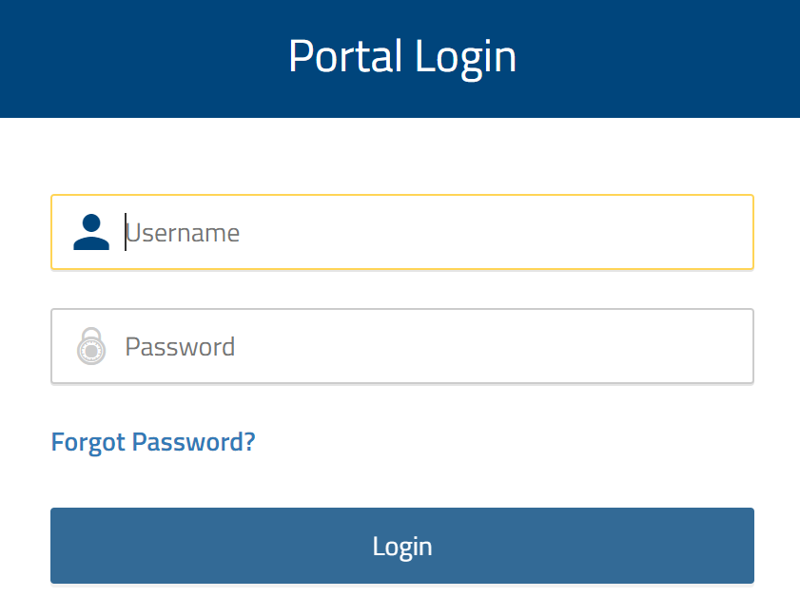

Step Three:

Students should click on the Google Classroom app.
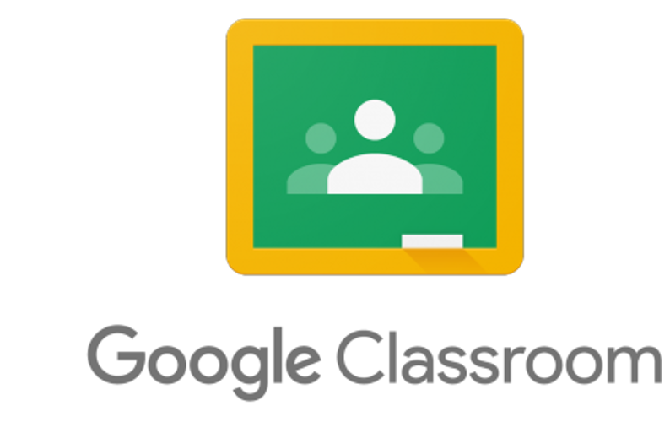

Step Four:
Let’s get to work! When they sign into Google Classroom, they should see several “classrooms’. They simply click on ‘JOIN’ for each class.

