2020-2021 PJHS Roadmap to Reopen School
Mission: The mission of Prattville Junior High School is to provide excellent educational opportunities, which enable our students to acquire the knowledge, skills, and personal qualities necessary to be responsible and successful citizens.

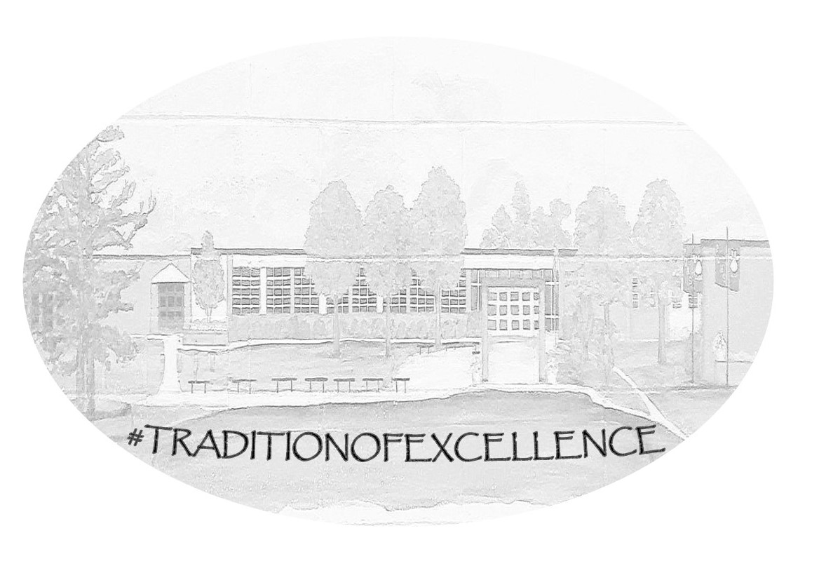
Flexibility is key to our success this year.
Our primary goal is to keep students and faculty safe.
We will work diligently to educate our students to the best of our ability.
All procedures are subject to change.

COMMUNICATION
- We want to be transparent. Knowledge is power. The safety of our students and staff is our top priority. Flexibility will be imperative this year.
- Task Force - The PJHS Task Force (comprised of administrators, counselors, and teachers) will be voluntary and will meet as needed to discuss procedures and change them as needed.
- Website / Newsletters - The website will be kept up to date with current information. Please visit www.pjhscats.com often. Newsletters will be an option once school begins.
- Call-outs will be consistent and on as needed basis. Callouts will also be posted on the website so parents can listen to them again as needed.
- Social Media will be utilized. PJHS uses the Instagram account frequently. @catspjhs
Administrators will use Remind for announcements for staff members.
- Signage - the district is providing COVID-19 signage for common areas. CNP is providing decals in the lunchroom for seating and social distancing purposes. PJHS will provide handwashing signage in all restrooms. Other signage may be provided as needed.
- Staff will answer phone calls / return emails within one business day.

PREVENTION PROTOCOLS
- Sanitizing - additional supplies (disinfecting backpack sprayer / hand sanitizing stations / non-working hand dryers will be replaced, etc)
- Face coverings - Masks are required by everyone entering the building. Students and staff masks must be in “dress code”.
- We will be able to use one (at a time) scheduled Student Center Volunteer - with appropriate PPE. No other volunteers will be allowed until further notice.
- Water fountains will be cleaned consistently. We have 3 water filling stations. We will be flexible about water bottles this year. Water bottles must have a top that completely closes. Only water is allowed.
- Deep clean before school starts. Schedule for daily disinfecting. This will be completed by our custodian staff.
- Student screening will utilize a three-pronged health approach: HOME (initial point of screening) TRANSPORTATION (signage) SCHOOL (training for staff of visual cues)
- LIMIT MOVEMENT!!!
After considering a several options, the new PJHS schedule will be as follows:

Alternating Modified Block Schedule
Swap Gray / Cardinal days every other day
GRAY - odd periods (1, 3, & 5) CARDINAL - even periods (2, 4, & 6)
7:29am-7:50am Homeroom
7:50am-7:55am Change classes (MASKS REQUIRED)
7:55am-10:10am First “block” with built in break (by department)
10:10am-10:15am Change classes (MASKS REQUIRED)
10:15am-12:50pm Second “block” with lunch
12:50pm-12:55pm Change classes (MASKS REQUIRED)
12:55pm-3:10pm Third “block” with 10-minute break
Staggered dismissal: First bell: First load bus riders
Car-riders released to gym (more info provided)
Second bell: Second load bus riders
Third bell: Remainder of bus riders

8. Homeroom: call-in will be at 7:29am with administrators working the courtyard prior to 7:29am. Teachers will show CNN10, health videos (proper handwashing, etc), anti-bullying videos, diversity videos, etc. These will be provided by the counselor with a schedule.

Student Transportation
- No Field trips until further notice.
- Athletic trips are subject to the Athletic COVID-19 Implementation Plan and Extra Curricular COVID-19 Implementation Plan.
- Fluid process - arrival times may be altered.

ENTRY / EXIT School Campus
- Staff members will wear a mask. Students will be required to wear face coverings during transitions.
- Hand sanitizing stations will be at entrance/exit points.
- Bus dismissal - Buses will release on 3 bells for 3 waves of buses. This will take a little time the first few days of school before we iron out the details.
- Car riders - Car riders will be released on the first bell to the GYM. Students must wear their masks and spread out in the gym. Students will be assigned a number that will be displayed in their car. We will use walkie-talkies to communicate with students in the gym. Parents will be asked to write the student’s name on a piece of paper the first couple days of school until the numbers are assigned. This process will likely have to be tweaked and is subject to revisions.

BREAKFAST / LUNCH
- Fifty percent capacity (longer lunch period)
- First 2 weeks will be grab-n-go (still working on what this looks like)
- Ordering decals for seats and social distancing in line

TRANSITIONS
- This is huge!! Everyone must wear a mask.
- Utilize directional reminders as needed. We will continue our normal procedures.
- LOCKER USE IS PROHIBITED!!
- Everyone MUST wear face coverings during transitions!
LARGE GROUP GATHERINGS
- Limit unnecessary congregations (Veteran’s Day Assembly, etc…)
- No CATalyst first semester. We will revisit this topic for second semester.
- Stagger activities as much as possible (grade level Honor Roll parties, etc.)
- Pep Rallies - OUTSIDE- I think we could do a couple around the track and allow for social distancing.
- Students must sit facing in one direction spread apart.

STUDENT LEARNING
- Schoology will be our virtual platform (like Google Classroom). The SDE will input curriculum from SchoolsPLP - additional training for Schoology and SchoolsPLP will be provided so we can provide a blended curriculum.
- Virtual lessons will be included weekly for all students in case we have to go all virtual.
- We will have e-Learning days! More information will be provided.
- No classroom sets of textbooks - all students must have their own.
- No community supplies.
- Discuss good hygiene frequently.
- Disinfect frequently IF any items are shared (lab equipment).
- Limit group / partner work (Masks must be worn).
- VIRTUAL LEARNING
  - Family must provide Internet
  - Family should provide device
  - On-campus attendance will be required for some electives (band, athletics, yearbook). The student will check in/out through the Student Center.
  - Student quarantine days are NOT Virtual (see Reopening Virtual document on ACOE website)
  - Moving between Virtual / Traditional - Any request to change from Virtual to Traditional or vice-versa should be made in writing and submitted to the principal and should begin at the next grading period. A team will review the request and communicate with the parents.

PHYSICAL EDUCATION
- No locker rooms or dressing out
- Social distancing as much as possible
- Disinfect equipment between classes

HEALTH SERVICES
- Student/staff health concerns will be evaluated on a case-by-case basis. We will be in constant communication with Nurse Johnston and our district level personnel.
- We will follow the guidelines outlined in the ACBOE Reopening Roadmap on the ACBOE website.

Orientation - We will offer an in-person Orientation (albeit altered and spread out) along with a virtual option. More information and dates will be released at a later date.
Open House -This will be a Virtual activity this year. Each teacher will make a 3-5 minute video with needed information. More information and date will be released at a later date.

