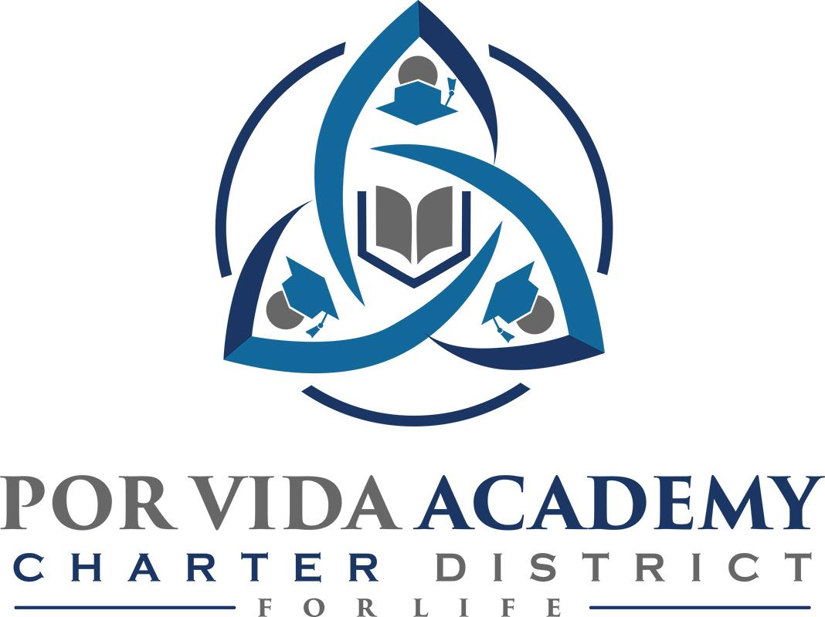

Tuesday, September 8, 2020 at 12:30pm 1135 Mission Road, SA TX 78210

Minutes of Regular Called Board Meeting

- Call to Order and Establishment of Quorum
  - Roll Call & Recording of Board Members Present - Declaration of Quorum Present.
Odilia Korenek and Edie Cogdell
  - Recording of the Executive Director/Superintendent and Staff Members Present.
Superintendent, Joseph G. Rendon, Stephanie Rodriguez, Danette Salazar, Sandra Valencia, Marilyn Dovalina, Loren Frankowiak

- Closed Session: None

- Pledge of Allegiance

- Salute to the Texas Flag- “Honor the Texas Flag; I pledge allegiance to thee, Texas, one state under God, one and indivisible.”

- Public Testimony

- Approval of Minutes: August 27 minutes. Edie Cogdell moves to approve the minutes, Sister Odilia seconded the motion. August 27th minutes approved as presented.

- Superintendent Items:

  - Campus Reports. PVA 74 students enrolled, 4 more came in today. Anticipates will be over 80 students by the end of week. Attendance has been great, students like online instruction. Started an Edgenuity program that tracks student progress. Students adjusted really well, teachers made it fun. Zoom meetings for star subjects, really good participation from students. Finished TEA plan on tracking students ready to be submitted to the state. Had some transcript requests from former students which means they are going to college, which we are excited about.
PVACC 47 enrolled, 3 more pending. Last week 94% attendance, some students struggling to adjust so we are adding layers each week to make sure no one falls through the cracks. Truancy officer and teachers staying in contact with teachers. We have some students starting college classes soon.

  - Dr. Davidson Report. Principal program that they worked on with Dr. Dieke is in. We are just waiting for what they have to say. Great plan for the present and future, sees this as a positive move. She likes what she hears when she listens in some meetings with principles. Still no news from TEA, still waiting.

  - 2020-2021 Allotment & Certification - allotment to be spent on said subjects needs to be signed and approved by board members. Edie Cogdell moves to approve the 2020-2021 Allotment & Certification, Sister Odilia seconded the motion. 2020-2021 Allotment & Certification approved as presented.

  - Request to extend the 2020-2021 school year beyond the first 4 weeks. After the 4 weeks expire if a parent and/or student wants face to face instruction, we are required to make arrangements. Right now parents on board with virtual online instruction. Sister Odilia moves to approve the second 4 weeks, Edie Cogdell seconded the motion. 2020-2021 school year second 4 week extension approved as presented.

  - Approval of Employee Handbook. Attorney’s provided their employee handbook that includes all the legal language. Edie requested to track changes when new items are added to the handbook. Edie Cogdell moved to approve the employee handbook, Sister Odilia seconded the motion. Employee handbook approved as presented.

  - Prioritized Focus Areas – share the two areas we are focusing on in TIP. We went from F to C and had a targeted improvement plan, kept the same title of comprehensive. Two areas we are focusing on are object driven daily lessons plans with formative assessment and data driven instruction. Leadership and teachers are constantly looking at benchmark data, star data, walk throughs, teachers observations to drive instruction. Board has to approve, Sister Odilia moves to approve Prioritized Focus Areas – two areas we are focusing on in TIP, Edie Cogdell seconded the motion. Focus areas approved as presented.

- Financials
  - None

- Board Items: None

- Adjournment
______________________________ ______________________
Sr. Odilia Korenek Date Edith Cogdell Date
President Secretary

