

Reminders

-**Masks** need to be brought and worn to school each day.

-Please send a **water bottle** every day.

-Please send in a cheap pair of **head phones** for your child to keep in their backpack each day.

-Any donated items for our classroom **treasure box** would be appreciated. (individually wrapped candy, pencils, stickers)

-**Timed test**: multiplication facts 0-10 starts this week (3 minutes 25 problems)

August 17 – 21

Homework

Monday:

-Numbers through one million worksheet

-study math facts

Tuesday:

-Place value relationship worksheet

-study math facts

Wednesday:

-Comparing whole numbers worksheet

Thursday:

-Rounding worksheet

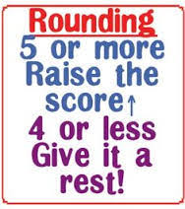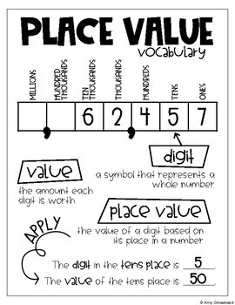[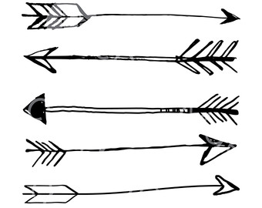](http://www.google.com/url?sa=i&rct=j&q=&esrc=s&source=images&cd=&ved=2ahUKEwjbyMqH2tncAhVGTt8KHRAyARgQjRx6BAgBEAU&url=http://moziru.com/explore/Drawn%20arrow%20transparent%20background/&psig=AOvVaw3O4nvR5-T0PL7ocsxFfq7j&ust=1533688766639822)

What we are learning…

Tests/Projects

-Timed test 8/26

-Unit 1 math test 9/1