Chemistry

Boswell and Fitts

Assignments for the weeks of

April 20, 2020 &

April 27, 2020

(April 20, 2020 through May 1, 2020)

Objectives:

* Writing formulas for covalent compounds; compare & contrast covalent & ionic compounds (watch Fitts video lesson + do 2nd half of ionic / covalent notes; practice problems)
* Drawing structures + determining shapes of small molecules (video & practice)
* Complete online molecule shapes lab
* Identify parts of chemical reaction, including two reaction types; introduction to balancing (law of conservation of mass) (video & practice + optional virtual lab)

**PART I. Covalent Compounds – Week of 4/20/20**

*To be completed after watching this week’s Video 1 (Fitts). This corresponds to section 9.3 in the textbook (pages 280 – 284).*

**Prefixes**

1. Write the number indicated by each of the following prefixes:
   1. di b. deca c. hepta d. tri e. hexa
2. Write the prefix that represents the following numbers of atoms in a covalent formula:
   1. 9 b. 8 c. 1 d. 4 e. 5

**Naming covalent compounds**

1. Name the following covalent compounds using the system for naming molecular compounds (not the common names). The first two are done for you as examples:
   1. H2O *dihydrogen monoxide*
   2. NH3 *nitrogen trihydride*
   3. NO2
   4. N2O
   5. CO
   6. CO2
   7. SO2
   8. SO3
   9. SiCl4
   10. P4O10
   11. Si2Br6
   12. CS2
   13. SF6
   14. H2S
   15. N2O5
   16. PCl5
   17. CCl4
   18. CH4
   19. C6H6
   20. H2O2

**Writing Formulas from the names:**

1. Write the formula of the following covalent compounds:
   1. dinitrogen tetroxide
   2. tetracarbon octahydride
   3. disulfur decafluoride
   4. phosphorous pentachloride
   5. sulfur trioxide
   6. dinitrogen monoxide
   7. sulfur dioxide
   8. diphosphorous trisulfide
   9. nitrogen trifluoride
   10. sulfur hexafluoride
   11. nonacarbon pentahydride
   12. lead tetroxide

**Empirical and Molecular Formulas**

1. List two possible *molecular* formulas from each of the following *empirical* formulas.
   1. BH3 b. P2O7 c. CH2O

d. HgCl e. C3H8O3 f. MgCl2

***Explain why the covalent compounds (written with molecular formulas) require the use of prefixes in their naming.***

PART II. *After* viewing the 2nd video on shapes of molecules (Fitts), use this guide and the PhET website to work through this exercise. If you can’t access the simulations, use the textbook (8.2 – 8.3).

**MODEL 1:**

***Molecule Shapes* Simulation**

**(**[**http://phet.colorado.edu/en/simulation/molecule-shapes**](http://phet.colorado.edu/en/simulation/molecule-shapes)**)**

PART I: ELECTRON DOMAINS

1. Explore (play with) the *Model* screen of the simulation. As you explore, answer the following questions. Be sure to press the triangular “play” button rather than download the sim.
   1. How does adding an **atom** affect the position of existing atoms or lone pairs?
   2. How does adding a **lone pair** affect the position of existing atoms and lone pairs?
2. Is the effect of adding bonded **atoms** and **lone pairs** to the central atom similar? Explain why this could be the case.

We can think of a bond or a lone pair of electrons as a “domain” of electrons. Single bonds, double bonds, and triple bonds each count as one domain.

1. How do the electrons in bonds (bonding domains) differ from lone pairs (non-bonding domains)?
2. What happens to the **bond angle** when you add or remove an electron domain?
3. Can you force the atoms into new configurations by pushing atoms around? What does this suggest about the configuration of atoms in real molecules?
4. What is the difference between *Electron Geometry* and *Molecule Geometry*?
5. In one or two grammatically correct sentences, write a definition for the term *Molecule Geometry*.

PART 2: DRAWING MOLECULES TO SHOW 3-DIMENSIONALITY

**MODEL 2:**

**Line, Wedge and Dash Drawings**

Line: In the plane of the paper: **_____**

Wedge: Coming forward, in front of the plane of the paper: 

Dash: Going backward, behind the plane of the paper: 

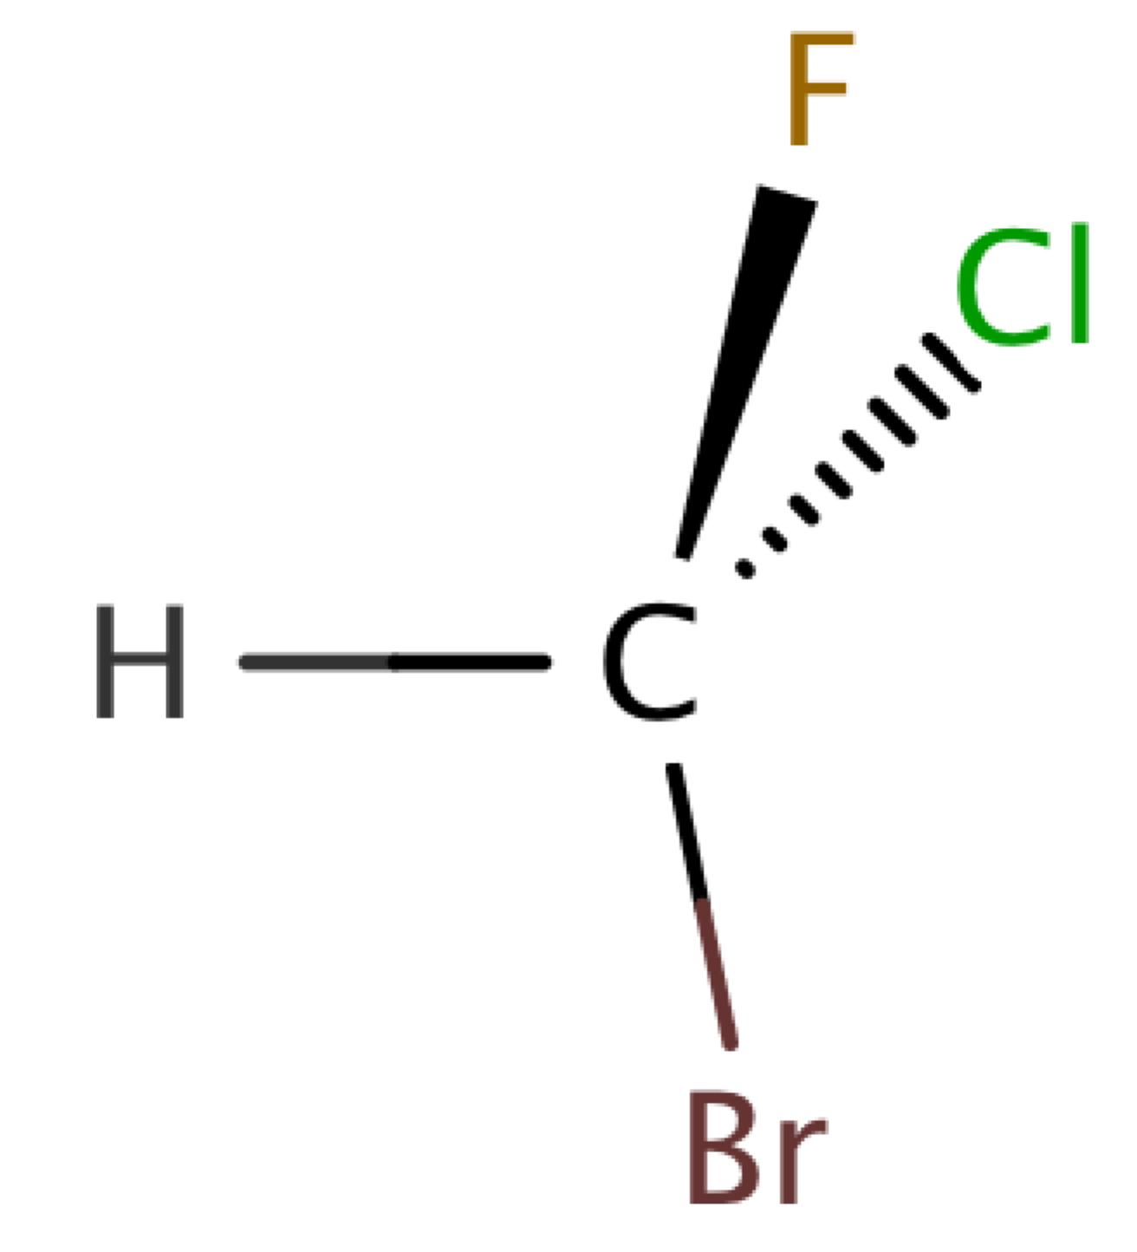

1. Where is each of the 5 atoms in the molecule CHFClBr?

In the plane of the paper ______ ______ ______

In front of the plane of the paper ______

Behind the plane of the paper ______

1. Using the *Model* screen, add bonding domains (●) to the central atom (○). Using lines, wedges and dashes from Model 2, draw each molecule’s shape.

|  |  |  |  |
| --- | --- | --- | --- |
| Bonding Domains Around Central Atom | Drawing of Shape | Electron Geometry | Bond Angles |
| 2 | ● ─ ○ ─ ● | Linear | 180º |
| 3 | ○ |  |  |
| 4 | ○ |  |  |
| 5 | ○ |  |  |
| 6 | ○ |  |  |

1. In the *Model* screen, build a molecule with 5 atoms attached to the central atom. Look at the molecule geometry and electron geometry. **Predict** what will happen to the molecule geometry as you replace atoms with lone pairs.

Your Prediction:

1. In the following table draw the **molecule geometry**. As a group, make a **prediction for each first,** and then compare your answers with the simulation.

|  |  |  |  |  |
| --- | --- | --- | --- | --- |
| Predict First, Then Compare with the Simulation | | | | |
| Number of Domains Around Central Atom | 1 Lone Pair | 2 Lone Pairs | 3 Lone Pairs | 4 Lone Pairs |
| 3 |  |  |  |  |
| 4 |  |  |  |  |
| 5 |  |  |  |  |
| 6 |  |  |  |  |

PART 3: COMPARING MODEL VS. REAL MOLECULES

1. Explore the *Real Molecules* screen.
   1. List the molecules that show a **difference in bond angle** between “Real” and “Model”. Note: differences in bond angle may be small.

|  |  |
| --- | --- |
| Molecule | Number of Lone Pair Domains |
|  |  |
|  |  |
|  |  |
|  |  |
|  |  |

* 1. What do all of the molecules in the table have in common?
  2. What trend do you observe that distinguishes lone pairs from bonding domains?

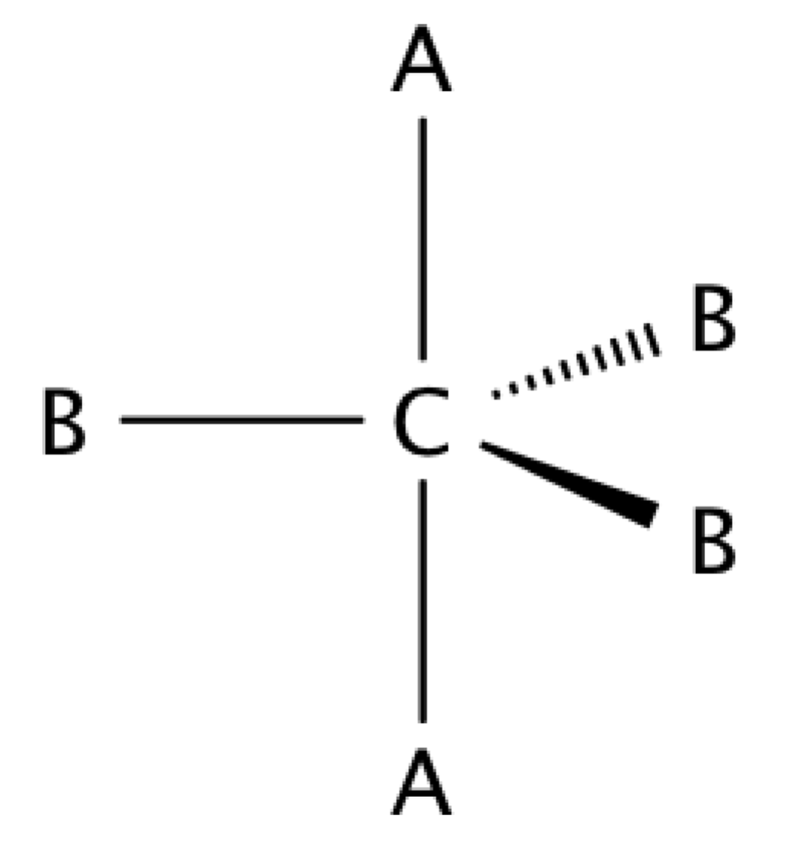

1. Use the simulation to build a system with 5 domains. This is called a trigonal bipyramidal structure. The two different sites in a trigonal bipyramid are labeled as A and B in the drawing to the right.

* 1. Each A atom is adjacent to 3 B atoms. What is the A-C-B bond angle?
  2. Each B atom is adjacent to 2 A atoms and 2 B atoms. What is the B-C-B bond angle.
  3. In a system with 4 atoms and 1 lone pair, predict whether the lone pair will be in a B site or an A site? Explain.
  4. Examine the molecule SF4 in the Real Molecules screen to check your prediction from question c. Which interactions are more important in determining where the lone pair will go?

**EXERCISES**:

1. A molecule has 2 double bonds on the central atom and no lone pairs. Predict the electron geometry. Predict the molecule geometry. What do you think the bond angles would be?
2. For each of the molecules below, determine the electron geometry, molecule geometry, and bond angles. Draw pictures to show your geometries.
   1. CCl4 (4 Cl atoms, no lone pairs on C)
   2. PF3 (3 F atoms, 1 lone pair on P)
   3. OF2 (2 F atoms, 2 lone pairs on O)
   4. I3- (2 I atoms and 3 lone pairs on central I)
3. Use any resources required to add names to all the geometries in the table on page 3.

**Challenge Question:**

Imagine a molecule with 7 electron domains.

The geometry is called pentagonal bipyramidal. This has a lot of similarities to a 6-coordinate molecule except there are 5 domains in one plane. Predict the following based on this information:

1. Draw the structure of a molecule with 7 bonding domains.
2. List all the bond angles possible between adjacent atoms.
3. Predict the electron and molecule geometry for a molecule with 6 bonding domains and a single lone pair.
4. Predict the electron and molecule geometry for a molecule with 5 bonding domains and two lone pairs.

**PART III. Intro to Reactions.**

Describe what happens in a synthesis reaction. How can you recognize this reaction type?

Describe what happens in a decomposition reaction. How can you recognize this reaction type?

Why must reactions be balanced?

What does a triangle over a reaction arrow indicate?