Work for the Coronavirus
Because even if we’re all coughing, we might as well be smart about it…

RL 7.2, RL 7.4, RL 7.6

Standards (Part 1)
- RL 7.4 Determine the meaning of words and phrases as they are used in a text, including figurative and connotative meanings; analyze the impact of rhymes and other repetitions of sounds (e.g., alliteration) on a specific verse or stanza of a poem or section of a story or drama.
- RL 7.2 Determine a theme or central idea of a text and analyze its development over the course of the text; provide an objective summary of the text.
Prior Knowledge (tasks)
  - 1. Provide an example of figurative language
  - 2. Provide an example of technical language and a reason an author may use that language
  - 3. A single sentence that has a clear literal meaning and a clear connotative meaning
Purpose
- To identify central ideas of smaller sections of text
  - Sometimes, smaller sections of text are integral to the development of larger themes
  - These smaller chunks of text allow us to be more focused when we read through text for evidence
- Once we have our information, we can put it together to make a summary.
  - Shoot for four to five statements that, when put together, summarize the work
- To identify themes in a text and then provide necessary evidence to justify those themes
  - Look for repeated, key words or ideas within the text
- Our Purpose is to be able to analyze texts and synthesize them into three separate products
  - Product 1: An analysis of the language used in the text to better understand the author’s meaning
  - Product 2: An objective summary that details important information in an organized fashion that allows for more efficient analysis
  - Product 3: A list of themes explored by the author and how the author approaches those themes

Critical vocab
Theme
Development
Central idea
Main idea
Supporting details
Critical information
Figurative language
Define and give an example of each:
Metaphor
Simile
Personification
Idiom
hyperbole
Technical language
Literal meaning
Connotative meaning

Our Tasks/Problems
- The Matrix/Chart
  - Choose four of the seven choices to create a summary of the passage
  - Chronologically order the sentences from 1-4
  - Note: The summary should only include essential information!
- Which of the statements should be included in an objective summary of the passage?
- Summarizing is easy, so long as we remember a few important things:
  - 1. Who- characters
  - 2. What- What are some major conflicts that occur in the text? Why is it interesting?
    - How does the drama occur?
  - 3. When- What time does the story take place?
  - 4. Where- Where does it take place?
Summaries focus on these particular points. The “why” and “how” are part of it, but our focus needs to be on vital information

Tools and Techniques
- A. The objective summary
  - Purpose: to map out a text so that we can easily reference parts of the whole text without having to spend time rereading unimportant information
  - How do we build it?
    - 1. Figure out the events of the text and list them
    - 2. Once you have the important information down, put it in order
    - 3. You’re done
- B. Focus on Themes
  - As you read, make note of the themes that you see being explored by the author.
  - A theme may be a moral, but it does not have to be
  - If there is one theme, there will most likely be more
  - You may have one of two themes: major or minor
    - Major theme- A complicated life issue that the author explores throughout the entire text
    - Minor theme- A life issue the author explores; will often be related to or a consequence of the major theme but it does not need to be
  - A text does not necessarily have to have a theme, but most texts will have something to analyze
- C. Focus on Language
  - 1. Highlight the key words or phrases
    - Key words are words that relate to repeated information or any words or phrases that relate directly to themes
  - 2. Ask why the author would want to use that particular type of language
    - Make note of patterns the author uses and connect those to themes
- D. The Hand Model
Index Finger= who
Middlefinger= what
Ring finger= when
Pinky finger= where
Thumb= put it all together

Cheat Sheet for theme

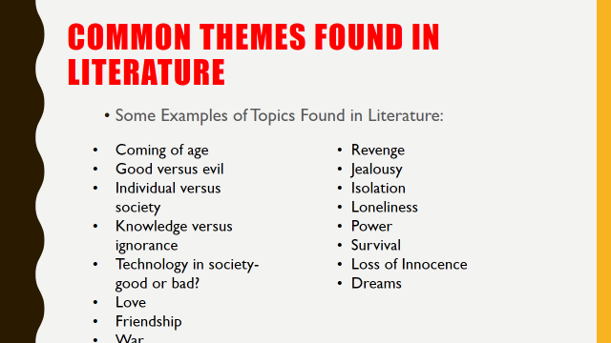

Practice

Identify the central Idea and one main idea of the text
- 1. Picture this: a herd of elephants flies past you at sixty miles per hour, followed by a streak of tigers, a pride of lions, and a bunch of clowns. What do you see? It must be a circus train! One of the first uses of the circus train is credited to W.C. Coup. He partnered with P.T. Barnum in 1871 to expand the reach of their newly combined shows using locomotives. Before circus trains, these operators had to lug around all of their animals, performers, and equipment with a team of more than 600 horses. Since there were no highways, these voyages were rough and took a long time. Circuses would stop at many small towns between the large venues. Performing at many of these small towns was not very profitable. Because of these limitations, circuses could not grow as large as the imaginations of the operators. After they began using circus trains, Barnum and Coup only brought their show to large cities. These performances were much more profitable and the profits went toward creating an even bigger and better circus. Multiple rings were added and the show went on. Today, Ringling Bros. and Barnum and Bailey Cirus still rely on the circus train to transport their astounding show, but now they use two.
Central Idea ____________________________________________________________________________________________________________________________________________________________________
Main Idea
____________________________________________________________________________________________________________________________________________________________________
- 2. How do you say “Holy cow” in French? The fastest thing in France may just be the fastest ground transportation in the world. The TGV (Train à Grande Vitesse: French for very high speed) is France’s national high speed rail service. On April 3rd, 2007, a TGV test train set a record for the fastest wheeled train, reaching 357.2 miles per hour. In mid 2011, TGV trains operated at the highest speed in passenger train service in the world, regularly reaching 200 miles per hour. But what you may find most shocking is that TGV trains run on electric power not petrol. Now if you’ll excuse me; I have a record to catch.
Central Idea ________________________________________________________________________________________________________________________________________________
Main Idea
________________________________________________________________________________________________________________________________________________

- 3. Giddy-up, cowboys and girls! In the Southwest during early half of the 1800s, cows were only worth 2 or 3 dollars a piece. They roamed wild, grazed off of the open range, and were abundant. Midway through the century though, railroads were built and the nation was connected. People could suddenly ship cows in freight trains to the Northeast, where the Yankees had a growing taste for beef. Out of the blue, the same cows that were once worth a couple of bucks were now worth between twenty and forty dollars each, if you could get them to the train station. It became pretty lucrative to wrangle up a drove of cattle and herd them to the nearest train town, but it was at least as dangerous as it was profitable. Cowboys were threatened at every turn. They faced cattle rustlers, stampedes and extreme weather, but kept pushing those steers to the train station. By the turn of the century, barbed wire killed the open range and some may say the cowboy too, but it was the train that birthed him
Central Idea ________________________________________________________________________________________________________________________________________________
Main Idea
_______________________________________________________________________________________________________________________________________________

Read the text and fill in the chart that follows
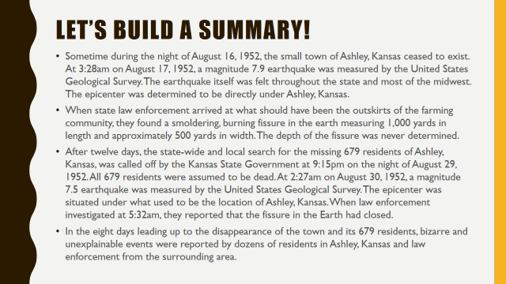
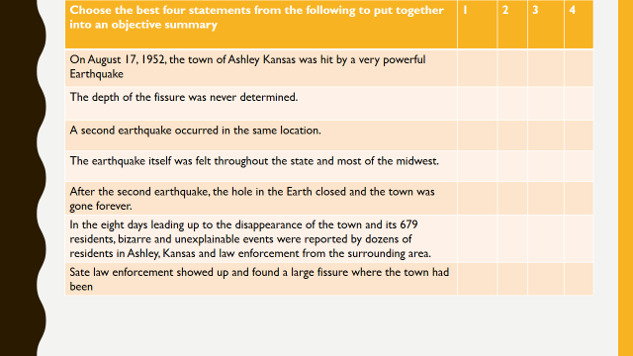

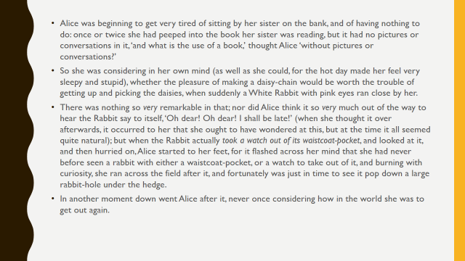
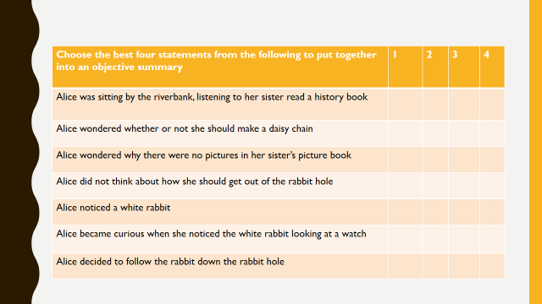

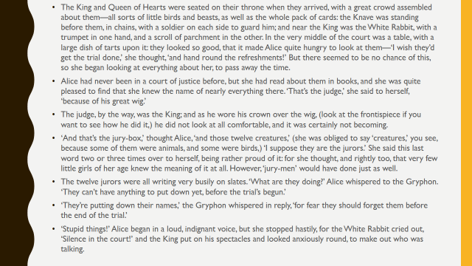
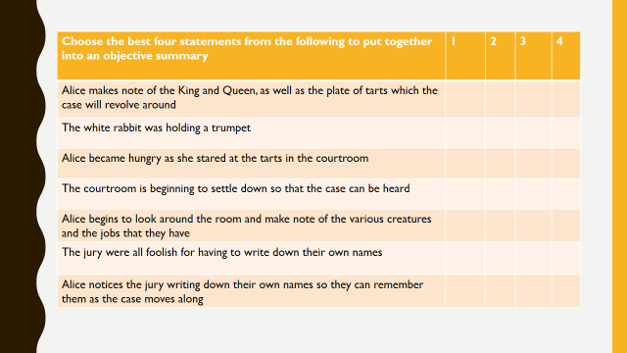

Read the story and complete the tasks that follow
Welcome to Hollywoodland
- Though the night was warm, Stella shivered as she rocked in the porch swing, pushing off with her feet against the wooden planks of the floor. She wasn’t cold as she looked into the clear, moonless night—she was excited. After months of watching men haul lumber and supplies up Mt. Lee, the Hollywoodland sign was finished, and though Stella had seen it being built from her backyard, tonight it would be lit up for the first time.
- “Do you think we will be able to see it?” her mother asked, coming out to join Stella on the porch. She sipped a glass of lemonade and sat beside her on the swing.
- “That eyesore is impossible to miss,” her father complained. He wouldn’t join them on the porch; instead he chose to remain in the house and peek through the screen door every few minutes.
- Stella glanced back at her father and saw his disgruntled expression. She sighed softly, wondering if he would ever feel at peace about selling their barn and property to a movie studio executive who had come knocking on their door last year. Her father flatly refused the offer at first, but her mother had eventually persuaded him.
- “Think of what we could do with the money,” she pleaded. He gave in to her, as he always did, and they used the money to buy their new house in a subdivision where the houses stood closer than Stella had ever thought possible. Without his acres of land to farm, her father had turned to construction work. Stella reassured herself that he was still working outdoors, which he loved, and she wanted to believe he enjoyed it—but she wasn’t so sure.
- Her mother started to say something to him, but he had already left the doorway and retreated back into the house. “Don’t you worry about him; he’ll come around,” she said to Stella, wrapping her in an embrace and gently resting her chin on top of her daughter’s head.
- Stella pulled her head away, an expression of disbelief across her features as her mother laughed and said, “Truly, he will adjust! So much has happened in the thirteen years since you were born: our town has gone from farming crops to filming movies, people are driving around in automobiles, and I even voted in the last election!”
- “But I like all of those things,” Stella said in a small voice.
- “I do, too,” her mother confided, playfully nuzzling Stella’s nose with her own. As she did so, her short hair brushed against Stella’s cheek, a reminder of the new bobbed haircut she had copied from a modern fashion magazine.
- Mother and daughter sat without speaking for a moment, listening to the song of the crickets and of the porch swing creaking as they glided back and forth. They gazed up earnestly into the darkness where they knew the sign stood, willing it to light up the black sky.
- Stella heard her dad at the screen door again. “Still nothing? The fool thing probably won’t even work,” he mumbled, starting to disappear into the house.
- “Dad, please come sit with us.” Stella moved closer to her mother, making space for him beside her on the swing. “Please?”
- She waited nervously for a moment and then smiled as she heard the screen door slam shut and her father’s heavy footsteps cross the porch. The swing groaned a bit under his weight but didn’t stop its gentle lulling motion as he draped his arm around both Stella and her mother and waited with them.
- Minutes later, the sky flashed with something brighter and longer-lasting than lightning. Breathlessly, Stella watched as “HOLLY . . . WOOD . . . LAND” blazed with thousands of light bulbs on the hill above their home. It lit the sky and made the stars seem to dissolve.
- “It’s beautiful,” her mother breathed just as her father grumbled, “There go our nights of peaceful sleep.”
- “Just think of the electricity we’ll save in the evenings,” Stella joked. Her father sighed, which turned into a small chuckle, and kissed the top of her head.
- He’ll come around, Stella thought, repeating her mother’s words, but for now she would enjoy the show of lights. It was a sign of so many things: to her, a bold sign of progress and promise; to her father, a symbol of old values being tossed aside; to them all, a sign that life would never be quite the same.

Complete the following tasks

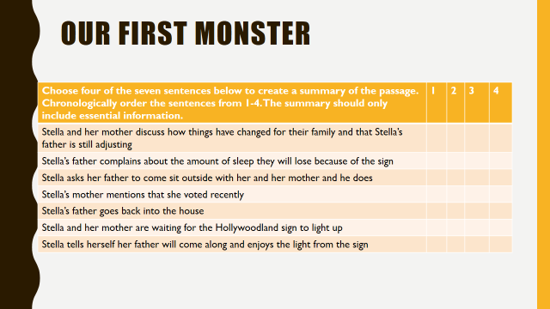

- 2. Which of the following statements should be included in an objective summary of the passage?
  - A. Stella’s father is unhappy because he had to sell his farm and he will always be kept up at night by the Hollywood sign
  - B. A mother and daughter think about abandoning the rest of their painfully conservative family
  - C. Stella and her mother wait for the Hollywood sign to light up while her father complains about the way things have changed
  - D. A mother and daughter must work tirelessly to convince the girl’s father to accept change
- 3. You have just read the first part of a text in which the family history of a man is described in detail. This family history is defined by a mystery that is made even more interesting by the behavior of the family members. In a well thought out (4-5 paragraph) essay, predict what that mysterious issue with the Jermyn family line is and then cite the specific relative you believe to provide the best reasoning for your claim. Be sure to use TEXTUAL evidence for support.

Standards (Part 2)
- A. RL 7.6 Analyze how an author develops and contrasts the points of view of different characters or narrators in a text
Prior Knowledge (tasks)
- A. What are the three perspectives in which a story can be told?
- B. How might those perspectives affect the work?
Purpose
- A. Our purpose is to analyze the way the characters are presented to make sure we understand the unstated psychological state of those characters
- B. Our purpose is to understand how the author uses information to get across some type of reason by looking at the differences in point of view between multiple characters
- C. We need to break down that information and analyze it to figure out the unnamed drama of the text
Critical vocab
- Influence
- Manipulate
- Author’s style
- Tone
- Explain
- Point of view
- Develop
- Development
- Narrator
- Speaker

Our Tasks/Problems
- A. What is the author’s purpose for including ____in paragraph __?
  - The first blank refers to a specific part of the text that requires analysis.
  - You have to look at the identified text and then ask how it affects the rest of the text
    - What differences would be made if that part of the text were to be removed?
- B. What does the speaker imply about ____when he has _____state, “______”?
  - Again, we break down the text to analyze a specific part to see how it affects the rest of the text
    - Ask the same question as the other task
- C. How is the point of view of _________ different from ________in paragraph 3?
  - Highlight the explicit text that describes the point of views regarding the two characters/elements EXACTLY WHERE THE STEM STATES
- D. How is _______ opinion about _______different from ______?
  - Again, we are looking at the explicit difference of opinion about two elements in the text regarding a single topic. FIND THAT TOPIC IN THE TEXT AND THEN HIGHLIGHT IT! Once you do that, search for the characters mentioned and then find the evidence within the context
- E. Which paragraphs from the passage best represents the contrasting points of view of ________ and ________?
  - This requires you to complete the first part of the second task, but instead of identifying the opinions, you simply note the location (paragraph) where the info is found

Tools and Techniques
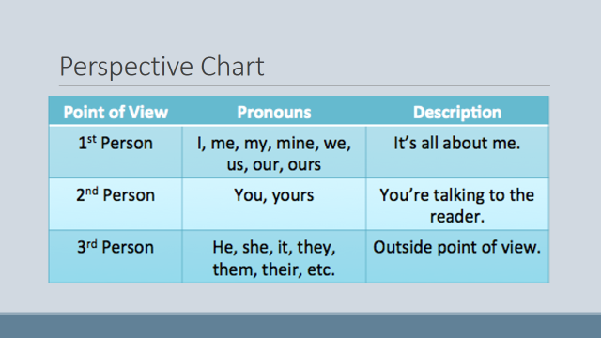
The Perspective Chart gives a brief understanding of the three different points of view/perspective. The Pronouns provide great key words to help the reader understand how the author is telling the story and the description gives a brief example of how that perspective would look in context
The Reality of Perspective Chart
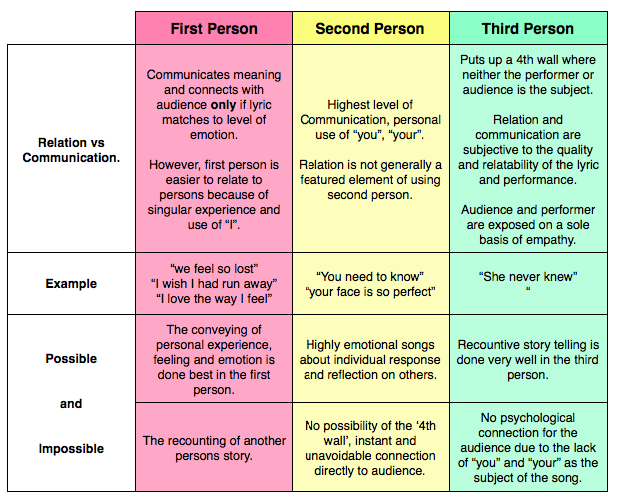
This chart provides a deeper look at the perspective types in context, showing what an author is able and is not able to do when she or he uses that style.

- C. Style in literature is the literary element that describes the ways that the author uses words
  - the author's word choice
  - sentence structure
  - figurative language
  - sentence arrangement
    - all work together to establish mood, images, and meaning in the text.
D. Style Examples
Original (dialect): "No sich uh thing!" Tea Cake retorted.
Informal: "Nothing like that ever happened," Tea Cake replied.
Formal: "With great fortune, that happenstance did not become a reality," Tea Cake stated.
Journalistic, after Ernest Hemingway: "It did not happen," Tea Cake said.
Archaic, after Nathaniel Hawthorne: "Verily, it was a circumstance, to be noted, that appeared not to so much have been a reality as to have evolved as a thing that had not yet come to be," Tea Cake impelled.

Practice

A. Identify the Style
- He's passed away.
- He's sleeping with the fishes.
- He died.
- He's gone to meet his Maker.
- He kicked the bucket.
- Which examples is formal? Journalistic? Informal? Dialect? Archaic?

B. Read the text and answer the questions that follow

Augustus Gloop Goes Up The Pipe
- 1-When Mr Wonka turned round and saw what Augustus Gloop was doing, he cried out, 'Oh, no! Please, Augustus, please! I beg of you not to do that. My chocolate must be untouched by human hands!'
- 2-'Augustus!' called out Mrs Gloop. 'Didn't you hear what the man said? Come away from that river at once!'
- 3-'This stuff is fabulous!' said Augustus, taking not the slightest notice of his mother or Mr Wonka. 'Gosh, I need a bucket to drink it properly!'
- 4-'Augustus,' cried Mr Wonka, hopping up and down and waggling his stick in the air, 'you must come away. You are dirtying my chocolate!'
- 5-'Augustus!' cried Mrs Gloop.
- 6-'Augustus!' cried Mr Gloop. But Augustus was deaf to everything except the call of his enormous stomach. He was now lying full length on the ground with his head far out over the river, lapping up the chocolate like a dog.
- 7-'Augustus!' shouted Mrs Gloop. 'You'll be giving that nasty cold of yours to about a million people all over the country!'
- 8-'Be careful, Augustus!' shouted Mr Gloop. 'You're leaning too far out!' Mr Gloop was absolutely right. For suddenly there was a shriek, and then a splash, and into the river went Augustus Gloop, and in one second he had disappeared under the brown surface.
- 9-'Save him!' screamed Mrs Gloop, going white in the face, and waving her umbrella about. 'He'll drown! He can't swim a yard! Save him! Save him!'
- 10-'Good heavens, woman,' said Mr Gloop, 'I'm not diving in there! I've got my best suit on!' Augustus Gloop's face came up again to the surface, painted brown with chocolate.
- 11-'Help! Help! Help!' he yelled. 'Fish me out!'
- 12-'Don't just stand there!' Mrs Gloop screamed at Mr Gloop. 'Do something!'
- 13-'I am doing something!' said Mr Gloop, who was now taking off his jacket and getting ready to dive into the chocolate. But while he was doing this, the wretched boy was being sucked closer and closer towards the mouth of one of the great pipes that was dangling down into the river. Then all at once, the powerful suction took hold of him completely, and he was pulled under the surface and then into the mouth of the pipe.
- 14-The crowd on the riverbank waited breathlessly to see where he would come out.
- 15-'There he goes!' somebody shouted, pointing upwards. And sure enough, because the pipe was made of glass, Augustus Gloop could be clearly seen shooting up inside it, head first, like a torpedo.
- 16-'Help! Murder! Police!' screamed Mrs Gloop. 'Augustus, come back at once! Where are you going?'
- 17-'It's a wonder to me,' said Mr Gloop, 'how that pipe is big enough for him to go through it.'
- 18-'It isn't big enough!' said Charlie Bucket. 'Oh dear, look! He's slowing down!'
- 19-'So he is!' said Grandpa Joe.
- 20-'He's going to stick!' said Charlie.
- 21-'I think he is!' said Grandpa Joe.
- 22-'By golly, he has stuck!' said Charlie.
- 23-'It's his stomach that's done it!' said Mr Gloop.
- 24-'He's blocked the whole pipe!' said Grandpa Joe.
- 25-'Smash the pipe!' yelled Mrs Gloop, still waving her umbrella. 'Augustus, come out of there at once!'
- 26-The watchers below could see the chocolate swishing around the boy in the pipe, and they could see it building up behind him in a solid mass, pushing against the blockage. The pressure was terrific. Something had to give. Something did give, and that something was Augustus. WHOOF! Up he shot again like a bullet in the barrel of a gun.
- 27- 'He's disappeared!' yelled Mrs Gloop. 'Where does that pipe go to? Quick! Call the fire brigade!'
- 28-'Keep calm!' cried Mr Wonka. 'Keep calm, my dear lady, keep calm. There is no danger! No danger whatsoever! Augustus has gone on a little journey, that's all. A most interesting little journey. But he'll come out of it just fine, you wait and see.'
- 29-'How can he possibly come out just fine!' snapped Mrs Gloop. 'He'll be made into marshmallows in five seconds!'
- 30-'Impossible!' cried Mr Wonka. 'Unthinkable! Inconceivable! Absurd! He could never be made into marshmallows!'
- 31-'And why not, may I ask?' shouted Mrs Gloop.
- 32-'Because that pipe doesn't go anywhere near it! That pipe — the one Augustus went up — happens to lead directly to the room where I make a most delicious kind of strawberry-flavoured chocolate-coated fudge . . .'
- 33-'Then he'll be made into strawberry-flavoured chocolate-coated fudge!' screamed Mrs Gloop. 'My poor Augustus! They'll be selling him by the pound all over the country tomorrow morning!'
- 34-'Quite right,' said Mr Gloop. 'I know I'm right,' said Mrs Gloop. 'It's beyond a joke,' said Mr Gloop.
- 35-'Mr Wonka doesn't seem to think so!' cried Mrs Gloop. 'Just look at him! He's laughing his head off! How dare you laugh like that when my boy's just gone up the pipe! You monster!' she shrieked, pointing her umbrella at Mr Wonka as though she were going to run him through. 'You think it's a joke, do you? You think that sucking my boy up into your Fudge Room like that is just one great big colossal joke?'
- 36-'He'll be perfectly safe,' said Mr Wonka, giggling slightly.
- 37-'He'll be chocolate fudge!' shrieked Mrs Gloop.
- 38-'Never!' cried Mr Wonka.
- 39-'Of course he will!' shrieked Mrs Gloop.
- 40-'I wouldn't allow it!' cried Mr Wonka.
- 41-'And why not?' shrieked Mrs Gloop.
- 42-'Because the taste would be terrible,' said Mr Wonka. 'Just imagine it! Augustus-flavoured chocolate-coated Gloop! No one would buy it.'
- 43-'They most certainly would!' cried Mr Gloop indignantly.
- 44-'I don't want to think about it!' shrieked Mrs Gloop.
- 45-'Nor do I,' said Mr Wonka. 'And I do promise you, madam, that your darling boy is perfectly safe.'
- 46-'If he's perfectly safe, then where is he?' snapped Mrs Gloop. 'Lead me to him this instant!'
- 47-Mr Wonka turned around and clicked his fingers sharply, click, click, click, three times. Immediately, an Oompa-Loompa appeared, as if from nowhere, and stood beside him. The Oompa-Loompa bowed and smiled, showing beautiful white teeth. His skin was rosy-white, his long hair was golden-brown, and the top of his head came just above the height of Mr Wonka's knee. He wore the usual deerskin slung over his shoulder.
- 48-'Now listen to me!' said Mr Wonka, looking down at the tiny man. 'I want you to take Mr and Mrs Gloop up to the Fudge Room and help them to find their son, Augustus. He's just gone up the pipe.'
- 49-The Oompa-Loompa took one look at Mrs Gloop and exploded into peals of laughter.
- 50-'Oh, do be quiet!' said Mr Wonka. 'Control yourself! Pull yourself together! Mrs Gloop doesn't think it's at all funny!'
- 51-'You can say that again!' said Mrs Gloop.
- 52-'Go straight to the Fudge Room,' Mr Wonka said to the Oompa-Loompa, 'and when you get there, take a long stick and start poking around inside the big chocolate-mixing barrel. I'm almost certain you'll find him in there. But you'd better look sharp! You'll have to hurry! If you leave him in the chocolate-mixing barrel too long, he's liable to get poured out into the fudge boiler, and that really would be a disaster, wouldn't it? My fudge would become quite uneatable!' Mrs Gloop let out a shriek of fury.
- 53-'I'm joking,' said Mr Wonka, giggling madly behind his beard. 'I didn't mean it. Forgive me. I'm so sorry. Good-bye, Mrs Gloop! And Mr Gloop! Good-bye! I'll see you later . . .'
- 54-As Mr and Mrs Gloop and their tiny escort hurried away, the five Oompa-Loompas on the far side of the river suddenly began hopping and dancing about and beating wildly upon a number of very small drums.

Complete the following tasks
- 1. How is the point of view of Willy Wonka different from Mrs. Gloop in paragraphs 35-36?
A. She thinks the entire thing must be some sort of joke while he remains serious about the event
B. She is worried about her son while he is worried about the state of his factory
C. He thinks that she must be intentionally trying to destroy his factory while she tries to deny it
D. She is worried about her son while he seems like he does not care about her son at all

- 2. How is the point of view of Willy Wonka different from Augustus in paragraphs 1 through 3?
A. Willy Wonka is worried that Augustus is touching his chocolate with his bare hands while Augustus is simply greedy
B. Augustus is more worried about upsetiing his mother by misbehaving while Willy Wonka only wants order in his factory
C. Augustus is worried that he will drown in the river while Willy Wonka is only worried about the cleanliness of his factory
D. Augustus tries to ignore how much Willy Wonka wants to kill him

- 3. How is Willy Wonka’s opinion about Augustus’ trip up the pipe different from Mrs. Gloop?
A. Willy Wonka is more worried about the state of his factory and the condition of his candy than Augustus’ safety
B. Willy Wonka does not understand why Mrs. Gloop does not care about her son
C. Willy Wonka wishes only to find Augustus before he is turned into marshmallows
D. Willy Wonka does not care about the situation and only wants to move on with the tour

- 4. How is Mrs. Gloop’s opinion about Augustus going up the pipe different from Mr. Gloop’s?
Mr. Gloop seems more worried about his son than Mrs. Gloop
Mr. Gloop agrees with Willy Wonka that whatever happens to Augustus is deserved
Mrs. Gloop is angry while her husband is worried
Mrs. Gloop seems worried about her son while Mr. Gloop seems more worried about small matters, such as his outfit

- 5. Which paragraphs from the passage best represents the contrasting points of view of Willy Wonka and Mrs. Gloop?
A. paragraphs 1 and 3
B. paragraphs 4 and 7
C. paragraphs 28 and 29
D. paragraphs 4 and 5

- 6. Which paragraphs from the passage best represents the contrasting points of view of Mr. Gloop and Mrs. Gloop?
A. paragraphs 6 and 14
B. paragraphs 9 and 10
C. paragraphs 17 and 18
D. paragraphs 22 and 23

Short Answer. On a separate piece of paper, answer the following
- 7. How is the point of view of Mrs Gloop different from Mr. Gloop in paragraphs 12 and 13?
- 8. How is Augustus’ opinion about eating the chocolate from the river different from Willy Wonka’s?

C. Read the following text and answer the questions that follow

Mr Wonka and the Indian Prince

1-'Prince Pondicherry wrote a letter to Mr Willy Wonka,' said Grandpa Joe, 'and asked him to come all the way out to India and build him a colossal palace entirely out of chocolate.'
2-'Did Mr Wonka do it, Grandpa?'
3-'He did, indeed. And what a palace it was! It had one hundred rooms, and everything was made of either dark or light chocolate! The bricks were chocolate, and the cement holding them together was chocolate, and the windows were chocolate, and all the walls and ceilings were made of chocolate, so were the carpets and the pictures and the furniture and the beds; and when you turned on the taps in the bathroom, hot chocolate came pouring out.
4-'When it was all finished, Mr Wonka said to Prince Pondicherry, "I warn you, though, it won't last very long, so you'd better start eating it right away."
5-'"Nonsense!" shouted the Prince. "I'm not going to eat my palace! I'm not even going to nibble the staircase or lick the walls! I'm going to live in it!"
6-'But Mr Wonka was right, of course, because soon after this, there came a very hot day with a boiling sun, and the whole palace began to melt, and then it sank slowly to the ground, and the crazy prince, who was dozing in the living room at the time, woke up to find himself swimming around in a huge brown sticky lake of chocolate.'
7- Little Charlie sat very still on the edge of the bed, staring at his grandfather. Charlie's face was bright, and his eyes were stretched so wide you could see the whites all around. 'Is all this really true?' he asked. 'Or are you pulling my leg?'
8- 'It's true!' cried all four of the old people at once. 'Of course it's true! Ask anyone you like!'
9- 'And I'll tell you something else that's true,' said Grandpa Joe, and now he leaned closer to Charlie, and lowered his voice to a soft, secret whisper. 'Nobody . . . ever . . . comes . . . out!'
10- Out of where?' asked Charlie.
11- 'And . . . nobody . . . ever . . . goes . . . in!'
12- 'In where?' cried Charlie.
13- 'Wonka's factory, of course!'
14- 'Grandpa, what do you mean?'
15- 'I mean workers, Charlie.'
16- 'Workers?'
17- 'All factories,' said Grandpa Joe, 'have workers streaming in and out of the gates in the mornings and evenings — except Wonka's! Have you ever seen a single person going into that place — or coming out?'
18- Little Charlie looked slowly around at each of the four old faces, one after the other, and they all looked back at him. They were friendly smiling faces, but they were also quite serious. There was no sign of joking or leg-pulling on any of them.
19- 'Well? Have you?' asked Grandpa Joe.
20- 'I . . . I really don't know, Grandpa,' Charlie stammered. 'Whenever I walk past the factory, the gates seem to be closed.'
21-'Exactly!' said Grandpa Joe.
22-'But there must be people working there . . .'
23-'Not people, Charlie. Not ordinary people, anyway.'
24-'Then who?' cried Charlie.
25-'Ah-ha . . . That's it, you see . . . That's another of Mr Willy Wonka's clevernesses.'
26-'Charlie, dear,' Mrs Bucket called out from where she was standing by the door, 'it's time for bed. That's enough for tonight.'
27-'But, Mother, I must hear . . .'
28-'Tomorrow, my darling . . .'
29-'That's right,' said Grandpa Joe, 'I'll tell you the rest of it tomorrow evening.'

- 1. What is the author’s purpose for including the Prince’s reaction to Wonka’s directions in paragraph 5?
A. To show how some people reacted to the beauty of Wonka’s creations
B. To foreshadow a humorous event once the sun melted the palace
C. To contrast the characters of Charlie and Willy Wonka
D. To compare Charlie’s first meeting with Willy Wonka to the Prince’s first meeting with him.

- 2. What is the author’s purpose for including the description of the Prince’s palace in paragraph 3?
A. To show how little Willy Wonka cared about the Prince’s palace
B. To provide evidence of Willy Wonka’s dark sense of humor
C. To compare the chocolate making skills of the Prince to that of Willy Wonka
D. To include some evidence of how good Willy Wonka is at his job

- 3. What does the speaker imply about Willy Wonka when he has Grandpa Joe state, “'Nobody . . . ever . . . comes . . . out!'”?
A. He is implying how clever Willy Wonka really is
B. He is implying how cruel Willy Wonka is to his workers
C. He is implying that Willy Wonka is a very dangerous man and Charlie should avoid him
D. He is implying that Willy Wonka is a very secretive, strange man

- 4. What does the speaker imply about Grandpa Joe when he has Charlie say, “'Is all this really true?' he asked. 'Or are you pulling my leg?’”?
A. He is implying that Grandpa Joe rarely ever jokes around and Charlie is upset about his news
B. He is implying that Grandpa Joe is the kind of person who would joke around with his grandson
C. He is implying that Grandpa Joe routinely lies to Charlie to be mean
D. He is implying that Grandpa Joe is a sick, old man

