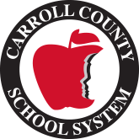

Mt. Zion Elementary School
2021-2022
4th Grade Supply List
1 pack wide-ruled paper
#2 pencils
6 pronged folders with pockets
- 1 blue (Math), 1 red (SS), 1 purple (Reading), 1 orange (Writing), 1 yellow (ELA) , 1 gray (Take-Home)
1 blue single-subject spiral notebooks (Math)
1 red single-subject spiral notebooks (Social Studies)
1 green single-subject spiral notebooks (Science)
Scissors (optional)
Earbuds/headphones
Crayons, markers, or colored pencils (optional)
Expo Markers
Index Cards
4th Grade Wish List

Kleenex
Clorox wipes
Candy (individually wrapped)
1 pack of construction paper
Sidewalk Chalk

