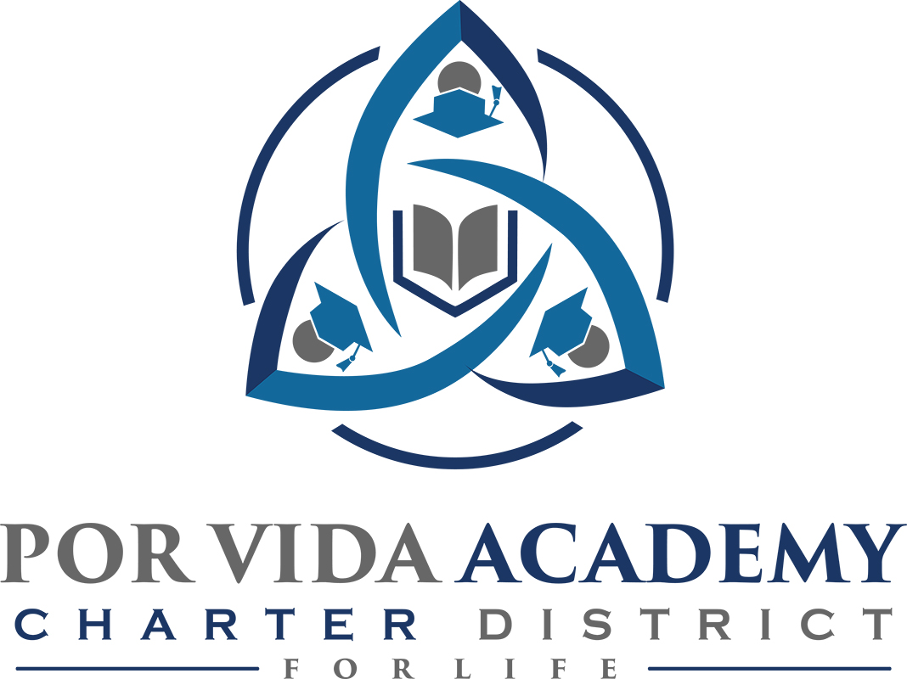

Tuesday, December 17, 2019 at 10:30am 1135 Mission Road, SA TX 78210

Agenda of Regular Called Board Meeting

- Call to Order and Establishment of Quorum
  - Roll Call & Recording of Board Members Present - Declaration of Quorum Present
  - Recording of the Executive Director/Superintendent and Staff Members Present.

- Closed Session: None

- Pledge of Allegiance

- Salute to the Texas Flag- “Honor the Texas Flag; I pledge allegiance to thee, Texas, one state under God, one and indivisible.”

- Public Testimony

- Approval of Minutes: August & November

- Superintendent Items:

  - TEA Letter
  - Campus reports
  - Monitor Report

- Financials
  - Latest financials
  - Financial Management Report

- Board Items: None

- Adjournment

