Junior/Senior News~ September 2020
Marbury High School

Important Upcoming Dates:

NACAC Virtual College Fair
(Free Virtual Fair)

Monday, Oct. 12 @ 1-9pm ET
Sunday, Oct. 18 @ 12-8pm ET
Sunday, Nov. 8 @ 2-10pm ET
Simply Sign up at
virtualcollegefairs.org

Colleges Who are Offering Virtual Tours

University of Montevallo

https://www.montevallo.edu/
admissions-aid/undergraduate-admissions/tours/virtual/

Huntingdon College

https://m.youtube.com/watch?
v=o_ZONgdRbqo

Dear Senior,
Not sure what you want to do with your life? Why not take a look back at your Kuder Career Interest Inventory that you completed a few years ago?
https://al.kuder.com

Helpful Websites:
https://www.scholarships.com/financial-aid/college-scholarships/scholarships-by-state/alabama-scholarships/
QUESTIONS TO ASK YOURSELF:
- Have I registered and been practicing to retake the ACT?

- Do I know where I want to attend college or technical school?

- Have I started researching the schools that I am interested in attending?

- Have I visited any university/college campuses yet?

Important Things to Remember While Planning for College

Applications for college admissions are available now.

December 1st is the deadline for most major university scholarships in the state of Alabama.

Some university/ colleges have the same application for both admissions and scholarships.

Once application process has been completed, request high school transcript through Parchment.com

FAFSA opens October 1st. Most colleges require FAFSA completion.

PLAN, PLAN, PLAN!!!!

ACT/SAT Updates!!!!!!

ACT Cost: No writing- $46.00

With Writing- $62.50

SAT Cost: No writing - $49.50

With Writing- $64.50

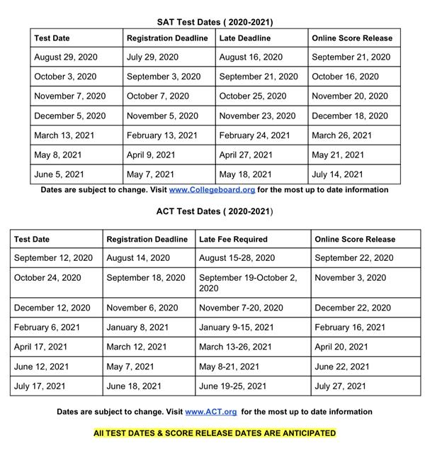
**** If you receive free/reduced lunch, see Mrs. Hicks for a fee waiver.

Ordering Transcripts
*Go to Parchment.com, click Sign up and follow the onscreen instructions to register
*Click Transcripts
*Find your high school, select it and click Save & Continue
* Sign the Transcript Request Form
*Select the Destination of the transcript
*Enter your payment details and click Submit.

