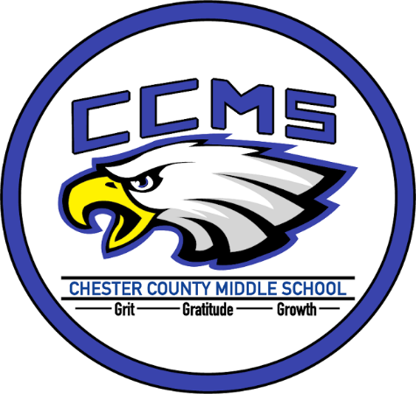
Communication About Student Learning

- 1st 45 Day period: Wednesday, August 1, 2018-Wednesday, October 3, 2018 (progress reports at/after Friday, August 31, 2018)
- 2nd 45 Day period: Thursday, October 4, 2018-Wednesday, December 19, 2018 (progress reports at/after Tuesday, November 13, 2018)
- 3rd 45 Day period: Friday, January 4, 2019-Monday, March 11, 2019 (progress reports at/after Tuesday, February 5, 2019)
- 4th 45 Day period: Tuesday, March 12, 2019-Thursday, May 23, 2019 (progress reports at/after Thursday, April 18, 2019)
Do you have questions about your child’s progress?

Contact your child’s teacher at 731-989-8150.You can also reach them by their email address which can be found on our website:chestercountyschools.org

West Chester Elementary School

2018-19 School-Parent Compact

What is a School-Parent Compact?

A School-Parent Compact is an agreement that families, students, and teachers develop together. It explains how families and teachers will work together to make sure all students reach grade level standards.

Effective Compacts:

-link goals to the School Improvement Plan;
-focus on student learning skills;
-describe how teachers will help students develop skills using high-quality instruction;
-share strategies families can use at home;
-and explain how teachers and families will communicate about student progress

Jointly Developed

The families, students, and staff of West Chester Elementary School developed this School-Parent Compact. Teachers suggested home learning strategies, families added ideas to make them more specific, and students told us what would help them learn. Meetings and events are held each year to review the compact and make changes based on student and family needs.

Building Partnerships

Parent Involvement Nights
Open Houses- First-third grades August 6; Kindergarten August 13
October 18, 2019
March 2019

Parent-Teacher Conferences
Oct. 4-5
February 14-15

Amy Wooley
731-989-8150
www.ChesterCountySchools.org

Our Goals for Student Achievement

District Goals
For the 2018-2019, the district will increase the percentage of students scoring on-track (proficient) and mastered (advanced) in Math.
For the 2018-2019, the district will increase the percentage of students scoring on-track (proficient) and mastered (advanced) in Language Arts.

School Goals
Our goal is to raise the percentage of on track and mastered students on the ELA TN Ready assessment by 10%. We will achieve this by strategically providing summer training opportunities to become more familiar with the best practices for reading including teaching through interactive read alouds and shared reading, teaching writing (based on fiction and non-fiction authentic texts), integrating writing into the language arts block, effective use of curriculum, and selection and utilization of educational resources. We will ensure that all students have access to high quality teachers and rigorous reading texts. Students will read, talk about, and write about texts.
We also aim to raise the percentage of on track and mastered students on the Math TN Ready assessment by 10%. We will accomplish this by ensuring our curriculum is rigorous and aligned to Tennessee State Standards and is being utilized at all grade levels with a renewed emphasis on the math practices. We will also place a greater emphasis on basic math skills: arithmetic, multiplication, division, and fractions.

Teachers, families, students – Together for Success
In the Classroom  We will work with students and families to support students’ success in reading and Math. Some of our key connections with families will be:  -Offer free Family Fun Nights that will focus on ELA, Math and Science  -Our monthly newsletter will feature games that families can play to review vocabulary words that have been introduced in class.  Our school web page will have links to family friendly web sites for building vocabulary and math skills. |  | At Home  WCES families joined staff to develop ideas about how families can support students’ success in reading and math. Families may have other ideas to add to this list.  -Try to attend Family Fun Nights or get information from my child’s teachers if we can’t attend.  -Play word games with the new vocabulary words and find ways to use these words in family conversations.  -Look at the class newsletter each month and check out the school’s website:  www.chestercountyschools.com
Students

WCES students joined staff and families to develop ideas about how they can succeed in school and reach for the stars in math and reading. Students thought of the following ideas to make connections between learning at home and school:

-Talk with my family about new vocabulary words, texts I am reading, and newly acquired math skills.
-Bring home our class newsletter and invitations for Parent Involvement Nights.
-Keep a log of games I play at home to practice new vocabulary words and math.

