**Roshambo or Rock Paper Scissors – Conflict Resolution**

[**https://www.playworks.org/game-library/ro-sham-bo-or-rock-paper-scissors/**](https://www.playworks.org/game-library/ro-sham-bo-or-rock-paper-scissors/)

**Development Goal:**

To develop a simple tool for conflict resolution.

**Before You Start:**

* Only two players are needed. If there are more, have everyone pair up.
* Explain and demonstrate the rules of play.
* Check for understanding.

**How to Play:**

* Partners say, “Roshambo” or “Rock Paper Scissors” together with their hands in a fist.
* On “bo” or “paper,” players pick one of three things to show with their hand:
  + Rock which is demonstrated by a fist.
  + Scissors with two fingers spread out to represent scissors. (This looks like a sideways peace sign).
  + Paper by holding out a palm down, flat hand.
* If players show the same things, they go again.
* If one player picks rock and one scissors, the player who showed rock wins the dispute. To explain this, say rock crushes scissors (no need to actually crush).

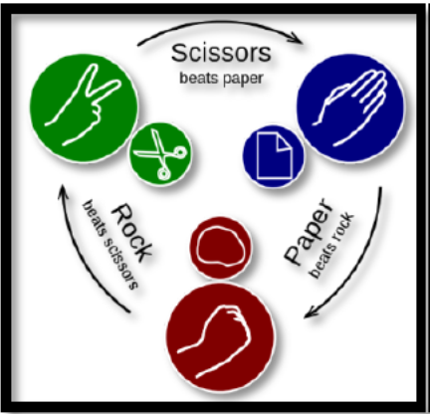

* If one player picks scissors and the other paper, the player who showed scissors succeeds. Scissors cuts paper.
* If a player shows paper while the other shows rock, the player who picked paper succeeds. Paper covers rock.
* Once game is taught, ask players to use in many different games and situations to solve minor disputes, such as is the ball in or out or who arrived first in line.

**Variations:**

* Play with your feet! Rock = feet together. Paper = feet spread out to sides. Scissors = feet spread front and back.
* Play with the whole body! Rock = body curled up. Paper = standing straight arms to sides. Scissors = arms high and wide, legs out wide.
* Though it loses its use as a conflict resolution tools, it is also fun to add additional creative things to play. Rock Paper Scissors Lizard Spock is one popular version.