Mrs. Daniel’s Newsletter
February 22-26, 2021
Grammar (adverbs that tell how) and
Reading Skills (plot and theme) Tests: Thursday
Vocabulary and Spelling (oo, ue, ew, ui) Tests: Friday
Dates to Remember: Friday, 2/26- Special Snack/Spirit Day
March 1-4 Read Across America Week
Story:  “The First Tortilla”  by Rudolfo Anaya  Phonics/Fluency:  vowel digraphs  oo, ue, ew, ui  Text-Based Comprehension:  plot and theme,  monitor and clarify  Grammar:  adverbs that tell  how |  | Selection Vocabulary Words (Students will be tested on these):  - awaken – cause to stop sleeping  - prize – something given to someone as a reward  - volcano – a cone-shaped mountain with a hole in the top that sends out melted rock and gases  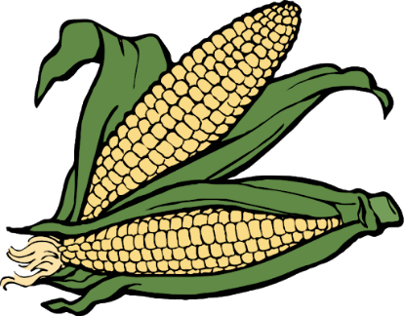  - cliffs – steep rock faces, like those at the edge of the sea  - rainbow – a display of many colors  - mountain – a high, steep hill that is often rocky  - suffer – to experience something bad or unpleasant  Amazing Words  condition, terrifying, whip, funnel,  predict, breeze, sparkle, swirl
Math: Topic 10  Understanding Place Value  This week, we are going to continue studying place value. We are working on identifying the value of each digit in a number, showing expanded form, and written form of a number. |  |  |  | Social Studies/Science  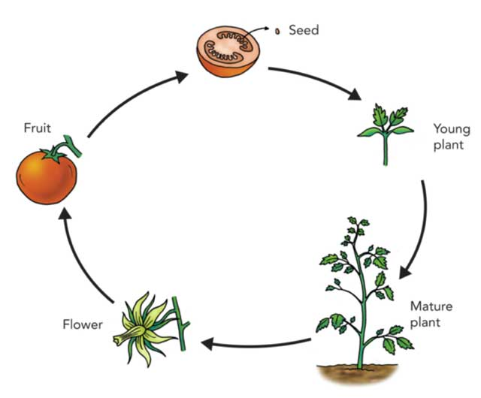  We are looking at how living things grow. Everything living goes through stages, each a part of its life cycle. Energy is  needed for things to grow.  We will study the life  cycles of people,  animals, and plants.
Spelling Words:
- too  - new  - fruit | - blue  - true  - fool |  | - suit  - spoon  - clue |  | - juice  - drew  - flew

