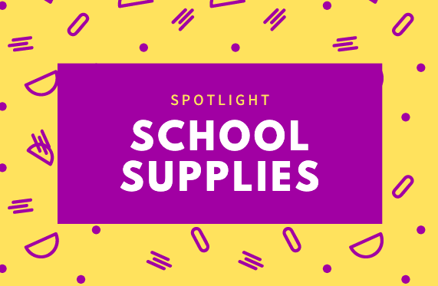

One vinyl folder with pockets and brads
Clear plastic bin- Shoebox size
Scissors
Markers (student choice)
Crayons or Colored Pencils
Oil Pastels (Amazon)
Pencils (Ticonderoga or Mechanical) *I will even allow erasable pens.

