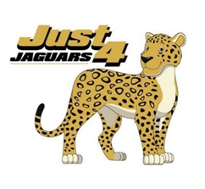
Just 4 Spirit Shirts Available!
Where: Just 4 Developmental Laboratory
Who: Parents and Families of Just 4 Students
What: Just 4 Spirit shirt sale
When: Tuesday, September 29th, 8 – 12 and Thursday, October 1st, 11 – 2
How: Drive thru purchasing. Pricing below. Please have correct change or check with phone number. Cards are NOT ACCEPTED.
