NO NEED TO REQUEST ACCESS. EITHER “MAKE A COPY,” DOWNLOAD OR USE THIS AS A GUIDE FOR HANDWRITTEN NOTES.

Handout and AP Practice
3/27/20

TASK ONE:
Underline the commentary for each example.
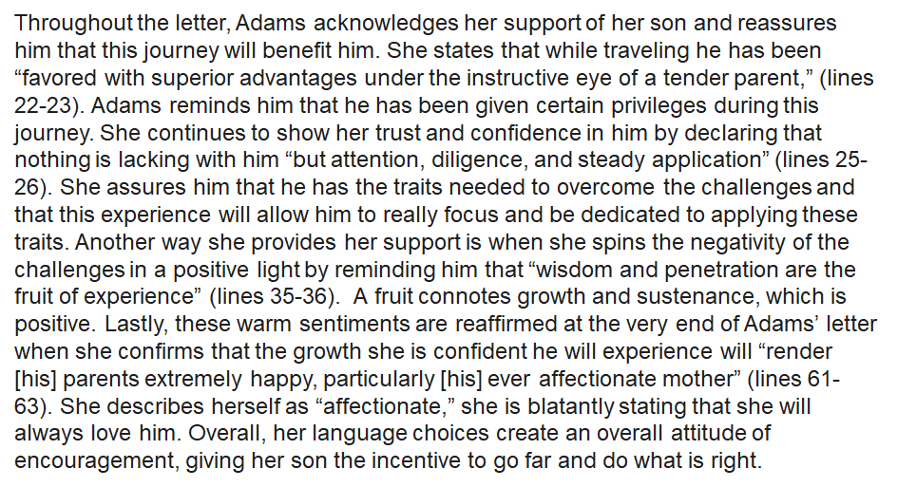

Tips for Writing Commentary Reflecting Rhetorical Situation
1.State your example.
2.Explain your example.
3.Analyze for writer.
4.Analyze for audience.
5.Describe why it is persuasive.

TASK TWO:
Compose additional commentary that provides a more complex understanding of the rhetorical situation.

Throughout the letter, Adams acknowledges her support of her son and reassures him that this journey will benefit him. She states that while traveling he has been “favored with superior advantages under the instructive eye of a tender parent,” (lines 22-23). Adams reminds him that he has been given certain privileges during this journey. ________________________________ _______________________________________________________________________________________________________________________________________________________________________________________________________________________________________________________________________________________________________________________She continues to show her trust and confidence in him by declaring that nothing is lacking with him “but attention, diligence, and steady application” (lines 25-26). She assures him that he has the traits needed to overcome the challenges and that this experience will allow him to really focus and be dedicated to applying these traits. ________________________________________ _______________________________________________________________________________________________________________________________________________________________________________________________________________________________________________________________________________________________________________________Another way she provides her support is when she spins the negativity of the challenges in a positive light by reminding him that “wisdom and penetration are the fruit of experience” (lines 35-36). A fruit connotes growth and sustenance, which is positive. _______________________ _______________________________________________________________________________________________________________________________________________________________________________________________________________________________________________________________________________________________________________________Lastly, these warm sentiments are reaffirmed at the very end of Adams’ letter when she confirms that the growth she is confident he will experience will “render [his] parents extremely happy, particularly [his] ever affectionate mother” (lines 61-63). She describes herself as “affectionate,” she is blatantly stating that she will always love him. ___________________________________ _________________________________________________________________________________________________________________________________________________________________________________________________________________________________________________________________________________________________________________Overall, her language choices create an overall attitude of encouragement, giving her son the incentive to go far and do what is right.

