[Christiana.helgeson@acboe.net](mailto:Christiana.helgeson@acboe.net)

[Susan.fedusenko@acboe.net](mailto:Susan.fedusenko@acboe.net)

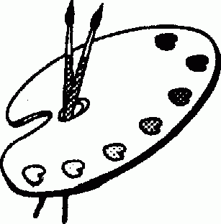

**Art Classroom Rules and Expectations**

1. ALWAYS be in your seat when the tardy bell stops ringing.
2. ALWAYS work quietly within the classroom.
3. ALWAYS clean up after yourself and be responsible for your work area.
4. ALWAYS come prepared for class.
5. ALWAYS put materials back in the proper place.
6. ALWAYS work only on art assignments and use your time wisely.
7. ALWAYS be respectful to others and their artwork.
8. ALWAYS be respectful of our school.

**Grading Policy**

1. Major tests and quizzes will be announced in advance. Point value will vary according to material.
2. The art student is responsible for all class notes given. Notes will be kept in the sketchbook along with the weekly sketchbook assignments.
3. Students who are absent are responsible for missed class assignments.
4. All class assignments are due on the day of the critique. Critique days will be announced ahead of time.
5. Any student with an excused absence will be allowed extra time to complete the art assignment, however this will be done before or after school.
6. Late Projects: 10 points will be deducted from the final project grade for every day late. After day 3 the project will be a zero.
7. Grades for this course will be determined as follows:

65% Projects/ Critiques

20% Daily Work

10% Sketchbook

5% Art History

Art 2 is designed to address the needs of students with Level 1 visual arts experience. These students require concrete experiences that provide direction and advanced skill development. As they continue to learn the visual language & understand the significance of artistic symbolism, focus on the production of visual relationships; the exploration of techniques, processes, and media; and the study of history, culture, aesthetics, and criticism. Students in Level 2 may be considering visual arts as a possible career option.

Mrs. Helgeson & Mrs. Fedusenko

**PHS Art II Syllabus**

**Supplies are due:** _________________

**ALL** students are required to bring **ALL** supplies by the due date. It is impossible to create any art assignment without the necessary supplies. Failure to bring supplies will result in disciplinary actions.

**Required art supplies**

**Art fee $25.00 due: ________________**

**Pencil Set (needed for every class)**

**Crayola markers (set of 24 or more)**

**Black Sharpies (4 fine & 4 ultra-fine)**

**2 Pink Pearl eraser**

**2 sheets of 28x22 poster board**

**1 bottle of hand soap**

**1 container of Clorox wipes**

***Prisma* Color Pencils (set of 48 or larger, purchased by December)**