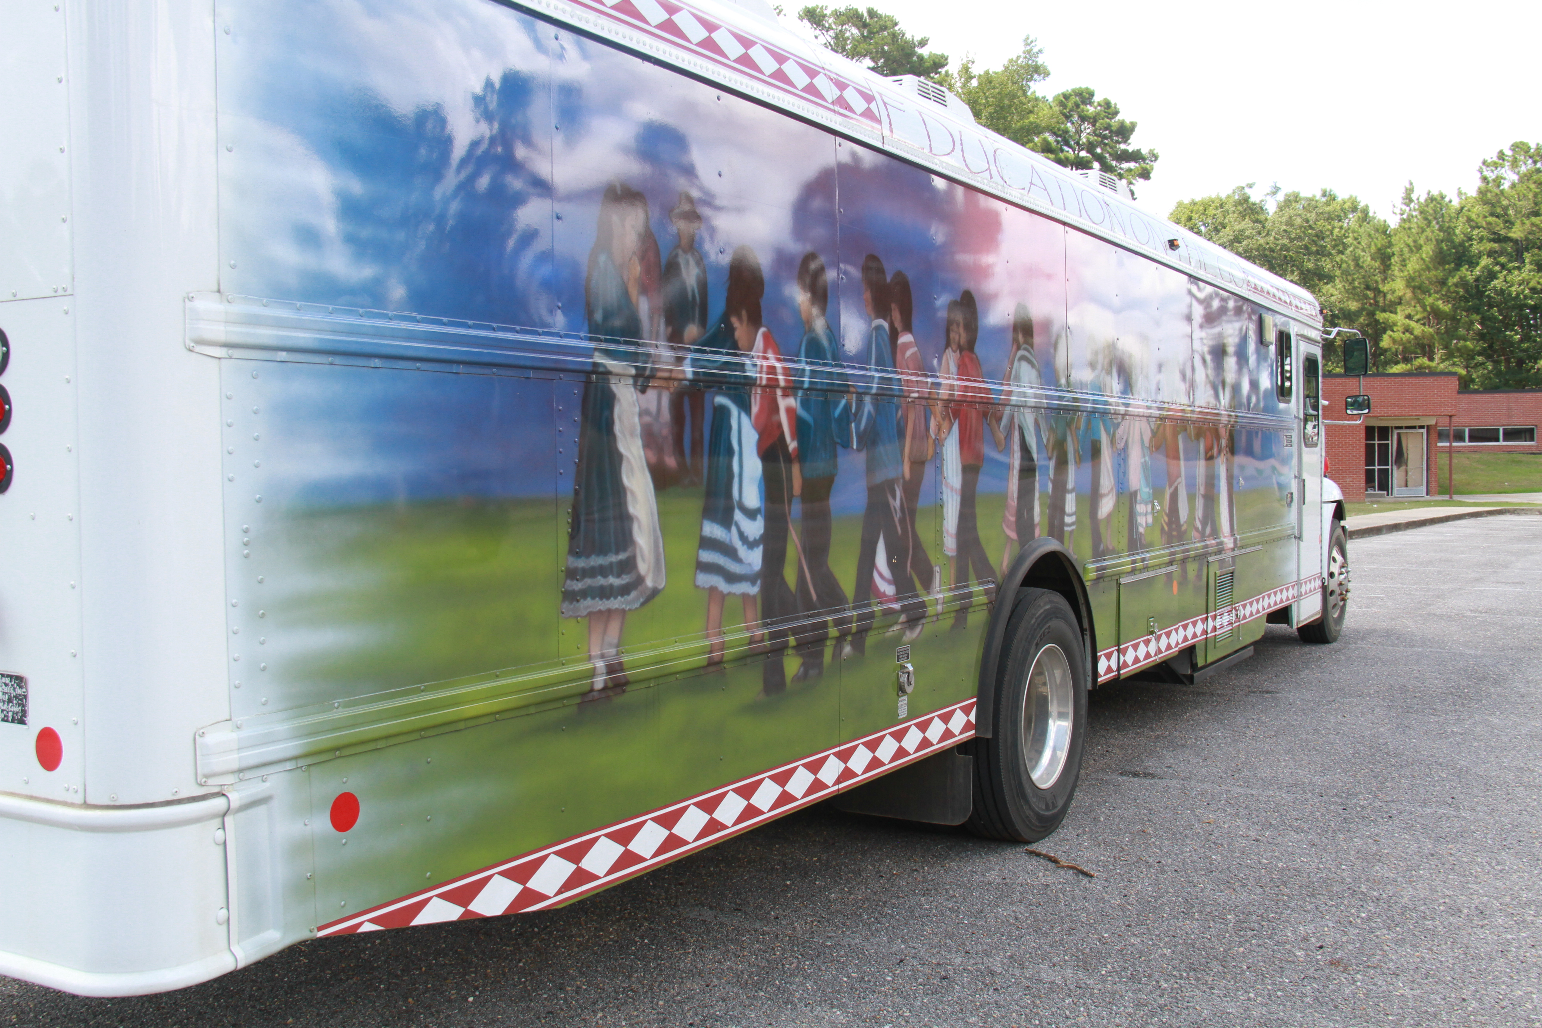
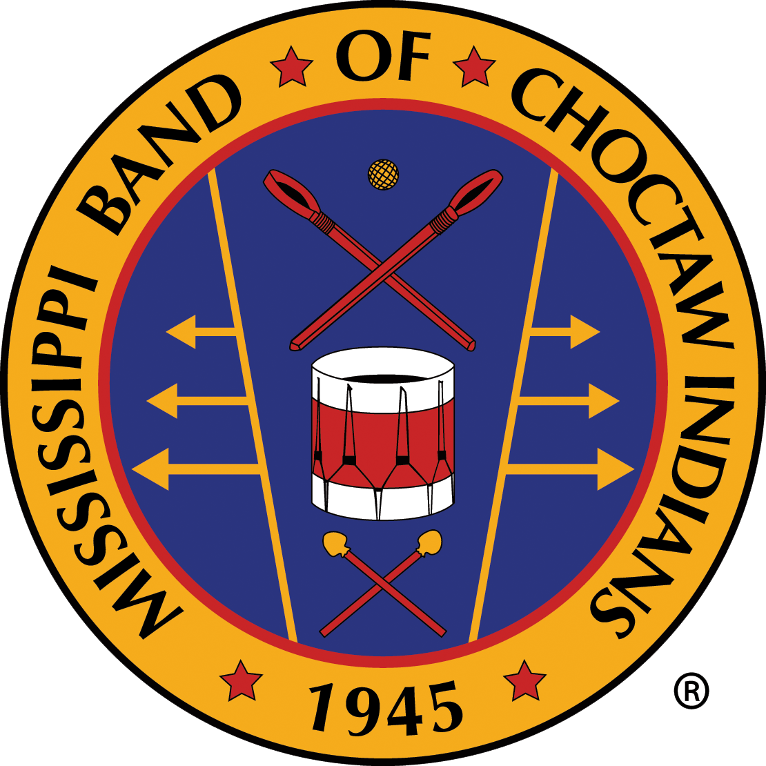
------------------------------------

Because we care, we’re still here
-------------------------------------

Choctaw Tribal Schools
essay contest
TOPIC  The Choctaw people have lived here for centuries and overcome many hardships to become the strong Tribe it is today. Now, with the COVID-19 virus, Choctaw Tribal Members face a new challenge.  In a maximum of 250 words, describe how you are staying healthy, strong and keeping the Choctaw spirit and traditions alive during this time of pandemic.  Competition Levels  5th – 6th Grade - Group A  7th – 8th Grade – Group B  11th – 12th Grade – Group C  Three winners per group with an overall winner to be selected. | OVERALL WINNER will be featured in State of the Tribe Annual Report distributed during Thanksgiving Feast activities as well as MBCI & CTS Social Media and Web Pages. Overall winner will be selected from the group of first place finishers.  FIRST PLACE:  $150  Featured in MBCI & CTS Social Media and Websites  SECOND PLACE:  $100  Featured in MBCI & CTS Social Media and Websites  THIRD PLACE:  $50  Featured in MBCI & CTS Social Media and Websites

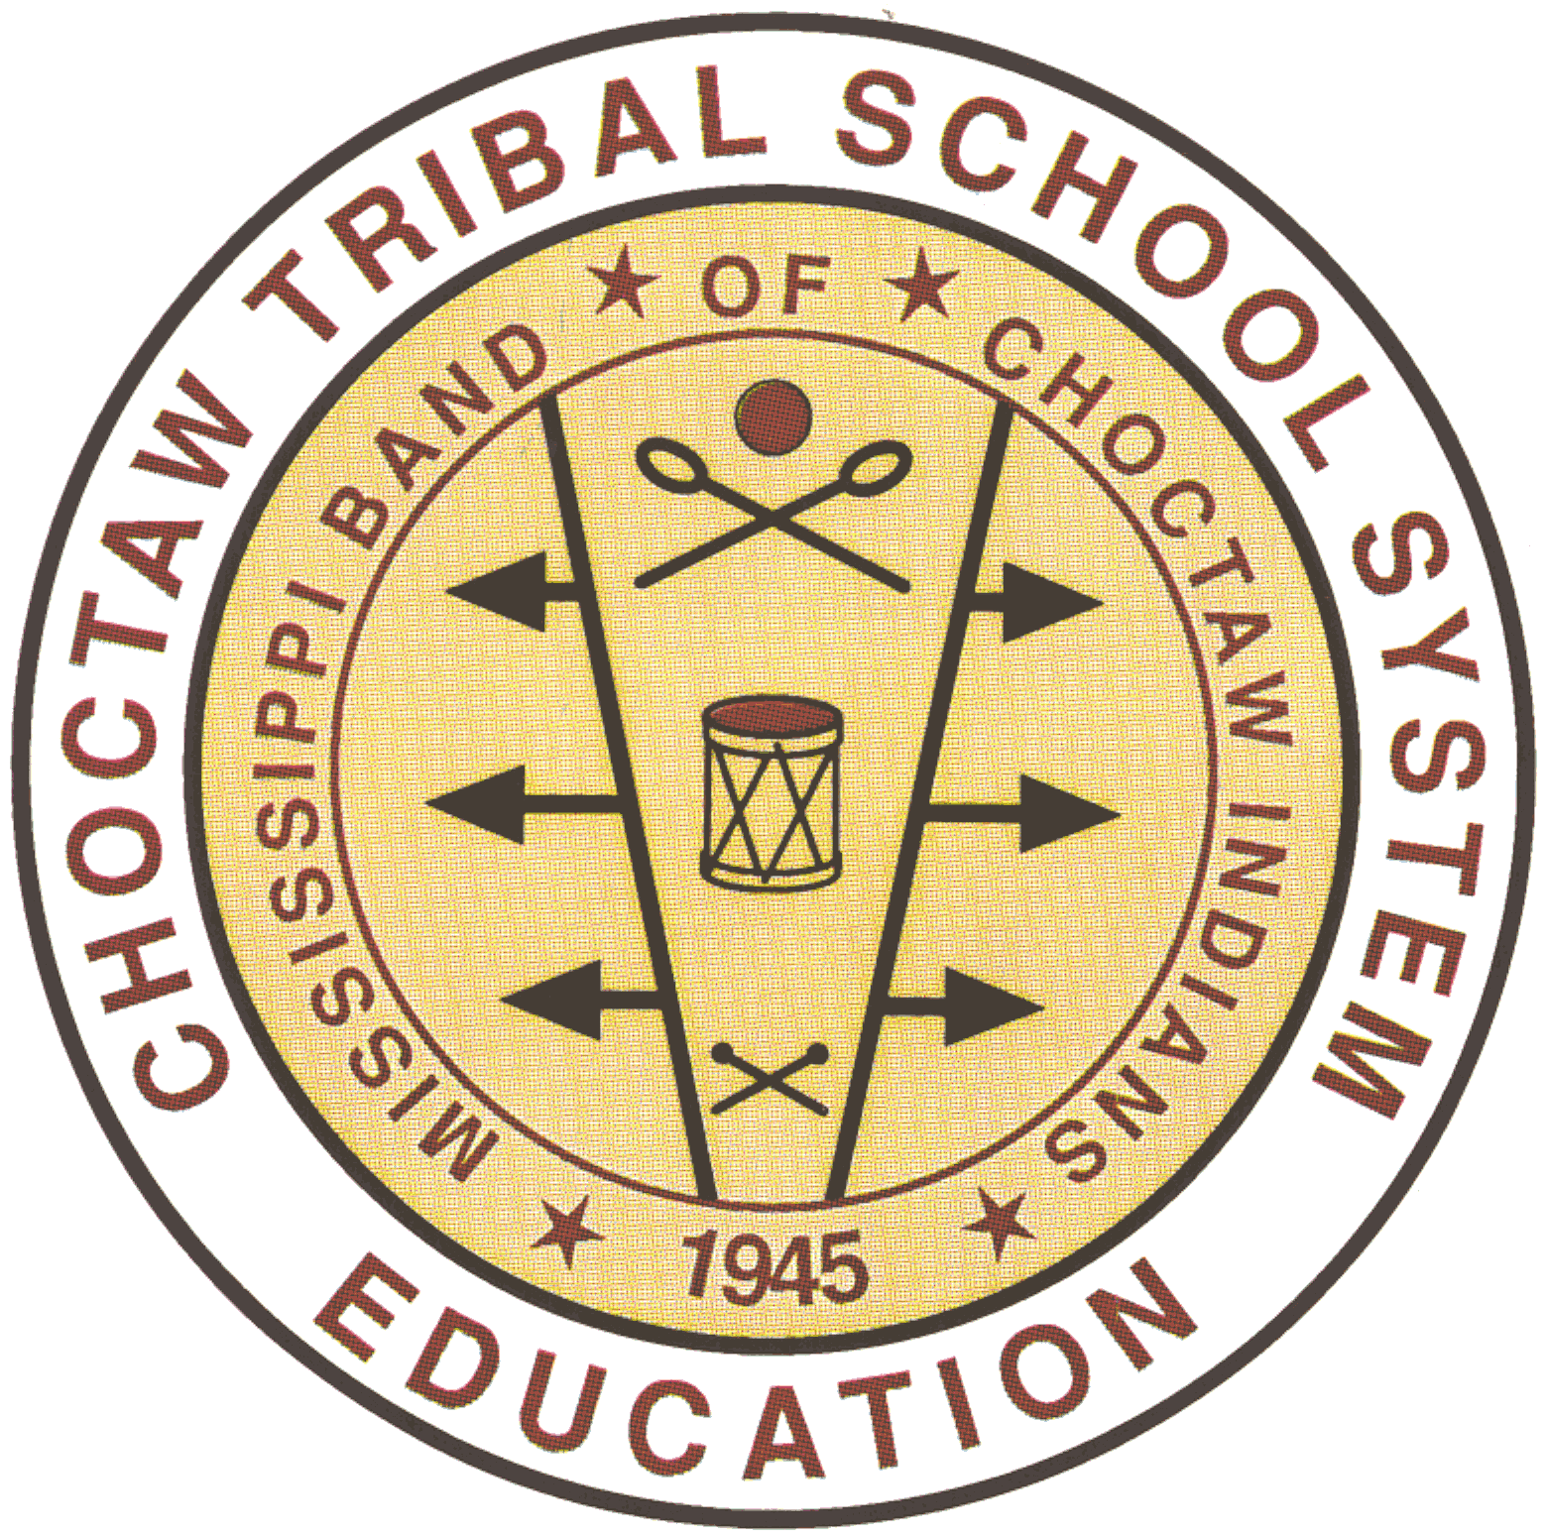  Deadline for Submission:  Friday, October 16, 2020 | ESSAY TITLE  STUDENT NAME  HOMEROOM TEACHER  SCHOOL  PARENT/ GUARDIAN NAME

Essay Contest Rules
1. Essay should be a maximum of 250 words, for students that would like to participate.
2. The overall theme for the essay is “Because We Care, We’re Still Here.”
- The student must describe their experience in staying healthy and strong in mind, body and spirit during COVID-19.
- How has COVID-19 impacted your life personally?
- How have you kept the Choctaw spirit alive and why is it important to respect traditions during times of hardships?
3. The essay must reflect the ideas, vocabulary, and efforts of the student acting alone.
4. Adult participation is limited to proofreading and typing the final product.
6. Essay will be judged on originality, adherence to the assigned topic, concrete ideas, and correctness of grammar, spelling, and punctuation.
7. The first-place essays from each group will be judged for an overall winner to be featured in the State of the Tribe Report.
8. A first, second and third place winner will be selected. Winners will receive $150, $100 and $50 respectively.

Essay# __________
1. Maximum of 250 words | Yes |  | No
2.Writing Task: Did they address the theme and meet writing prompt? | Yes |  | No
3. Student generated (adults may proof read/type only) | Yes |  | No
4. Completed entry form (page 2 of this document) | Yes |  | No
- A. Title | Yes |  | No
- B. Name of Student | Yes |  | No
- C. Name of Teacher | Yes |  | No
- D. Name of School | Yes |  | No
Judging Criteria | Points Earned
1. Originality (possible 40 pts) ________

2. Adherence to assigned topic (possible 20 pts) ________

3. Concrete ideas (possible 20 pts) ________

4. Correctness of grammar,
spelling, punctuation (possible 20 pts) ________
Total Points (possible 100 pts) ________

