January 14, 2020
Superintendents’ Workshop
Central Junior High, East Peoria, IL
8:30 – 10:30

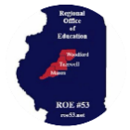
Agenda
8:00 Doors open for coffee and networking
8:30 to 10:30
- Jay Greening
- Jason Hawksworth & Ken Zika
- Rob Houchin
- ROE#53 Updates
  - Jeff Ekena
  - Jon Smith
  - Courtney Lyons
  - Pat Durley

Mandated Trainings
- Mandated Trainings for Professional Development- Representatives of IARSS, the Illinois Principals Association, and ISBE recently met to discuss using mandated trainings for professional development. After careful review, medical and health-related mandated trainings will generally be ineligible for professional development because they do not align to the standards required for PD that center around student learning and school improvement. However, if a provider chooses to increase the content and robustness of a course in order to align to the required standards, the course can be used for professional development. We will be releasing a guidance document created by this group soon, and I will email to you at that time. Thank you to the members of IARSS who contributed to this discussion and guidance document!
- 73-58 Document

PEAC / PERA
- Principal Evaluation coming in March.
  - 1865 Pre-work now added to initial work

Admins Academies to meet Retraining Requirements
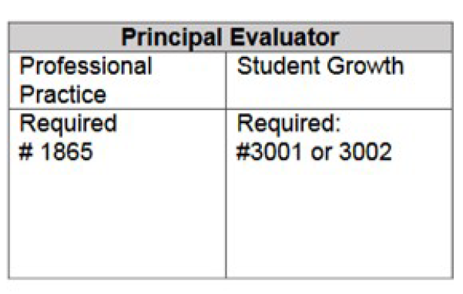

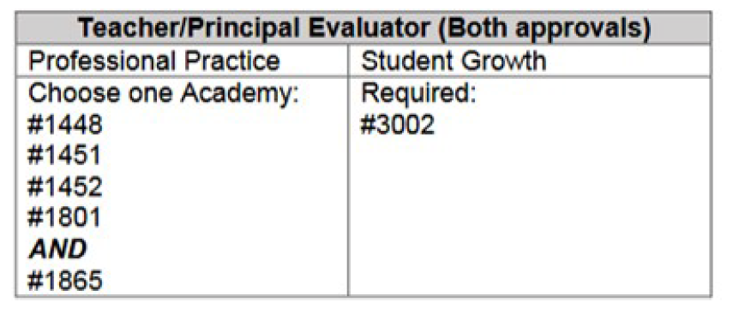

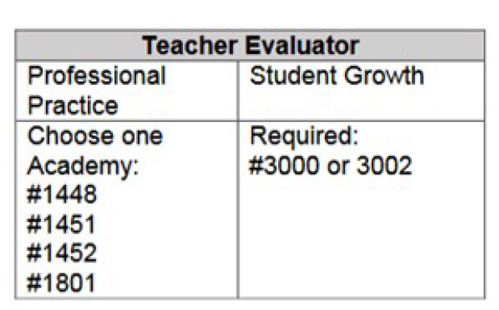

Health Life Safety
- Rob Houchin
- Ron Folwer retiring
- What does this mean?

Parapro Legislation is Signed

- reinstates the ETS Paraprofessional test and WorkKeys (coupled with a high school diploma) as options to earn the ELS-PARA license.
- ISBE issued 155 paraprofessional licenses retroactively

Equitable Restrooms Act

- Flexibility in Language “All Gender” for signs
- Brian Cox
  - Department of Public Health – Plumbing & Quality Water Program
  - Brian.Cox@illinois.gov
  - 217-524-0791.
(c) Notwithstanding any other provision of law, every single-occupancy restroom in a place of public accommodation or public building shall be identified as all-gender and designated for use by no more than one person at a time or for family or assisted use. Each single-occupancy restroom shall be outfitted with exterior signage that marks the single-occupancy restroom as a restroom and does not indicate any specific gender.

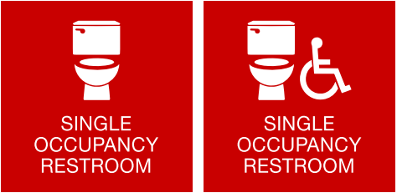

Credit: MTHS & Simply Signs & Screen-printing
Seclusion Rooms
- MOORE BARBARA <BMOORE@isbe.net>
- In School Suspension is a disciplinary action and is neither isolation or seclusion.
- A sensory break is not a time out. Neither is sitting outside an office waiting to see someone.

MAP21
- most likely delayed
- https://www.isbe.net/Documents/MAP-21-Guidance.pdf
- FAQ is from an outside site (non-ISBE)
  - Indicates 2022
  - https://www.schoolbusfleet.com/article/734090/20-questions-and-answers-on-map-21

At recent ISBE Board meeting, names changed to designations
    - Lowest performing = Eligible for Comprehensive Support
    - Underperforming = Eligible for Targeted Support

School board resignation update: 60 Math Gordon email

Short term sub
Training Documents - https://www.isbe.net/Pages/Short-Term-Sub-Teach.aspx
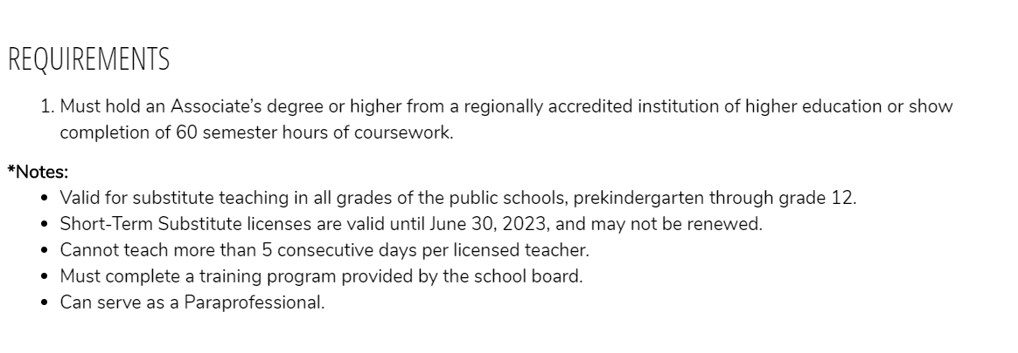

Changes to Highly Qualified Section in ELIS
- On April 1, 2020, all highly qualified records in ELIS will be archived
- “Highly qualified” no longer carries any meaning under ESSA;
- Educators are instead required to meet state licensure requirements for their positions.
- They may screenshot their “Highly Qualified” page or print it.

30-day district calendar

Thank you for your leadership!

Topics for discussion:
- Paying Student Teachers
- ISBE Proposed Rules

