Vocabulary Project Options:

Choose ONE of the following ways to create your vocabulary packet. You can mix and match options if you so choose (but I am not sure how effective this method will be in order for you to remember the words), BUT each word MUST BE defined in context or illustrated in order to get credit. Please make sure to label the chapters you are doing on your pages. These can be done on white copy paper OR colored paper OR notebook paper. Just make sure that I can read the words or fully see the illustration. The vocab word MUST be visible on each page. You may use the back if you so choose.

Option 1: Illustrate EACH vocabulary word. Make sure that the picture represents the definition of the word whether it be the dictionary definition or the context definition (I prefer context definition because dictionary definition may not fit the context of the word usage). See example below:

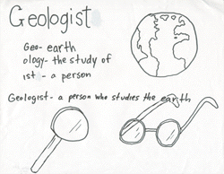

2. Make a colorful list of words (similar to what we did with Night, but you could use colored paper OR colored pens to make it more appealing). You can divide the words into parts or chapters. You will need to define these words in context and include the page number where the word is found. Please include at least two synonyms and antonyms for each word.

3. Make flash cards that include the word on one side and the definition (dictionary and context) as well as synonyms and antonyms on the back of the card. You could also include a small illustration or word clue to help you remember the word.

