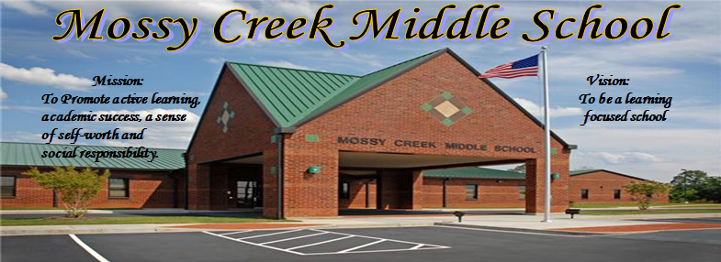

***Key Actions (1-3 years)***

|  |  |  |
| --- | --- | --- |
| *Actions to be Taken* | *Related Goal* | *Timeline* |
| Develop assessments based on state standards and that they measure a student’s mastery of those standards. Design lesson plans based on state standards that meet a student’s individual needs and that are challenging to each student.  Create an instructional program that will meet the individual needs of all students based on data collection, progress monitoring and common assessments.  Students will be provided an organized reading instruction based on lexiles to achieve growth in all content areas. | Goal 1  Goal 1  Goal 1  Goal 1 | 2016-17  2016-17  2016-17  2016-17 |
| Create a STEM/Problem-Based Learning program that will provide opportunities for community and stakeholder partnerships.  Ensure communication with the stakeholders through many platforms to develop community relationships and partnerships.  Facilitate a shared-decision making culture for all stakeholders through continuous collaboration Create community involvement through various activities. | Goal 2  Goal 2  Goal 2  Goal 2 | 2016-17  2016-17  2016-17  2016-17 |
| Ensure the training and mentoring of new staff members  Create a school calendar that is communicated on a daily basis to the staff through morning emails, grade level meetings and faculty meetings on a monthly basis.  Utilize the Gator Good program to create a positive learning environment and safe school climate for the students and teachers.  Ensure students are taught how to use organizational tools to create a college and career ready student.  Facilitate financial stability through a school budgeting process used to support instruction and achievement. | Goal 3  Goal 3  Goal 3  Goal 3  Goal 3 | 2016-17  2016-17  2016-17  2016-17 |
| Maintain an embedded professional learning plan based on staff needs, interest, and best practices.  Develop professional learning for support staff.  Provide opportunities for teacher led professional learning.  Create professional Learning Communities within the school to increase the collaboration and support within the school setting. | Goal 4  Goal 4  Goal 4  Goal 4 | 2016-17  2016-17  2016-17  2016-17  2016-17 |
| Click here to enter text. | Click here to enter text. | Click here to enter text. |
| Click here to enter text. | Click here to enter text. | Click here to enter text. |
| Click here to enter text. | Click here to enter text. |  |
| Click here to enter text. | Click here to enter text. |  |
| Click here to enter text. | Click here to enter text. |  |
| Click here to enter text. | Click here to enter text. |  |
| Click here to enter text. | Click here to enter text. |  |
| Click here to enter text. | Click here to enter text. |  |

***2016-2017 College and Career Readiness Targets***

1 .CCRPI Overall Score for 2014-2015 **80.5**

2. Percent of students passing EOG in all subjects

ELA –

Math-

Science-

SS-

3. Growth percentile for 2015—2016

**55% typical or high growth**

***Long Range Goals***

1. Ensure high quality instruction aligned with state standards

2. Provide opportunities for stakeholder engagement

3. Plan, implement and monitor process and procedure for organizational effectiveness.

4. Build capacity for continuous improvement PLCs.

5. Implement STEAM in all three grade levels – STEM certification.

***Our Beliefs***

A welcoming, safe and orderly environment is key to teaching and learning

Appropriate, rigorous learning and success are achieved through differentiated instruction.

Enhancing self-esteem, self-motivation, responsibility, work ethic and good citizenship are essential to success.

On-going professional learning through collaboration is vital to high quality instruction.

***Strengths***

1. Promotion of high academic success and student self-worth

2. Positive school climate and family culture

3. Commitment to school improvement

***External Challenges***

1. Financial stability

2. Low growth of student population

3. Teacher stress and morale

***Opportunities for Growth***

1. Integration of all content areas

2. Meeting high academic success through STEM

3. Increase in student reading abilities for fiction and non-fiction