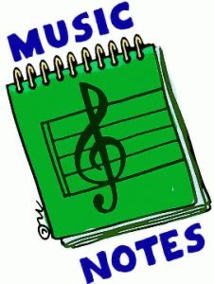
Week of:
APR. 13-Apr. 17
4/13: Our integrity word this week is Yes! Lots of times when we say yes, we clap our hands because we agree with what someone says. So this week see if you can keep the beat with our integrity song of the week, “Handclap”
4/14: Watch “The Music in Me”
4/15: Let’s have a “Shake Break” with Jack Hartman
4/16: Let’s play the “Freeze Dance” with The Kiboomers
4/17: Let’s Dance and Sing to our fun song Friday tune, “Trolls Wanna Have Fun” from the new Netflix movie “Trolls World Tour” that came out April 10. Check it out!

