Monday, March 30 Today is Vincent Van Gogh's Birthday

Watch the biography on Vincent Van Gogh: https://youtu.be/vBLvusSwHRk

Watch an artist create a 3-D illusion of Starry Night 3D Painting Starry Night
https://youtu.be/Woc0GZkDa7k

Who was Vincent Van Gogh?
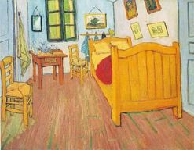 | - Occupation: Artist, Painter  - Born: March 30, 1853 in Zundert, Netherlands  - Died: July 29, 1890 in Auvers-sur-Oise, France age 37  - Famous works: Starry Night, The Bedroom, Irises, Sunflowers  - Style/Period: Post-impressionist, Modern Art

Where did Vincent van Gogh grow up?
Vincent van Gogh was born in the Netherlands in 1853. Vincent had two brothers and three sisters. He was closest to his younger brother Theo.

Although he enjoyed drawing from the time he was a young boy, Vincent had a number of other jobs before he decided to work as an artist full time. He worked as a teacher in London and then as a minister. At around the age of 27, van Gogh decided to devote himself completely to art.

Early Years
In this early part of his career, van Gogh used a lot of dark colors such as browns and dark greens. His pictures were often somber or sad. His most famous early painting was called The Potato Eaters. It was a dark picture of a peasant family eating potatoes for dinner.

Letters to His Brother
Much of what we know about van Gogh comes from letters he wrote to his brother Theo. Theo worked in an art gallery in Paris and supported Vincent's art career. He sent Vincent money and encouraged him. Theo tried to sell Vincent's paintings, but no one wanted to buy them.

Years in Paris
Theo wrote to Vincent to tell him about a new style of painting in Paris called Impressionism. In 1886 Vincent moved to Paris to learn from these new painters. His art became influenced by painters such as Claude Monet, Edgar Degas, and Camille Pissarro. He also became good friends with artist Paul Gauguin.

During this time van Gogh began to use brighter colors. He painted subjects from the streets and cafes of Paris as well as the countryside. Van Gogh also became interested in painting portraits of people. When he couldn't find models, he would paint himself for practice. He painted over twenty self portraits during this time.

Arles, France
In 1888 van Gogh moved south to Arles, France to start up an artist's commune.
Van Gogh began painting with intensity and emotion. The colors in his paintings became more vibrant and bright. He would sometimes apply the paint directly onto the canvas from the tubes leaving the paint thick with rough brush strokes. Sometimes it would take weeks for his paintings to dry because the paint was so thick.

Vincent painted hundreds of pictures during this time, sometimes painting masterpieces in a single day. He became fully obsessed with art. Paul Gauguin came to visit for a time, but the two artists had an argument and Gauguin soon left.

Mental Hospital
In 1889 van Gogh committed himself to a mental hospital. He could barely take care of himself. He still continued to paint and painted one of his most famous paintings Starry Night. Many of his paintings during this time featured cypress trees and lots of swirling colors.

Van Gogh's mental state continued to deteriorate. On July 29, 1890 he died from a self-inflicted bullet wound to the chest.

Legacy
Although he wasn't famous during his lifetime, today he is considered one of the greatest and most influential artists of his time. Many of his paintings sell for millions of dollars today. There are over 800 surviving oil paintings as well as over a thousand watercolors and sketches of his work.

Did he really cut off his ear?
Yes. After an argument with painter Paul Gauguin, van Gogh went home and cut off part of his left ear with a razor blade. He then wrapped up the ear in a cloth and presented it to a woman as a "present".

Interesting Facts about Vincent van Gogh
- He would get so obsessed with painting that he often wouldn't eat. He had poor health as a result.
- Van Gogh was influenced by Japanese prints and woodcuts which he studied intensely.
- Some people think that he may have only sold one work during his lifetime. It was called The Red Vineyard.
- His brother Theo died six months after Vincent and was buried next to him.
- In some of his self portraits his ear is bandaged from when he cut it. It looks like his right ear in the pictures because he was using a mirror to paint himself.
- You can see the painting Starry Night at the New York Museum of Modern Art.

Tuesday, March 31, 2020

Understanding the 7 Elements of Art

The Element of Line

Watch the following video: https://youtu.be/Es1QYp7XVW4

Line An element of art defined by a point moving in space. Line may be two-or three-dimensional, descriptive, implied, or abstract.

The Visual Element of Line is the foundation of all drawing. It is the first and most versatile of the visual elements. Line in an artwork can be used in many different ways. It can be used to suggest shape, pattern, form, structure, growth, depth, distance, rhythm, movement and a range of emotions.
We have a psychological response to different types of lines:
- Curved lines suggest comfort and ease
- Horizontal lines suggest distance and calm
- Vertical lines suggest height and strength
- Jagged lines suggest turmoil and anxiety
The way we draw a line can convey different expressive qualities:
- Freehand lines can express the personal energy and mood of the artist
- Mechanical lines can express a rigid control
- Continuous lines can lead the eye in certain directions
- Broken lines can express the ephemeral or the insubstantial
- Thick lines can express strength
- Thin lines can express delicacy
Create a drawing with as many different kinds of lines that you can think of.

Wednesday, April 1st
What is Op Art?

Watch this video and find out: https://youtu.be/2Y-qLhOK9Gg

Look at the step-by-step instructions below and make the optical illusion.

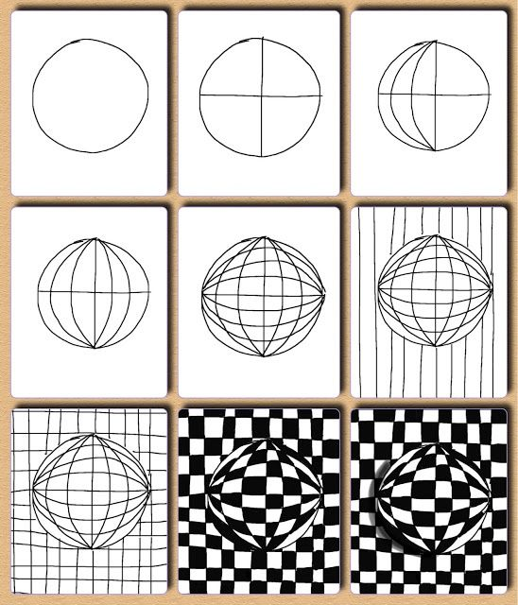

Thursday, April 2nd
Op art wave illusion

Watch the video and draw the optical illusion. https://youtu.be/98OrhVDGlWA

Draw the illusion below.
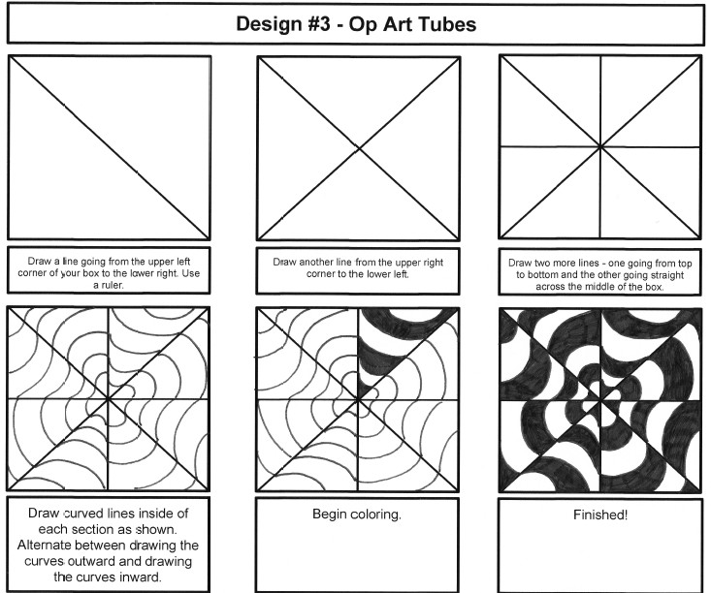

Friday, April 3rd
Happy Friday

Draw one of these op art illusions: https://youtu.be/pNskHdOs7XE

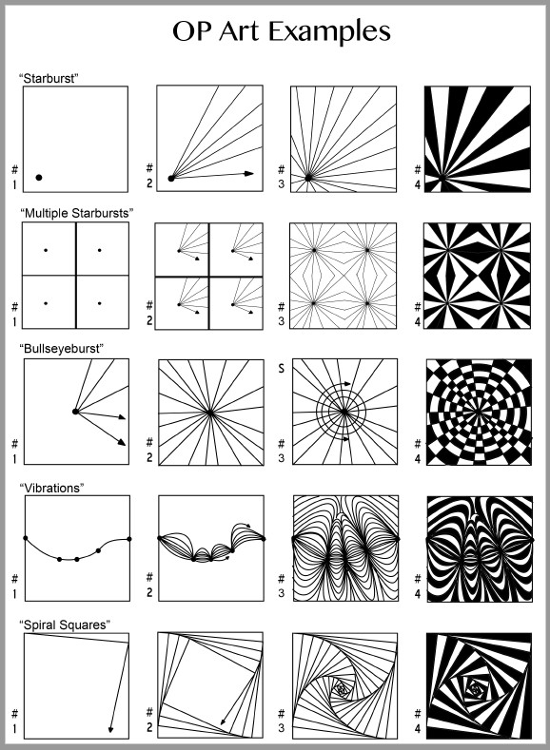

Optional Online fun for the week of Spring Break:

Art Teacher Cassie Stephens - Robot Week
(Learn some sign language too)
https://youtu.be/IC7pCZTvXX0

Make a Collagraph Robot
https://youtu.be/0-mI4vuYNNA

Printing robots
https://youtu.be/t0L9Twq0Q1A

Robot Collage
https://youtu.be/vL9Pa31h1yQ

3-D Robot Drawing
https://youtu.be/GqCQCG8BsdA

