Have you ever stopped to think about the history of your furry little canine pal? The dog, which is known in the scientific community as Canis lupus familiaris, is currently the most abundant carnivore on land. These creatures come in many shapes and sizes, and they can be found in countries all over the world. Dogs were also the first species to be tamed by man; the human-canine bond goes back 15,000 years. However, scientists are still debating about the history and evolution of dogs and the timeline of these animals’ domestication. But here’s what we know so far.
Where did dogs originate?
We know dogs evolved from wolves, and researchers and geneticists have extensively studied canines to try and pin down the exact moment in history when the first dog walked the Earth.
Archaeological evidence and DNA analysis make the Bonn-Oberkassel dog the first undisputed example of a dog. The remains, a right mandible (jaw), were discovered during basalt quarrying in Oberkassel, Germany in 1914. First mistakenly classified as a wolf, the Bonn-Oberkassel dog was buried with two humans around 14,220 years ago.
However, there are other theories that suggest dogs may in fact be older. For example, many experts agree that dogs started to separate from wolves starting around 16,000 years before present in Southeastern Asia. The progenitors of the dogs we know and love today may have first appeared in the regions of modern-day Nepal and Mongolia at a time when humans were still hunter-gatherers.
Additional evidence suggests that around 15,000 years ago, early dogs moved out of Southern and Central Asia and dispersed around the world, following humans as they migrated.
Hunting camps in Europe are also thought to be home to canines known as Paleolithic dogs. These canines first appeared some 12,000 years ago and had different morphological and genetic features than the wolves found in Europe at the time. In fact, a quantitative analysis of these canine fossils found that the dogs had skulls similar in shape to that of the Central Asian Shepherd Dog.
Overall, while the Bonn-Oberkassel dog is the first dog we can all agree was in fact a dog, it’s possible dogs are much older. But until we uncover more evidence, it will be difficult to know for sure exactly when dogs completely separated from their wolf ancestors.

When did dogs first become pets?
There’s even more dispute about the timeline of the history of dogs and humans. What most scientists and canine geneticists agree on is that dogs were first tamed by hunter-gatherers between 9,000 and 34,000 years ago, which is such a wide timeframe that it’s hardly useful.
More recent studies suggest humans may have first domesticated dogs some 6,400-14,000 years ago when an initial wolf population split into East and West Eurasian wolves, which were domesticated independently of each other and gave birth to 2 distinct dog populations before going extinct.
This separate domestication of wolf groups supports the theory that there were 2 domestication incidents for dogs.
Dogs that stayed in East Eurasia may have been first tamed by Paleolithic humans in Southern China, while other dogs followed human tribes further west to European lands. Genetic studies have found that the mitochondrial genomes of all modern dogs are most closely related to the canids of Europe.
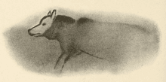
Studies have also reported that the dog’s domestication was heavily influenced by the dawn of agriculture. Evidence for this can be found in the fact that modern dogs, unlike wolves, have genes that allow them to breakdown starch. (1)

The origins of the human-canine bond
The bond between humans and dogs have been extensively studied due to its unique nature. This special relationship can be traced all the way back to when humans first started living in groups.
An early domestication theory suggests that the symbiotic, mutualistic relationship between the two species started when humans moved into colder Eurasian regions.
Paleolithic dogs first began to appear at the same time, developing shorter skulls and wider braincases and snouts compared to their wolf ancestors. The shorter snout eventually led to fewer teeth, which may have been the result of humans’ attempts to breed aggression out of dogs.
Ancestors of the modern dog enjoyed plenty of benefits from living around humans, including improved safety, a steady supply of food, and more chances to breed. Humans, with their upright gait and better color vision, also helped in spotting predators and prey over a larger range. (2)
It has been hypothesized that humans in the early Holocene era, around 10,000 years ago, would have chosen wolf puppies for behaviors like tameness and friendliness towards people.
These puppies grew to be hunting companions, tracking and and retrieving wounded game as their human packs settled in Europe and Asia during the last Ice Age. The dog’s heightened sense of smell greatly assisted in the hunt, too.

Aside from helping humans hunt, dogs would have proved useful around the camp by cleaning up leftover food and huddling with humans to provide warmth. Australian Aborigines may have even used expressions such as “three dog night”, which was used to describe a night so cold that three dogs would be needed to keep a person from freezing. (3)
These early dogs were valued members of forager societies. Considered superior to other types of dogs back then, they were often given proper names and considered part of the family. (4)
Dogs were often used as pack animals, too. Some studies suggest that domesticated dogs in what is now Siberia were selectively bred as sled dogs as early as 9,000 years ago, helping humans migrate to North America.
The weight standard for these dogs, 20 to 25 kg for optimum thermo-regulation, is found in the modern breed standard for the Siberian Husky. (5)
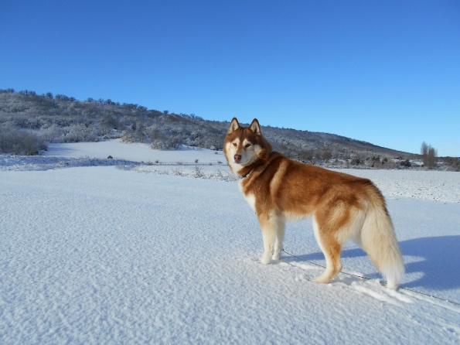
snow dog pet mammal vertebrate siberian husky inuki dog like mammal saarloos wolfdog wolfdog czechoslovakian wolfdog dog breed group greenland dog east siberian laika west siberian laika norwegian lundehund
While it may seem like humans valued dogs in a merely utilitarian sense, studies suggest that humans have formed emotional bonds with their canine companions since the late Pleistocene era (c. 12,000 years ago)..
This is evident in the Bonn-Oberkassel dog, which was buried with humans even though humans had no practical use for dogs in that particular period.
The Bonn-Oberkassel dog would have also required intensive care for survival, as pathology studies hypothesize that it suffered from canine distemper as a puppy. All these suggest the presence of symbolic or emotional ties between this dog and the humans with which it was buried.
No matter the exact history of dogs’ domestication, dogs have learned to adjust to human needs. Dogs became more respectful of social hierarchies, recognized humans as pack leaders, became more obedient compared to wolves, and developed skills to effectively inhibit their impulses. These animals even adjusted their barking to communicate with humans more efficiently.

