©2018 lead4ward Source: Texas Education Agency STAAR™ Released Test Questions Created on 02.28.19 2/8

Organism Growth and Cell Differentiation
B.5 Science concepts. The student knows how an organism grows and the importance of cell differentiation.

IQ Analysis | Investigating the Question | B.5(A) |  |  |  |  | RC 1
Units
B.5(A) describe the stages of the cell cycle, including deoxyribonucleic acid (DNA) replication and mitosis, and the importance of the cell cycle to the growth of organisms |  | Analysis of Assessed Standards
2018 – Q19  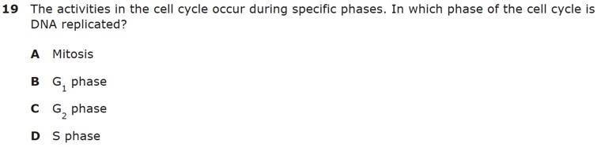 |  | Cluster |  | Organism Growth and Cell Differentiation
 |  | Subcluster |  | Cell Cycle
 |  | Content |  | Readiness
 |  | Process
 |  | Stimulus
 |  | Data Analysis
 |  | Item | State | Local | Error Analysis  ▢ Guessing  ▢ Careless Error  ▢ Stopped Too Early  ▢ Mixed Up Concepts
 |  | A
 |  | B
 |  | C
 |  | D
 |  | Learning from Mistakes Instructional Implications

B.5(A) describe the stages of the cell cycle, including deoxyribonucleic acid (DNA) replication and mitosis, and the importance of the cell cycle to the growth of organisms | Analysis of Assessed Standards
2018 – Q46  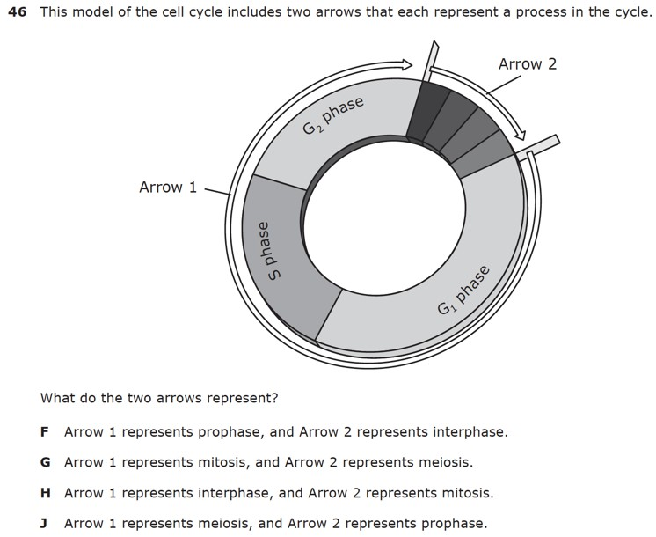 | Cluster |  | Organism Growth and Cell Differentiation
 | Subcluster |  | Cell Cycle
 | Content |  | Readiness
 | Process |  | B.2(G)
 | Stimulus
 | Data Analysis
 | Item | State | Local | Error Analysis  ▢ Guessing
 | F |  |  | ▢ Careless Error  ▢ Stopped Too Early  ▢ Mixed Up Concepts
 | G
 | Learning from Mistakes Instructional Implications

B.5(A) describe the stages of the cell cycle, including deoxyribonucleic acid (DNA) replication and mitosis, and the importance of the cell cycle to the growth of organisms | Analysis of Assessed Standards
2017 – Q7  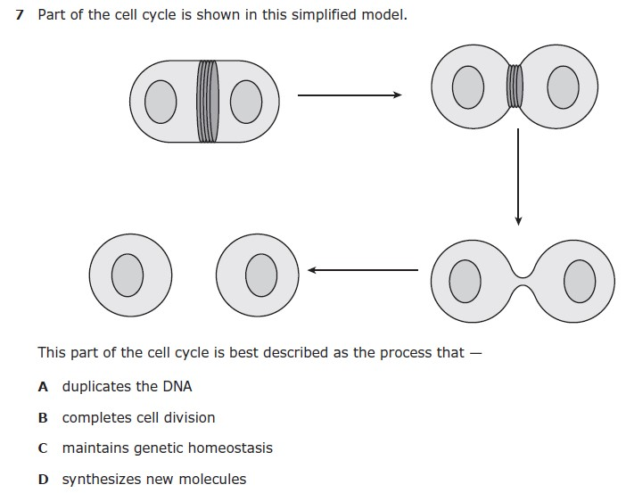 | Cluster |  | Organism Growth and Cell Differentiation
 | Subcluster |  | Cell Cycle
 | Content |  | Readiness
 | Process |  | B.2(G)
 | Stimulus
 | Data Analysis
 | Item | State | Local | Error Analysis  ▢ Guessing
 | A |  |  | ▢ Careless Error  ▢ Stopped Too Early  ▢ Mixed Up Concepts
 | B
 | C
 | D
 | Learning from Mistakes Instructional Implications

B.5(A) describe the stages of the cell cycle, including deoxyribonucleic acid (DNA) replication and mitosis, and the importance of the cell cycle to the growth of organisms | Analysis of Assessed Standards
2017 – Q33  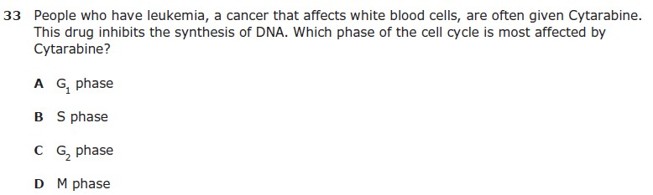 | Cluster |  | Organism Growth and Cell Differentiation
 | Subcluster |  | Cell Cycle
 | Content |  | Readiness
 | Process
 | Stimulus
 | Data Analysis
 | Item | State | Local | Error Analysis  ▢ Guessing  ▢ Careless Error  ▢ Stopped Too Early  ▢ Mixed Up Concepts
 | A
 | B
 | C
 | D
 | Learning from Mistakes Instructional Implications

