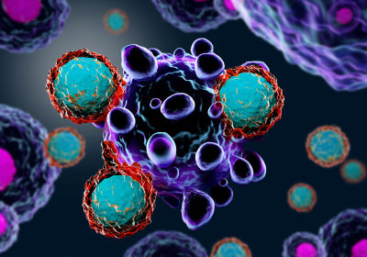
SECTION 1
CELLS: LIFE’S DESIGN & VIRUSES

EVERYTHING in Biology, you will review, are based on these 4 ideas…

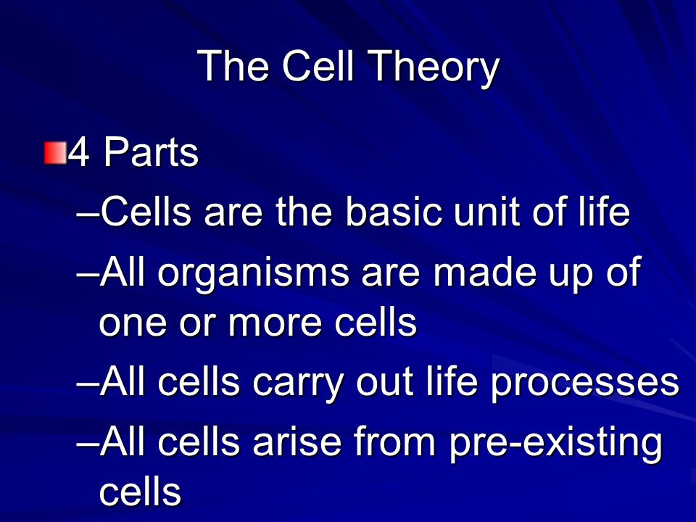

KEY CONCEPTS ABOUT CELLS: LIFE’S DESIGN & VIRUSES
MS-CCR Standard(s):
Bio. 1A. Students will demonstrate an understanding of the characteristics of life and biological organization.
BIO. 1A. 1. Develop criteria to differentiate between living and non-living things
BIO. 1A. 2. Describe the tenets of cell theory and the contributions of Schwann, Hooke, Schleiden, and Virchow.
BIO. 1A. 3. Using specific examples, explain how cells can be organized into complex tissues, organs, and organ systems in multicellular organisms.
BIO. 1A. 4. Use evidence from current scientific literature to support whether a virus is living or non-living.
BIO. 1A. 1/4

Criteria to be living… if it doesn’t have this it’s NOT alive!

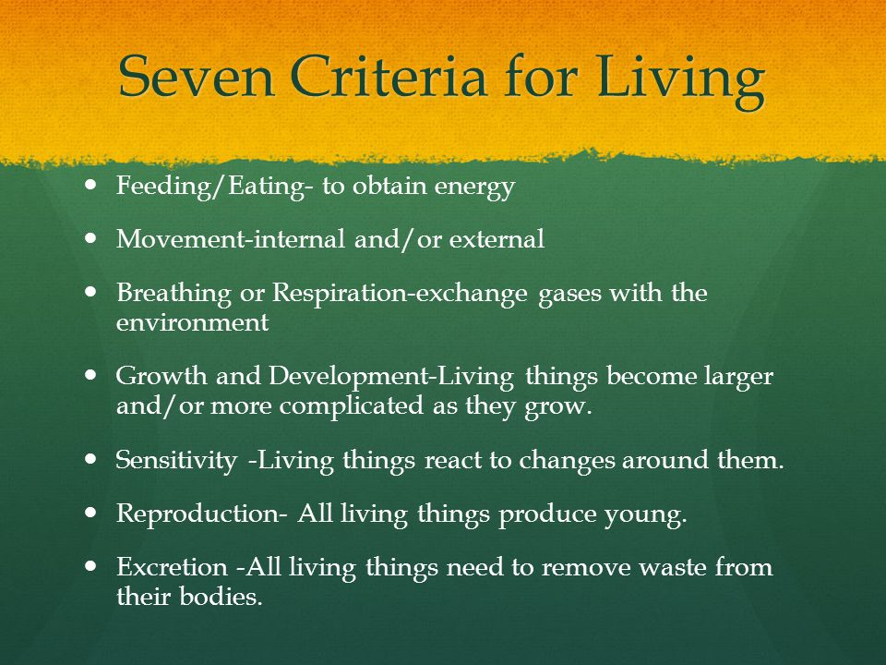
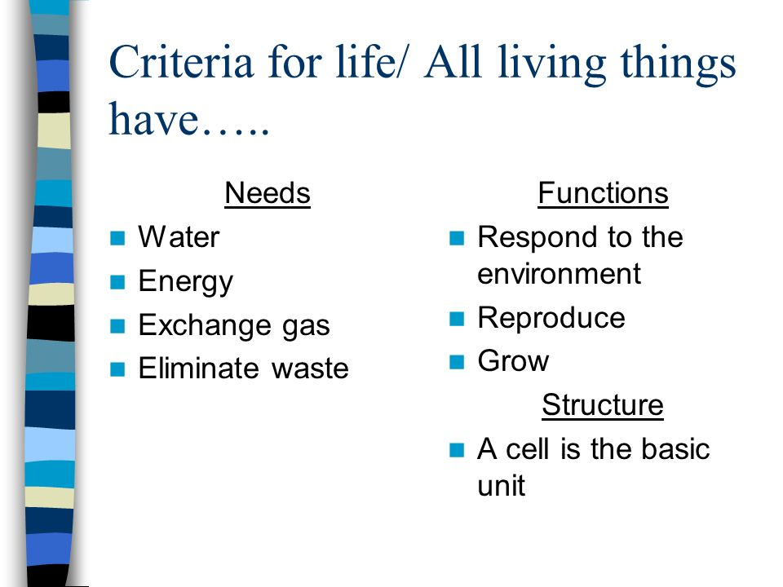

& DNA

Characteristics of Living/Non-living things (Not to lame or boring!!!) It’s only 3:38 minutes and gives a visual to the information above….why virus or not living…
Okay they are lame, but they do explain the concept

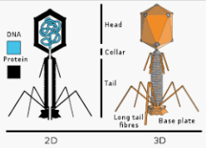
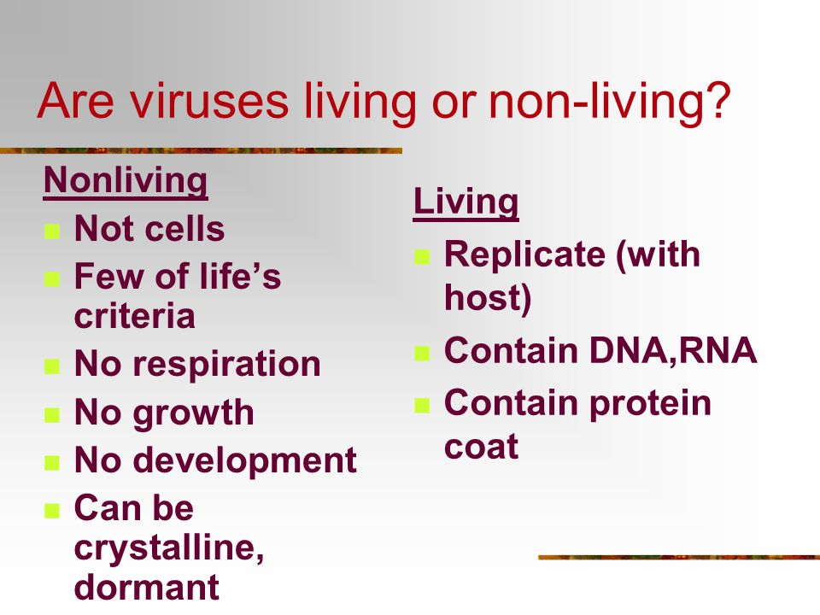

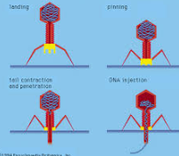
Parts labeled, how it invades, and a video below to show both!
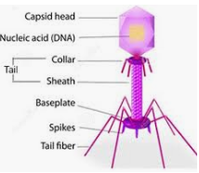
Bacteriophage (Virus)
Video

You just need to know why viruses are not considered living and how Bacteriophage destroy cells.

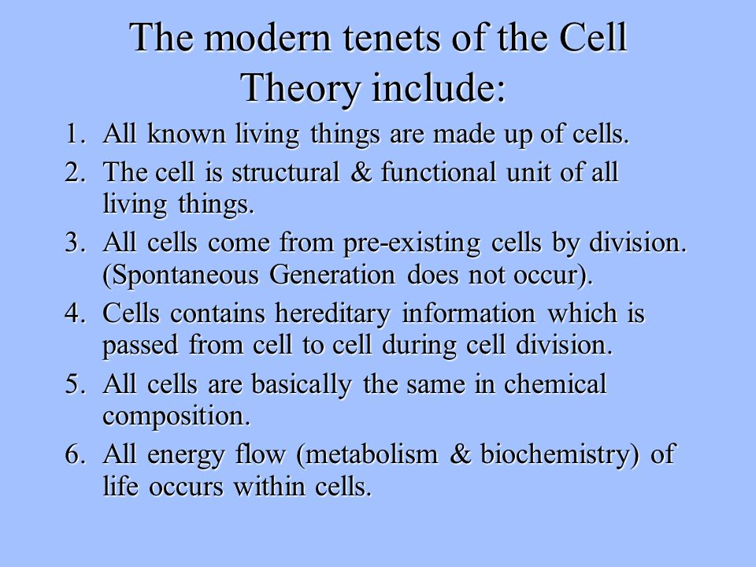
BIO. 1A. 2

Tenets (principles) of the Cell Theory

No cool visuals just recalls

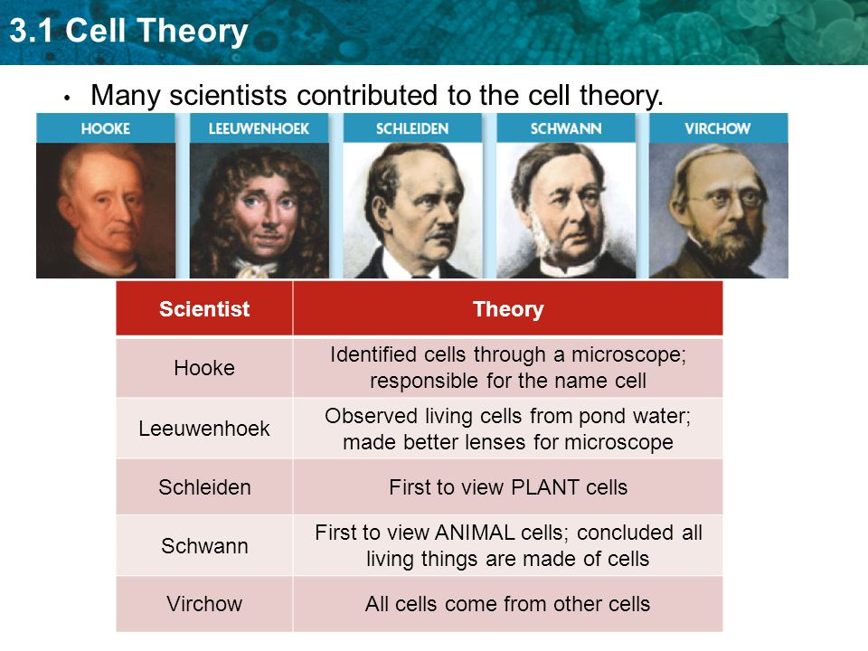

Memorized their contributions!
You will be asked

Largest
BIO. 1A. 3

How cells are organized
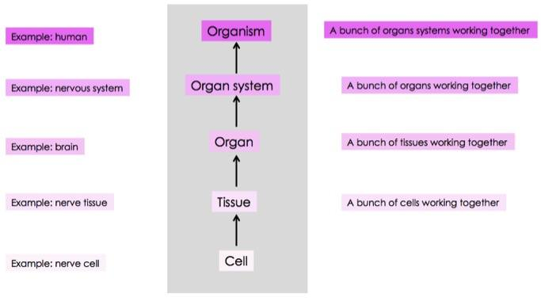

Same Thing

Smallest

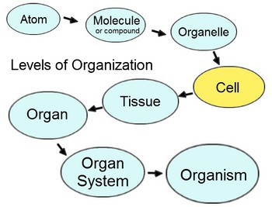
Smallest

Largest

Important Hint: Know the levels of organization both ways with words and through pictures. Study all pictures. (It’s just a few questions on the test, but they are easy if you review this information.)
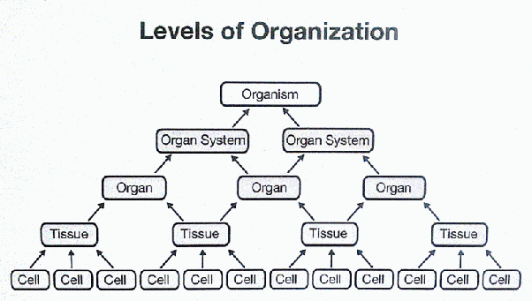
Smallest/ Least Complex
Largest/Most Complex

Below is another way they may ask…Review this picture as well

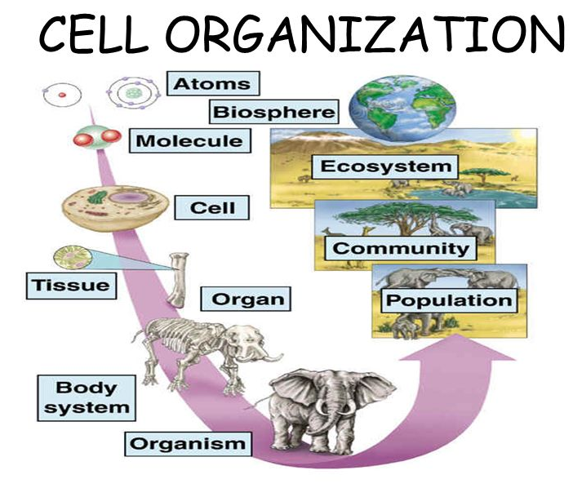
Largest
Smallest

KEY VOCABULARY TERMS ABOUT CELLS: LIFE’S DESIGN & VIRUSES
MS-CCR Standard(s):
Bio. 1A. Students will demonstrate an understanding of the characteristics of life and biological organization.
BIO. 1A. 1. Develop criteria to differentiate between living and non-living things
BIO. 1A. 2. Describe the tenets of cell theory and the contributions of Schwann, Hooke, Schleiden, and Virchow.
BIO. 1A. 3. Using specific examples, explain how cells can be organized into complex tissues, organs, and organ systems in multicellular organisms.
BIO. 1A. 4. Use evidence from current scientific literature to support whether a virus is living or non-living.

Cells | 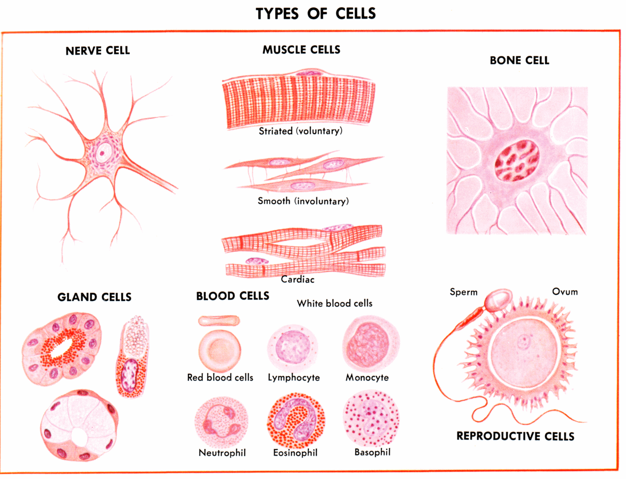
Virus | 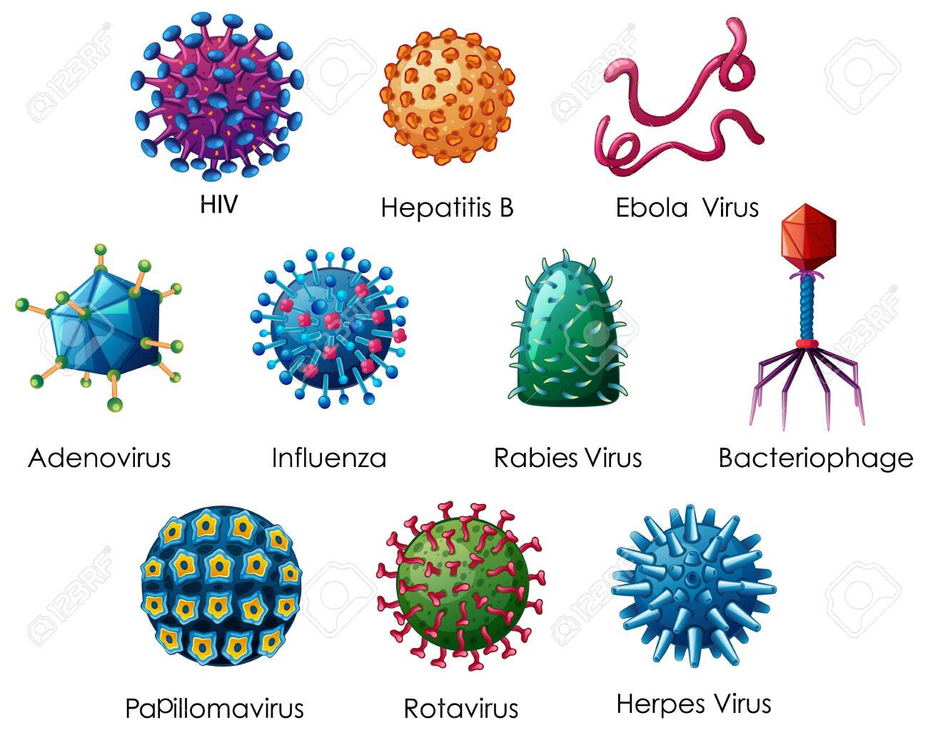
Cell Theory | 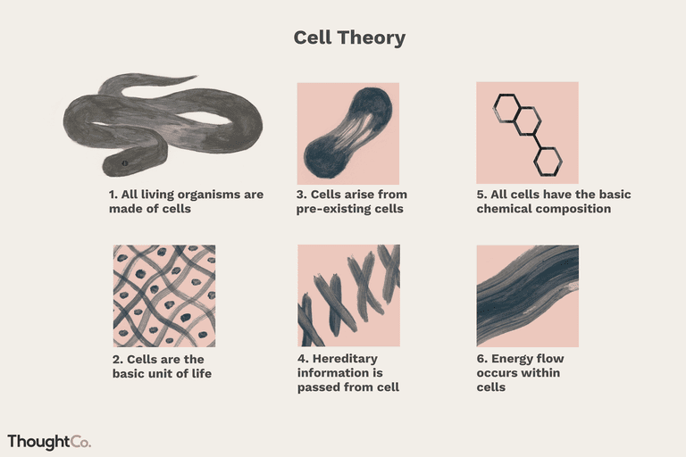
Schleiden | 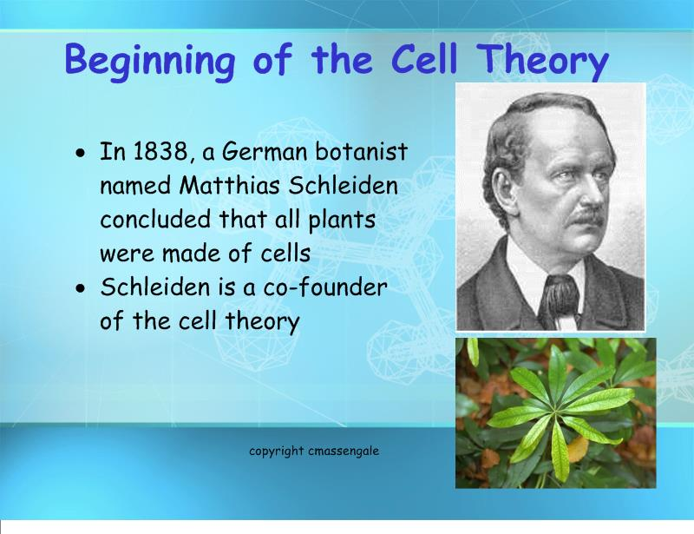
Schwann | 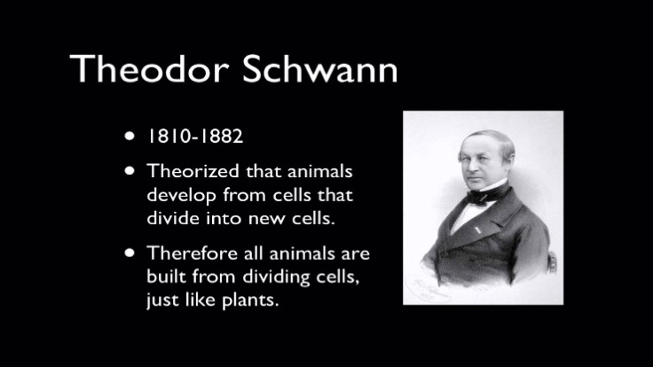
Hooke | 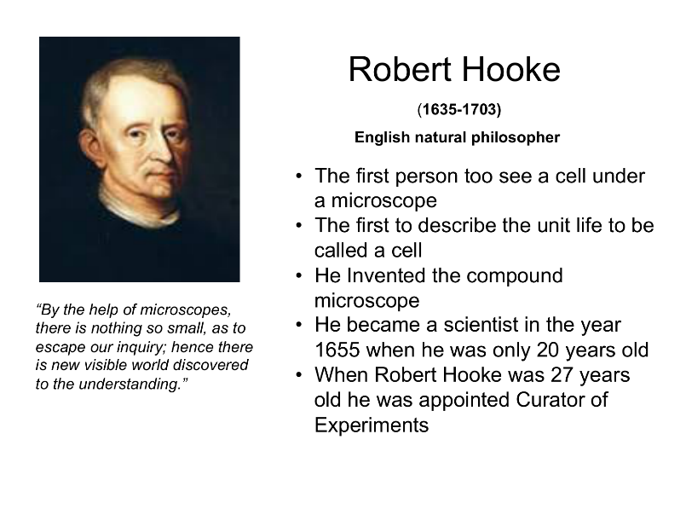
Virchow | 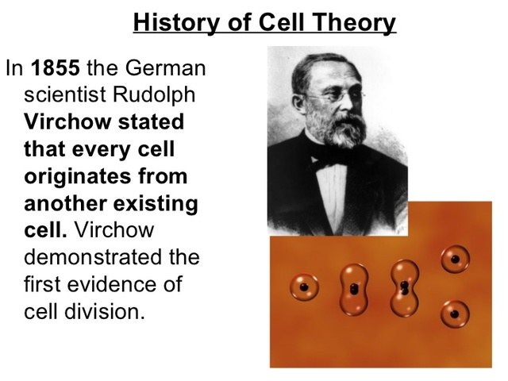
Tissue | 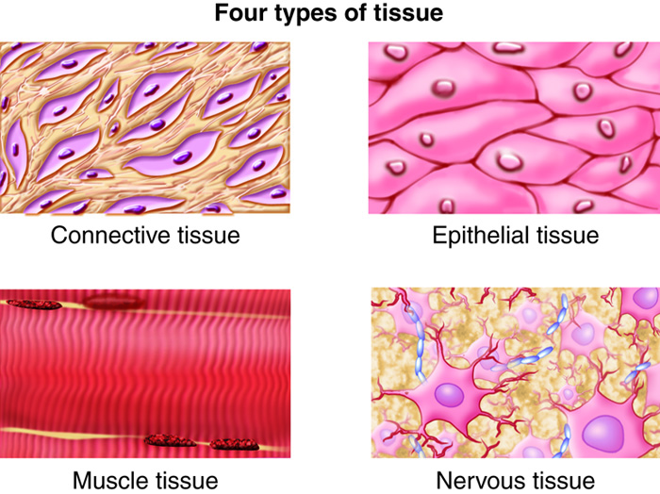
Organ | 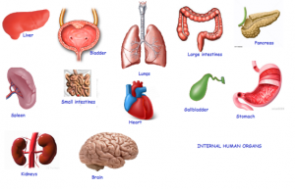
Organ System | 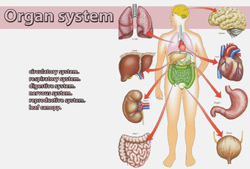
Organism | Living things
Hierarchy | Largest  Most  Complex  Smallest  Least  Less Complex

REVIEW & TEST PREP FOR
CELLS: LIFE’S DESIGN & VIRUSES
MS-CCR Standard(s):
Bio. 1A. Students will demonstrate an understanding of the characteristics of life and biological organization.
BIO. 1A. 1. Develop criteria to differentiate between living and non-living things
BIO. 1A. 2. Describe the tenets of cell theory and the contributions of Schwann, Hooke, Schleiden, and Virchow.
BIO. 1A. 3. Using specific examples, explain how cells can be organized into complex tissues, organs, and organ systems in multicellular organisms.
BIO. 1A. 4. Use evidence from current scientific literature to support whether a virus is living or non-living.

CONTENT REVIEW
- Identify which of the following characteristics are shared by all living organisms. Write a Y by the characteristics that are shared by all living organisms. Write an N by the characteristics that are not shared by all living organisms.
  - ___Y___ share a universal genetic code
  - ___N___are able to make their own food
  - ___Y___ are made of protein
  - ___Y__are made of one or more cells
  - ___Y ___ must use the energy from something else
  - ___Y __ are able to respond to changes in their environment
  - ___N___ need to breathe in oxygen
  - ___Y___ maintain a fairly stable internal environment

- __________HOOKE________ English scientist that cut a thin slice of cork and looked at it under his microscope. To him, the cork seemed to be made up of empty little boxes, which he named cells.

- ___________LEEUWENHOEK_______Dutch naturalist who created a very powerful (for the time period) single lends microscope, He observed pond water. In pond scum he discovered small animals he called animalcules, or little animal (Protista) ,and also discovered bacteria while examining scarping of crud from his teeth.

- ___________SCHLEIDEN___________ German botanist who determined plants are composed of cells.
- ________SCHWANN________ German physiologist and histologist who in 1838 and 1839 identified the cell as the basic structure of plant and animal tissue

- ______VIRCHOW_________A doctor who stated that all living cells come from other living cells (part 3 of the cell theory)

- What are the three parts of cell theory?

  - ___ Cells come from existing cells__

  - _ All living things are made of cells

C. ___ Cells are the basic unit of life ___

- Label the parts of the virus pictured below

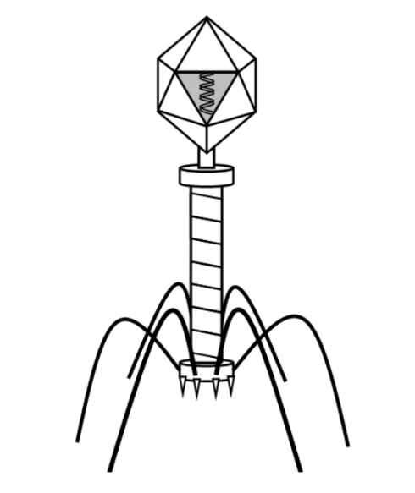

- _______ See Picture on page 12____

- _____________________

- _____________________

- _____________________

- _____________________

- _____________________

- _____________________

- _____________________

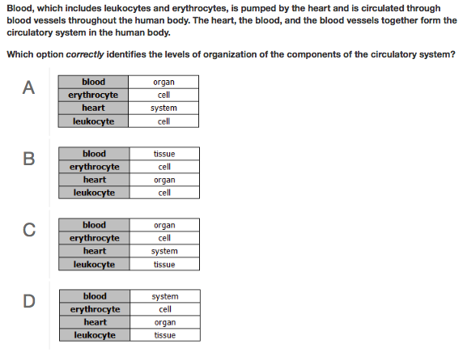

- Define the following terms from the question above:

Organ system- A group of organs working together

Organ- A group of tissues working together

Tissue- A group of cells working together

Cell- The basic unit of life
- Rewrite the question in your own words. What are they really asking?
How does everything in a living organism function together?

- What is the correct answer and WHY? (you will not get credit without an explanation)
B, because eruthrocytes and leukocytes are cells that work together to make blood, and the heart (organ) pumps the blood.

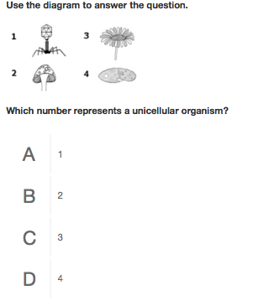

- Define the following terms from the question above:
Unicellular- made of one (1) cell - simple, few or no membrane bound organelles

Multicellular- made of more than one cell - complex, many membrane bound organelles

- Rewrite the question in your own words. What are they really asking?
- Which organism pictured is made of only one cell?

- What is the correct answer and WHY? (you will not get credit without an explanation) D (or #4), because #3 (flower) and #2 (fungi) are multicellular organism, and #1 is virus which is not a cell.

3)
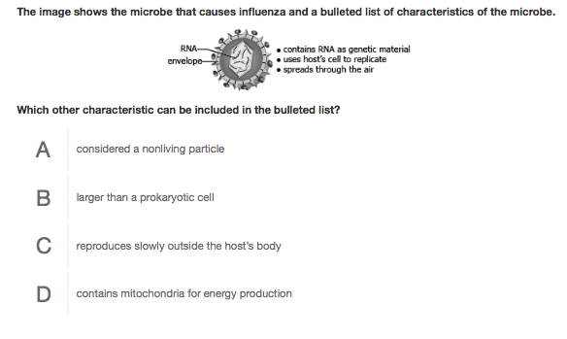

- Define the following terms from the question above:

Microbe- a microscopic organism

- Rewrite the question in your own words. What are they really asking?

What are characteristics of a virus?

- What is the correct answer and WHY?A, because they are not considered living and must have a living host to reproduce.

MAAP TEST PREP
MDE PT 1. # 7
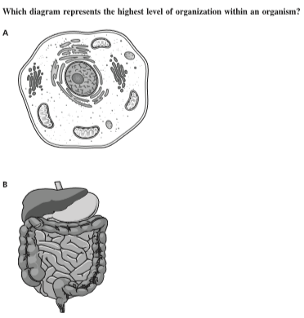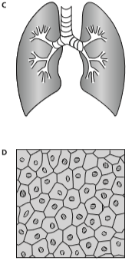
Answer B. Clues- “highest level”. B is the digestive systems which an organ system is right below an organism (the highest). A is a cell, D is tissue and C is an organ.

MDE PT. 1 # 58
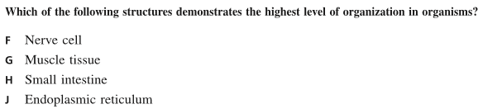
Answer H. Clues- “highest level”. J is an organelle which help makes up a cell.

MDE PT. 2 # 27
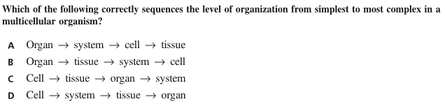
Answer C. Clues- “Level of organization”, “simplest” to “most complex”.

MDE PT. 2 #65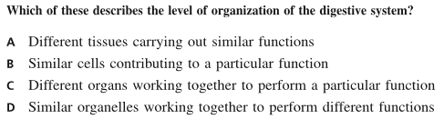
Answer C. Clues- “level of organization” of “digestive system”. An organ system is made of a “group of organs”. C is the only answer choice that states that information.

MDE PT.3 # 28
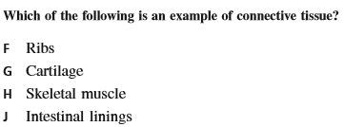
Answer G. Clues- “connective tissue”.

MDE PT. 3 # 32
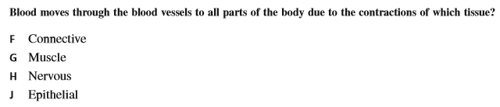
Answer G. Clues- “contractions”.

MDE PT. 3 # 53
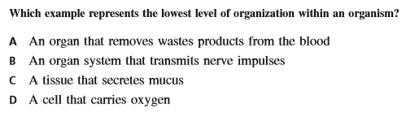
Answer D. Clues- “lowest level of organization”. The cell is the lowest level.

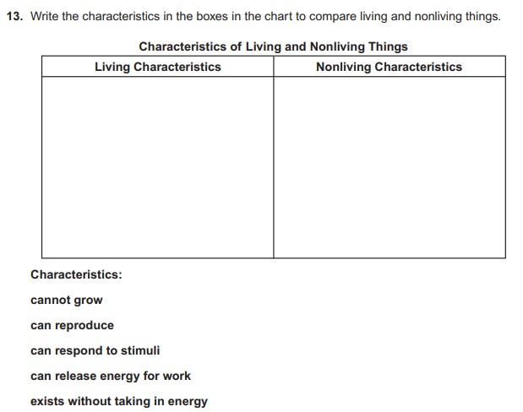

Answer. Living=Can respond…, Can release…, Can reproduce / Non-living= Cannot…, exist without…. Clues: “Can” for living and “Cannot/Without”
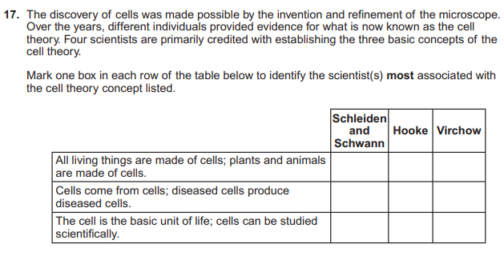

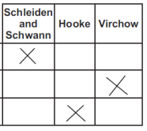
Answer.

