8/31 | 9/1 | 9/2 | 9/3 | 9/4
Grilled Cheese | Chicken Patty | Turkey Sandwich | Pizza Crunchers | Turkey Hot Dog
Fresh Fruit & Veggies | Fresh Fruit & Veggies | Fresh Fruit & Veggies | Fresh Fruit & Veggies | Fresh Fruit & Veggies
Milk | Milk | Milk | Milk | Milk
Alt. Sunbutter & Jelly | Alt. Sunbutter & Jelly | Alt. Sunbutter & Jelly | Alt. Sunbutter & Jelly | Alt. Sunbutter & Jelly
Breakfast: | Breakfast: | Breakfast: | Breakfast: | Breakfast:
Cereal | Choc. Chip Muffin | Apple Roll | Cinnamon Roll | Cereal
9/7  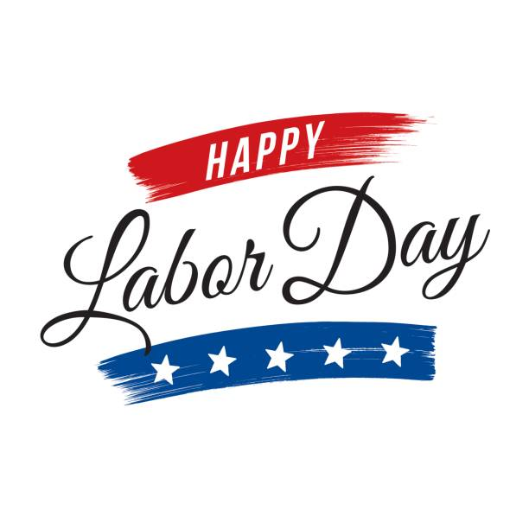 | 9/8 | 9/9 | 9/10 | 9/11
 | Mozzarella Sticks | Turkey Sandwich | Cheeseburger | Meatball Grinder
 | Fresh Fruit & Veggies | Fresh Fruit & Veggies | Fresh Fruit & Veggies | Fresh Fruit & Veggies
 | Milk | Milk | Milk | Milk
 | Alt. Sunbutter & Jelly | Alt. Sunbutter & Jelly | Alt. Sunbutter & Jelly | Alt. Sunbutter & Jelly
 | Breakfast: | Breakfast: | Breakfast: | Breakfast:
 | Cinnamon Roll | Apple Roll | Choc. Chip Muffin | Cereal
9/14 | 9/15 | 9/16 | 9/17 | 9/18
Pizza Crunchers | Turkey Hotdog | Turkey Sandwich | Grilled Cheese | Chicken Patty
Fresh Fruit & Veggies | Fresh Fruit & Veggies | Fresh Fruit & Veggies | Fresh Fruit & Veggies | Fresh Fruit & Veggies
Milk | Milk | Milk | Milk | Milk
Alt. Sunbutter & Jelly | Alt. Sunbutter & Jelly | Alt. Sunbutter & Jelly | Alt. Sunbutter & Jelly | Alt. Sunbutter & Jelly
Breakfast: | Breakfast: | Breakfast: | Breakfast: | Breakfast:
Cereal | Choc. Chip Muffin | Apple Roll | Cinnamon Roll | Cereal
9/21 | 9/22 | 9/23 | 9/24 | 9/25
Cheeseburger | Meatball Grinder | Turkey Sandwich | Mozzarella Sticks | Chicken Tenders
Fresh Fruit & Veggies | Fresh Fruit & Veggies | Fresh Fruit & Veggies | Fresh Fruit & Veggies | Fresh Fruit & Veggies
Milk | Milk | Milk | Milk | Milk
Alt. Sunbutter & Jelly | Alt. Sunbutter & Jelly | Alt. Sunbutter & Jelly | Alt. Sunbutter & Jelly | Alt. Sunbutter & Jelly
Breakfast: | Breakfast: | Breakfast: | Breakfast: | Breakfast:
Cereal | Cinnamon Roll | Apple Roll | Choc. Chip Muffin | Cereal
9/28 | 9/29 | 9/30
Grilled Cheese | Chicken Patty | Turkey Sandwich
Fresh Fruit & Veggies | Fresh Fruit & Veggies | Fresh Fruit & Veggies
Milk | Milk | Milk
Alt. Sunbutter & Jelly | Alt. Sunbutter & Jelly | Alt. Sunbutter & Jelly
Breakfast: | Breakfast: | Breakfast:
Cereal | Choc. Chip Muffin | Apple Roll
Fresh Fruits and Veggies served Every Day!

Meal Prices:
Daily Lunch: $3.25 (reduced $.40)
Milk (only): $.60
Breakfast is available to ALL students
for FREE
Staff Meal: $4.00

Sterling Community School
Breakfast & Lunch Menu
AUG/SEPT 2020
FOOD NEWS!
Welcome!
…to the 2020-2021 school year! We hope you all had a great summer!

- Please note during this time we will only have one breakfast option and one alternate lunch option. Also during this time there will be no snacks offered for purchase.
- All meals will be packaged individually in to-go style containers to keep your students safe and healthy.
- If you choose to send your child in with a home lunch, we are encouraging parents to do so in a non-fabric lunch box (preferably disposable) to ensure these items can be properly sanitized.
- We are trying to limit cash handling as much as possible. You can view your child’s account balance and purchase history online! Payments for your child’s lunch account can be made online with a debit/credit card at www.MySchoolBucks.com (you will need your child’s student ID number).

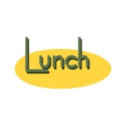
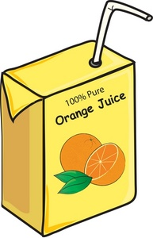
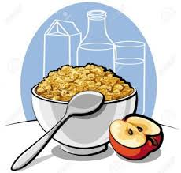
A complete breakfast includes; Whole Grain based Entrée, Milk, Fruit and/or 100% Fruit Juice.

All meals will be packaged individually in to-go style packaging keeping your students’ safety our number one priority.

If you choose to send in a home lunch, we are encouraging parents to do so in a non-fabric lunch box (preferably disposable) to ensure these items can be properly sanitized.

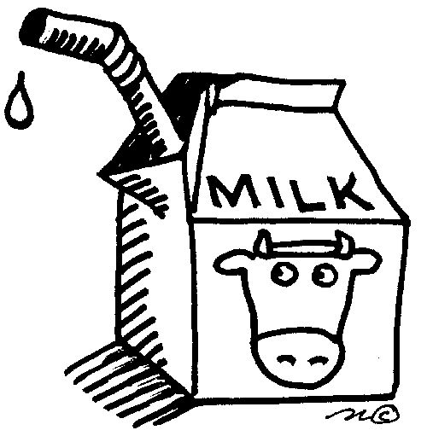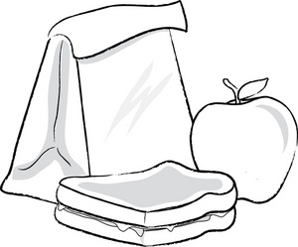
Lunch choices include: 1% Regular Milk and fat-free chocolate milk 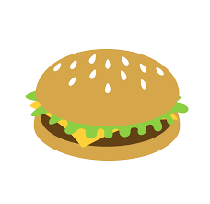
What does a complete hot lunch include?
Grain, meat/meat alternate, vegetable, fruit & milk

Make all checks out to:
EASTCONN Food Services

This is an equal opportunity institution.

