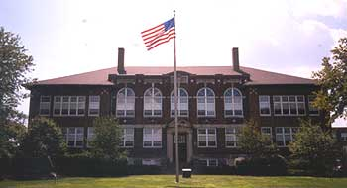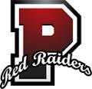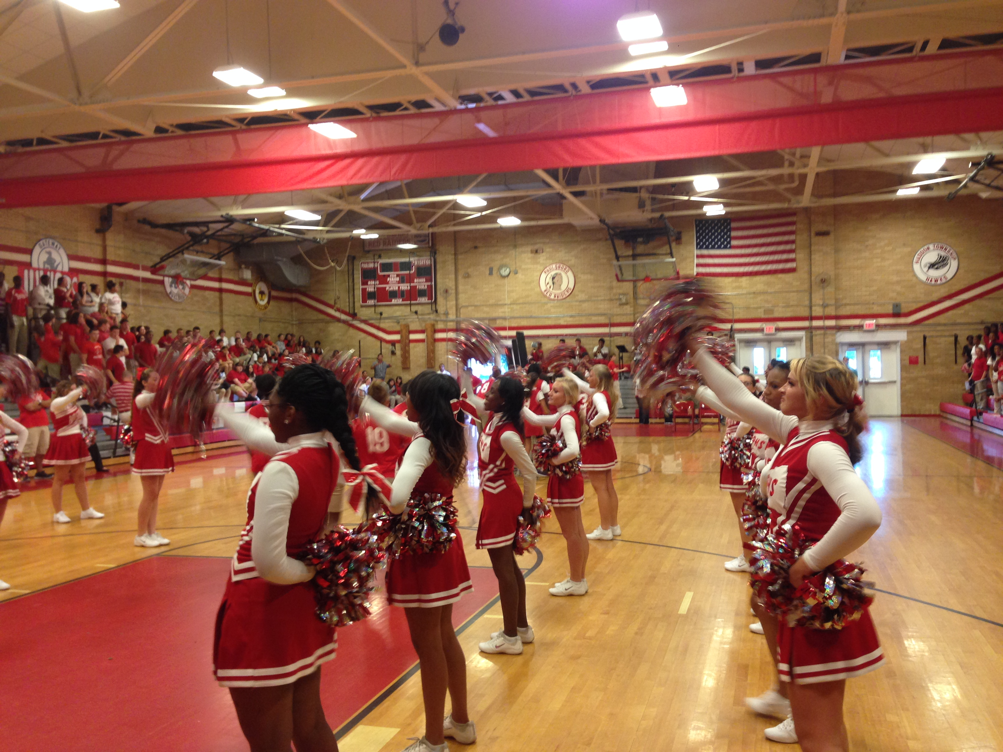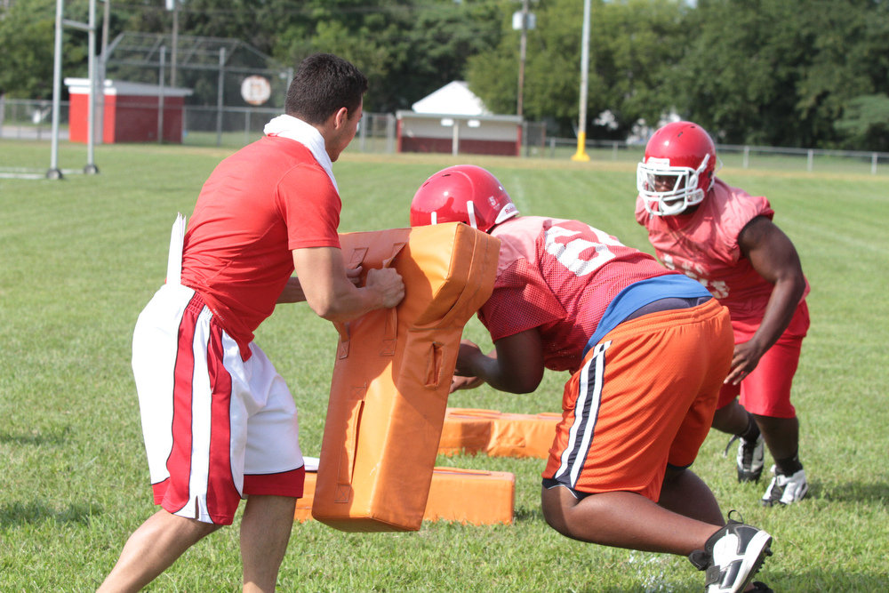

**Paulsboro Red Raiders**

In order to keep our bodies physically fit and mentally fit, we must teach a variety of activities that promote a healthy, and active lifestyle. In our physical education program, we will focus on fitness, team sports, individual & dual sports, recreation & dance as well as team building activities. It is the mission of the members of the Paulsboro School District to provide students with a variety of physical activities that enrich their lives and teach them how to live a healthy and active lifestyle.

# Paulsboro High School

# Physical Education

# 7th – 12th

## Mission Statement

Brenda Caltabiano

Nick Cappolina

Tony Chila

Ashlie Gaynor

Stephanie Taraschi

Paulsboro High School

“Intelligence and skill can only function at the peak of their capacity when the body is healthy and strong.”

- John F. Kennedy

Physical Education Program Overview

P.E. DEPT

Physical activity is an essential component of a healthy lifestyle. In combination with healthy eating, it can help prevent a range of chronic diseases, including heart disease, cancer, and stroke, which are the three leading causes of death. Physical activity helps control weight, builds lean muscle, reduces fat, promotes strong bone, muscle and joint development, and decreases the risk of obesity. Children need 60 minutes of play with moderate to vigorous activity every day to grow up to a healthy weight.

FITNESSGRAM assessment measures three components of health-related physical fitness that have been identified as important to overall health and function: aerobic capacity; body composition; and muscular strength, endurance, and flexibility. Examples of FITNESSGRAM testing include:

**AEROBIC CAPACITY**

* PACER test
* Shuttle Run

**BODY COMPOSITION**

* Body Fat %
* Body Mass Index (BMI)

**MUSCULAR STRENGTH, ENDURANCE & FLEXIBILITY**

* Sit-Ups
* Push-Ups
* Pull-Ups/Flex Arm Hang
* Trunk (Back) Extension
* Sit & Reach
* Broad Jump

Paulsboro Pride & Raider Respect

Why is fitness important?

Fitness Day

Every Wednesday, students will participate in a variety of activities conducive to physical fitness. This will allow students to work on their fitness to improve upon their FITNESSGRAM results. Fitness Day will consist of:

**WARM UP**

* Jog 4 laps around GYM
* Static Stretching
* Dynamic Stretching
* Sit-Ups & Push-Ups
* Jumping Jacks

**FITNESS CIRCUITS**

* Core
* Upper Bod**y**
* Lower Body
* Aerobic

### FITNESSGRAM

### Fitness Program

**FALL**

Fitness Testing, Football, Tennis, Soccer, Archery, Field Hockey, Cooperative Games, Speedball, Cross Country

**SPRING**

Fitness Testing, Softball, Golf, Archery, Recreational Games, Kickball, Cooperative Games, Lacrosse, Wiffleball, Track & Field

**WINTER**

Fitness Testing, Basketball, Volleyball, Dance, Wrestling, Badminton, Pickle ball, Handball, Hockey, Ping Pong Cooperative Games, Bowling

The physical education department has 4 Nintendo Wiis and 4 32” Television displays that are used for physical education. Students are able to use the Nintendo Wii to play games that follow the Physical Education curriculum. Some games that students are able to play include Wii Sports and Just Dance. The physical education department also has a flat screen TV that is in the wrestling room. The TV has a DVD hook up that allows us to use DVDs such as: P90x, Insanity, Yoga, Zumba, Aerobic and other Strength and Conditioning videos that help the children achieve an active lifestyle.

Technology

&

Physical Education

A variety of activities will be offered to students that incorporate fitness, team sports, individual & dual sports, recreation & dance, as well as a variety of team building exercises that promote good sportsmanship, cooperation and everyone achieving a common goal. These activities are broken down by season as follows:

Activity Overview

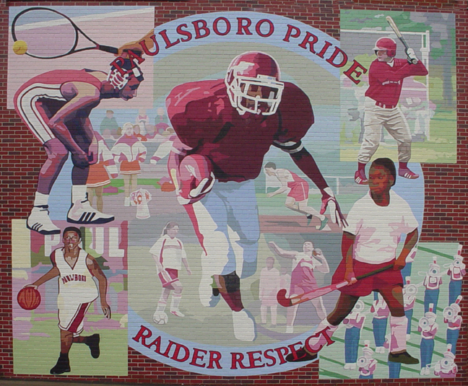

* **2.1 WELLNESS**
  + All students will acquire health promotion concepts and skills
* **2.2 INTEGRATED SKILLS**
  + All students will develop and use personal and interpersonal skills
* **2.3 DRUGS & MEDICINES**
  + All students will acquire knowledge about alcohol, tobacco, other drugs, and medicines
* **2.4 HUMAN RELATIONSHIPS & SEXUALITY**
  + All students will acquire knowledge about the physical, emotional, and social aspects of human relationships and sexuality
* **2.5 MOTOR SKILL DEVELOPMENT**
  + All students will utilize safe, efficient, and effective movement
* **2.6 FITNESS**
  + All students will apply health-related and skill-related fitness concepts and skills

New Jersey Core Curriculum Content Standards

Comprehensive Health & Physical Education

7th Grade – Body Systems, Human Growth & Development, Human Relationships (Part 1)

8th Grade – Body Systems, Human Growth & Development, Human Relationships (Part 2)

9th Grade – Male & Female Reproductive System

10th Grade – Driver’s Education

11th Grade - Safety & First Aid, Drugs & Alcohol

12th Grade - Pregnancy & Family Dynamics

12

#### Paulsboro High School

670 N. Delaware Street  
Paulsboro, NJ, 08066

*All health content has been developed to meet the needs of the curriculum as well as the New Jersey Core Curriculum Content Standards for Comprehensive Health & Physical Education.*

Paulsboro High School Health Education 7th – 12th