

**Desoto Central Middle**

**Supply List – all grades**

**Students should have a backpack with the following items:**

**2” binder which includes:**

* Dividers
* Paper
* Graph paper

**Notebook(s):**

6th Grade

* 2 Composition (math)
* 2 composition (ELA)

7th Grade

* 5-subject MEAD spiral

8th Grade

* Two 5-subject MEAD spiral

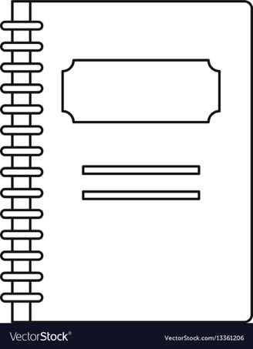

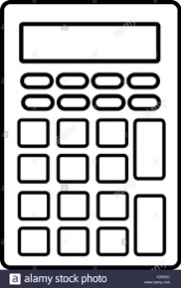

**Calculator**

6th and 7th graders

* TI-108 (basic)

8th Graders

* TI-30X ISS (scientific)

**Vinyl folder with prongs**

**Clip board**

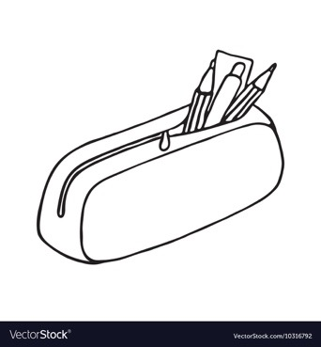

**Teacher Wish List Items**

*These items will help us keep all our jags safe and are appreciated.*

* Clorox wipes
* Lysol spray
* Hand sanitizer
* Tissue
* Paper towels
* Ziplock bags (all sizes)
* Colored paper

**Pencil Pouch or Pencil Box which includes:**

* Pencils (3-5)
* Pencil sharpener
* Glue sticks (3)
* Erasers
* Colored pencil pack
* Pack of markers
* Scissors
* Red pens (2)
* Highlighters
* Pack of index cards
* Post-it notes (2)
* Expo Marker