HOLLY SPRINGS SCHOOL DISTRICT
5th GRADE SCIENCE HYBRID INSTRUCTIONAL GUIDE
Week of February 15 through February 19, 2021

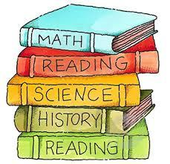

STANDARDS
E.5.8B.2 Develop and use a model of the Earth-Sun-Moon system to analyze the cyclic patterns of lunar phases, solar and lunar eclipses, and seasons.

STANDARD (S)  E.5.8B.2 Develop and use a model of the Earth-Sun-Moon system to analyze the cyclic patterns of lunar phases, solar and lunar eclipses, and seasons.  ESSENTIAL CONCEPTS  ~ Analyze the cyclic patterns of lunar phases, and the differences between a solar and lunar eclipse.  STANDARD VOCABULARY  - Moon phases  - Solar eclipse  - Lunar eclipse  - Seasons  - Analyze | ACTIVITY/ ASSIGNMENT SCHEDULE  MONDAY, February 15th:  - Read the powerpoint presentation.  - I DO, WE DO, YOU DO.  - EXIT TICKET  - HOMEWORK: Complete worksheet in Schoology.  TUESDAY, February 16th:  - Read powerpoint presentation.  - Classwork activity~USA TEST PREP  WEDNESDAY, February 17th:  - Quick quiz  - Independent Practice complete assignment in USA Test Prep through Schoology, if not completed it becomes HOMEWORK FOR WEDNESDAY  - Pulling of targeted students  THURSDAY, February 18th:  - Complete the worksheet in USA Test Prep.  - Pulling of targeted students  FRIDAY, February 19th:  - Assessment (Test) in Performance Matters in all subjects.  - Help or Pulling Session 1-3p.m. on Google Meet for students who targeted, and who need additional support in Science.  ﻿
E.5.8B.2  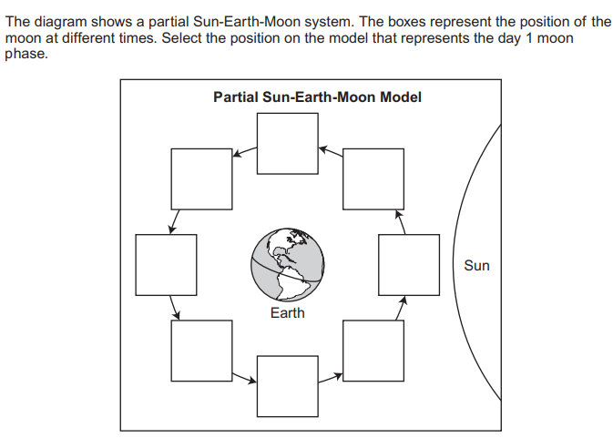 | WEBSITES/SUPPORT MATERIALS  District website – hssdk12.org  School website - intermediate.hssdk12.org  Schoology-schoology.com  Savvas Realize- savvasrealize.com  USA Test Prep- usatestprep.com  Performance Matters-performancematters.com

