Step 1: Enter your students information, click submit
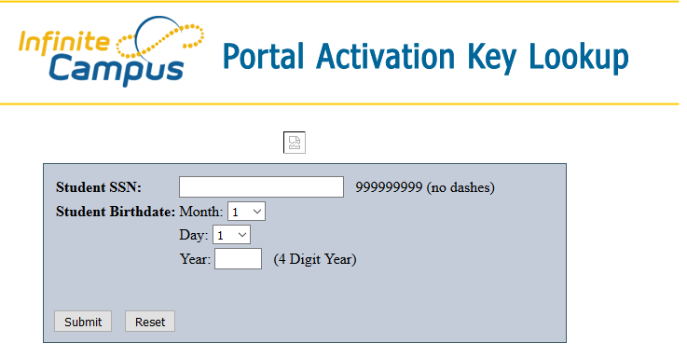
The parents name and GUID activation key will be listed in a blue box. Write down the GUID activation key. (The copy and paste function will not work). You will need to use this in the next screen.
Step 2: Select the link ‘Activate Your Parent Portal Account Now’.
Step 3: Enter a username and password. You must enter the password a second time.
