45. visible light is a small part of the electromagnetic spectrum that the human eye is capable of seeing.

46. the human eye sees colors and matter in terms of the wavelength of each color. (We ONLY see reflected light!)

47. a matter’s color is that of the colors reflected by the matter, not absorbed by the matter.

48. the chemical make-up of matter determines the colors that are either absorbed or reflected.

49. to see an object, reflected light from that object must enter the eye.

50.. light passes through the cornea, pupil and lens before reaching the retina

51.. the retina contains the receptors (cones and rods) that respond to light.

52. the pupil changes size to control how much light enters the eye.

53. different shaped lenses will affect the path of light – concave/convex

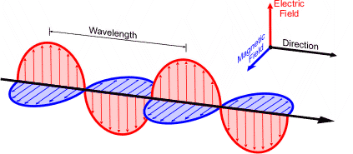

**ELECTROMAGNETIC WAVE** is a disturbance that transfers energy through a FIELD. A field is an area around an object that can apply force upon another object without actually touching it. **Can you identify all the EM waves in the following sentences?** Millie lays out in the sun reading a book. She puts on sunscreen to protect her skin from the sun’s rays. She turns on her radio to listen to some music. She gets hungry and steps inside to pop some popcorn in the microwave when her cellphone rings and she answers it.

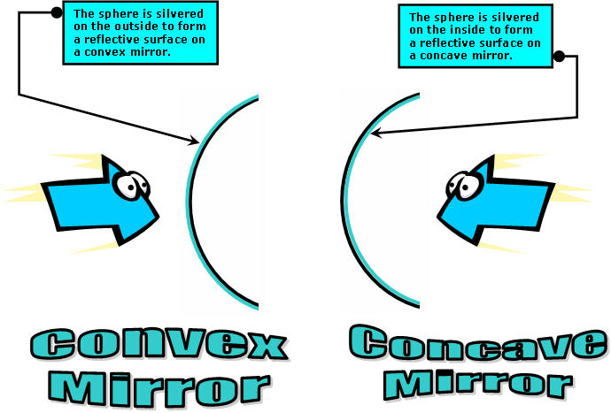

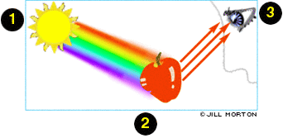

**HOW WE SEE COLOR = COLOR REFLECTION AND ABSORPTION.**

The color of an object determines on the wavelengths it **absorbs** and **reflects**. This apple is red because it absorbs all color wavelengths except red, which it reflects. Our eye sees the reflected red waves so we perceive the apple as red.

Objects that reflect all wavelength of light appear **WHITE.** Objects that absorb all wavelengths of light appear **BLACK**.

What color are your shoes? Why do you see that color or colors?

***What determines a wave’s color***? The _______________________! Remember Roy G. Biv?

So, what determines what wavelength an object will absorb or reflect? The **______________________________**of the object does!

The **Law of Reflection** states the angle of reflection equals the angle of incidence. In other word, when you change the angle of the flashlight, the angle of the reflection will also change.

Try making a **periscope** and see how reflection works. (See page 595 in your book.)

