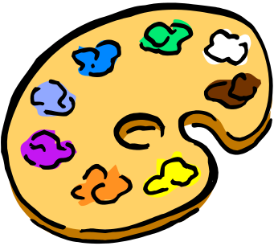
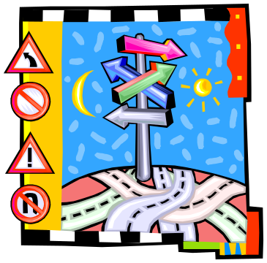

Presents
The Signmaker’s Assisstant
Actors: Townsfolk 1, 2, & 3
The Signmaker
Norman

Townsfolk 1: Everyone in town agreed. The old signmaker did the finest work for miles around.
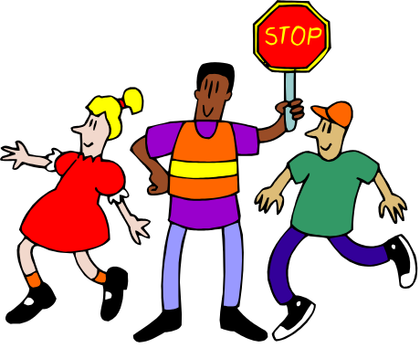

Townsfolk 2: Under his brush, ordinary letters
became beautiful words -

Townsfolk 3: words of wisdom,

Townsfolk 1: words of warning,

Townsfolk 2: or words that simply said which door to use.

Norman: When he painted STOP, people stopped because the sign looked so important.

Townsfolk 3: When he painted PLEASE KEEP OFF THE GRASS, they kept off because the sign was polite and sensible.

Norman: When he painted GOOD FOOD, they just naturally became hungry.


Signmaker: People thanked me and paid me well.

Townsfolk 1: But the kind old man never failed to say,

Signmaker: I couldn’t have done it without Norman’s help.

Norman: I’m Norman, and I am the signmaker’s assistant.

Signmaker: Each day after school he cut wood, mixed colors, and painted simple signs. Norman told me,

Norman: Soon I will have a shop of my own.

Signmaker: I told him, “Perhaps, but not before he cleans these brushes.”

Norman: One day, after my work was done, I stood at a window over the sign shop and watched people. I noticed that…

Townsfolk 2: They stopped at the STOP sign.

Townsfolk 3: They entered at the ENTER sign.

Townsfolk 1: They ate under the GOOD FOOD sign.

Norman: They do whatever the signs say! I wonder…

Signmaker: Norman crept into the shop while I napped. With brush and board he painted a sign of his own.

Norman: Early the next morning I put up the sign, then ran back to my window to watch. I heard the principal mutter,

Townsfolk 2: No school? How could I forget such a thing?

Norman: The teacher said,


Townsfolk 3: No one informed me.

All: Hooray!

Norman: cheered the children. Then everyone went home. This is great!

Signmaker: Norman looked around town for another idea. When he saw the fountain in the park, he said,

Norman: Oh! There is something I have always wanted to do.
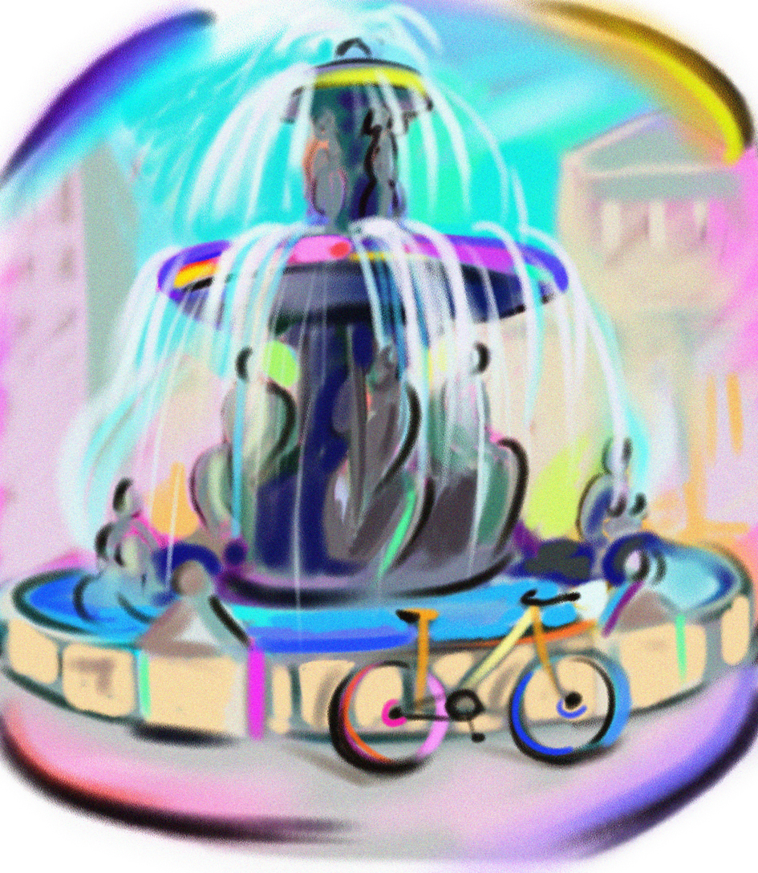
Townsfolk 1: The following day Norman jumped from the top of the fountain in the park. As he swam, he thought to himself,

Norman: I can do lots of things with signs.

All: Ideas filled his head.

Townsfolk 2: That afternoon when Norman went to work, the signmaker said,

Signmaker: I must drive to the next town and paint a large sign on a storefront. I’ll return tomorrow evening, so please lock up the shop tonight.

Norman: As soon as the signmaker was gone, I started making signs. I painted for hours and hours and hours.

Townsfolk 1,2, and 3: In the morning we discovered new signs all around town.
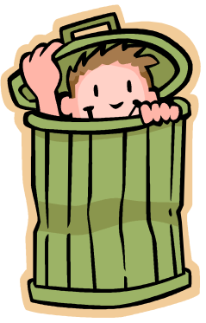

Boys: Banks closed. Deposit money here.
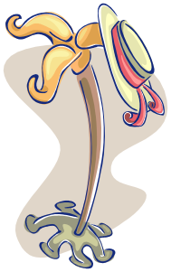
Girls: EAT YOUR HAT.

All: Toy Shop. BUY NORMAN
A
PRESENT

Townsfolk 3: Norman watched it all and laughed until tears came to his eyes.
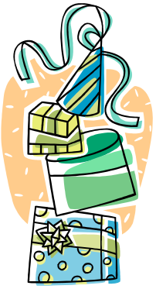

Norman: But soon I saw people becoming angry.
They started shouting.

Townsfolk 1: The signmaker is playing tricks!

Townsfolk 2: He has made fools of us!

Signmaker: The teacher tore down the NO SCHOOL TODAY sign.

Norman: Suddenly people were tearing down all the signs – not just the new ones but every sign the signmaker had ever painted.

All: Then the real trouble started!

Townsfolk 3: Without store signs, shoppers became confused.

Townsfolk 1: Without stop signs, drivers didn’t know when to stop.

Townsfolk 2: Without street signs, firemen became lost.

Signmaker: In the evening, when I returned from my work in the next town, I knew nothing of Norman’s tricks.

Norman: An angry crowd of people met him at the back door of his shop and chased him into the woods. As I watched, I suddenly realized that without signs and without the signmaker, the town…

All: was in danger!

Norman: It’s all my fault!

Townsfolk 3: cried Norman, but no one was lestening.

Signmaker: Late that night, I returned and saw a light on in my shop. Norman was feverishly painting.
Townsfolk 1: While the town slept and the signmaker watched,

Norman: I put up stop signs,
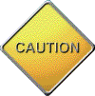


Townsfolk 1, 2, and 3: shop signs,

Boys: street signs,
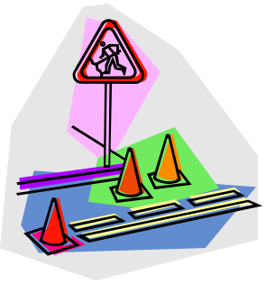
Girls: danger signs,


All: and welcome signs;

Signmaker: in and out signs,
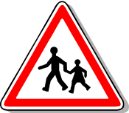

Townsfolk 1 and 2: large and small signs,

Signmaker and Townsfolk 3: new and beautiful signs.

Norman: I returned all of my presents and cleared away the garbage at the grocery store. It was morning when I finished putting up my last sign for the entire town to see.

Townsfolk 1, 2, and 3: DON’T BLAME THE SIGNMAKER, I TRICKED YOU AND I’M SORRY. NORMAN

Signmaker: Then Norman packed his things and locked up the shop.

Norman: But as I turned to go, I discovered the signmaker and all the townspeople gathered at the door.

Townsfolk 1: Norman said to us with downcast eyes,
Norman: I know you’re angry with me for what I did, so I’m leaving.

Signmaker: The school principal answered Norman by saying,

Townsfolk 2: Oh, we were angry all right! But we were also fools for obeying signs without thinking.

Signmaker: You told us you were sorry, and you fixed your mistakes. So stay and work hard. One day this shop may be yours.

Townsfolk: As Norman hugged the signmaker, we heard him say,

Norman: Perhaps, but not before I finish cleaning those brushes.



