11/6/19 Graves Biology Notes
Cell Division is important because:
Asexual reproduction-mitosis =2 genetically identical Diploid (2n or full DNA) daughter cells made from 1 “Parent” cell. This is how Sex cells AKA “Gametes” are made.
Purpose: Repair, Reproduction, Growth and Development
Sexual reproduction-meiosis=4 genetically varied Haploid (n or half DNA) daughter cells made
from 1 “Parent” cell. This is how Body cell AKA “Somatic cells” are made.
Purpose: Reproduction with genetic variation only
Amoeba Sisters: Cell cycle and Cancer Notes
*Cells grow in order make you and other living things grow larger and develop structures. Ex. Seeds to small plants, Small plants to large plants. Zygote to baby, Baby to Adult.
*Cells that don’t stop reproducing when they are supposed cancerous. They grow uncontrollably. They may not be anchored properly and travel to other parts of the body where they anchor and reproduce. This is what we call cancer metastasizing and end up traveling throughout the body.
*It may send out corrupt messages throughout the body, directing all the blood from other healthy cells causing those other cells to suffer from a lack of energy.
*Uncontrolled growth causes more cancer cells and growth of a tumor which may or may not sit still.
*Interphase is the longest part of the cell cycle. It is about 90% of a cells life where it is constantly doing its job
*Cyclins and Kinase (positive regulators) control the different stages of cell growth. When cyclins are turned on, they check to make sure the cell is ok to move to the next stages and to start division.
*If it realizes that it isn’t working right, then P53 (a negative regulator) causes apoptosis which is when the cell destroys itself.
*Cancer drugs attack cells that reproduce quickly –reason cancer treatments cause hair loss and skin issues because hair and skin cells reproduce quickly like cancer cells do.
P53 associated with cancer – negative responders – causes apoptosis. If you are low on P53 you will be more susceptible to cancer.
*Cyclins and CDK = checkpoints ---cell ok-it divides, cell not ok----cell doesn’t divide and P53 causes apoptosis.

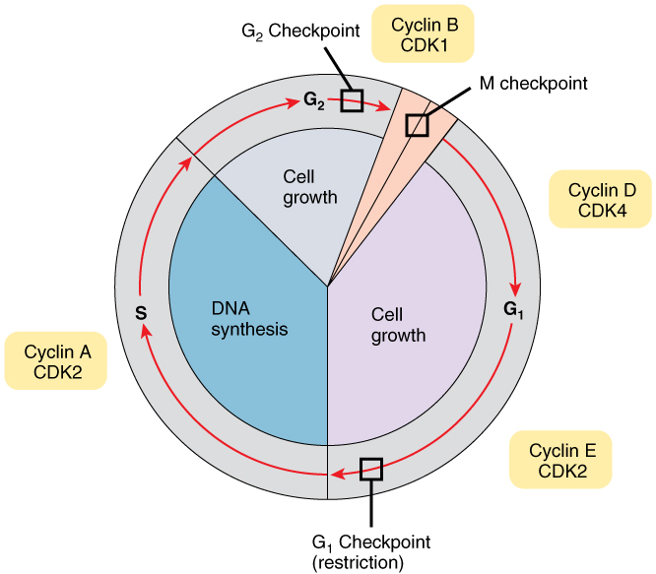

6 Stages of cell division
Interphase (long stage) 90% of a cell’s life
G1- Cell grows and is doing its job
S - Cell makes a copy of its DNA and is doing its job
G2- Cell grows more, preps for division and is doing its job
Another stage in some cells is G(o) it is actually the STOP/resting phase. Where cells ONLY do their job for the body no growth or division is occurring (ex brain cells & spinal cord nerve cells are in limited amounts and are not easily repaired or replaced)
Mitosis (5 quick steps) remember “PMATC”
Prophase—Chromosomes form, centrioles migrate and spindle fibers form, nucleus disintegrates
The cell then Packs DNA up into chromosomes
Metaphase - Chromosomes line up in the middle of the cell, spindle fibers attach to Centromeres
The chromosomes line up in the Middle of the cell
Anaphase- Chromosomes Separate and are pulled to opposite ends of the cell
Chromosomes move Apart and Away from each other to opposite ends of the cell.
Telophase- The Spindle disappears, the Two new nuclei form and a cleavage furrow (animals) or Cell plate (plants) forms between the two new daughter cells
Cytokinesis -two new cells are formed when the Cytoplasm divides and membranes close.

5 Stages of Mitosis
