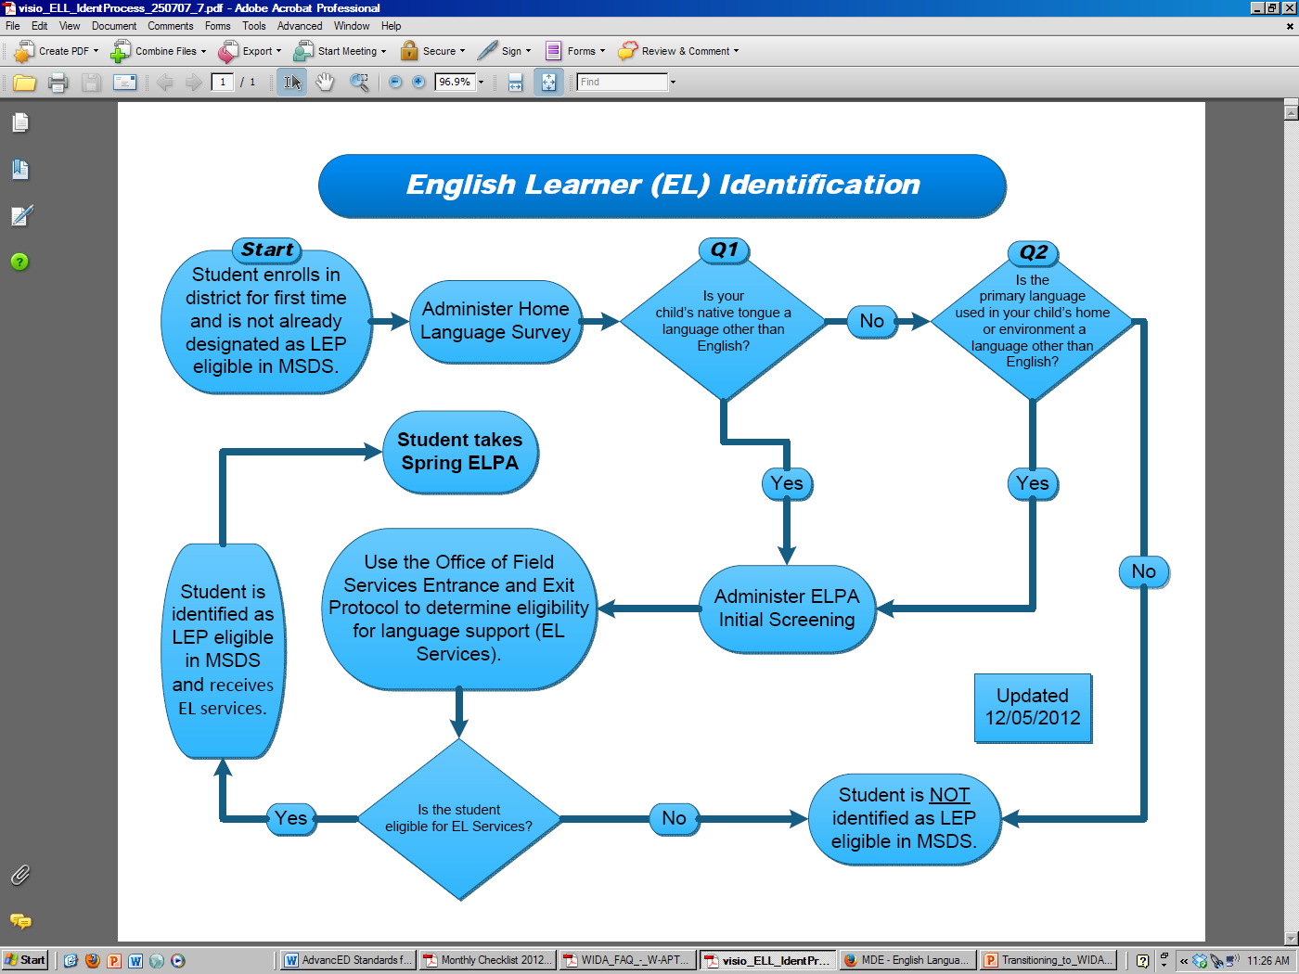

**W-APT**

**WIDA****PT**